Learning Goals: Students will be able to:
- Use the language of calculus to discuss and interpret motion
- Given a function, sketch the derivative, or integral curves
This goal is part of the lesson, but not stated on the student directions because the wording may be cognitive overload.
- Students generalize the idea of a graph [F(x) vs x] or [x(t) vs t] can represent the same thing.

Background: I teach algebra-based College Physics at my high school to juniors. To see how this activity fits into my curriculum, check my website at http://jeffcoweb.jeffco.k12.co.us/high/evergreen/science/loeblein/phys_syl/syllabus_p.html
My syllabus reflects plans, but adjustments are often made based on the students’ skills. I will use this as a homework assignment to reinforce ideas from Moving Man and the course text College Physics: A Strategic Approach, Knight – Jones – Field. Pearson 2007. We will have done labs with cars, carts, motion probe, and Moving Man PhET. See my activity for Moving Man at: http://phet.colorado.edu/teacher_ideas/view-contribution.php?contribution_id=5.

Calculus Grapher Introduction: These are my plans for the first time using this simulation. I will revise these plans after I use it. I don’t plan to do any introduction to the simulation, but I have plans to follow up with clicker questions.

Lesson:
I will be assigning some questions from Chapter 2 College Physics: A Strategic Approach, Knight – Jones – Field. Pearson 2007and I have put in the assignment “Try Calculus Grapher PhET simulation to check your ideas”. The questions require skills similar to my activity using Moving Man . For example, the students are given a velocity graph and asked: Which of the following position-time graphs would be consistent with the motion? Students are also asked to describe possible motion, construct graphs, or make interpretations based on slope or area. This is an example from my pre/post test used with Moving Man.
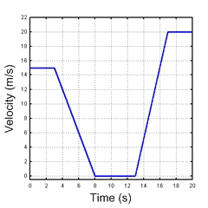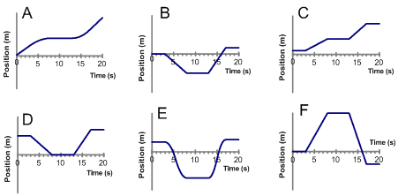

Post lesson: Clicker questions

