Lab objectives:
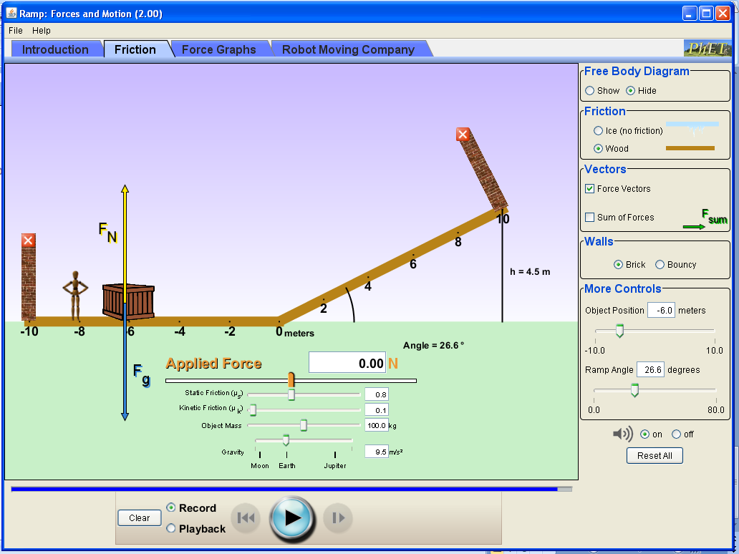
- Write an effective, testable hypothesis.
- To experimentally determine the relationship between the mass of an object and how far it slides from the bottom of a ramp.
- To experimentally determine the relationship between the angle of a ramp and how far an object slides from the bottom of a ramp.
- To confirm the experimentally determined relationship with a theoretical derivation.

Outline
- Go to the PhET simulation Ramp: Forces and Motion and click “Run Now”. You will place a crate at the top of a ramp and let it slide down. The simulation is at http://phet.colorado.edu/en/simulation/ramp-forces-and-motion. Set μ_{s}=0.5, μ_{k}=0.3, g=9.8m/s².

- First you will test the relationship between the mass of an object and how far that object slides off the end of the ramp.
  - Write a testable hypothesis in the form “If the mass of an object (blank), then the distance it slides from the end of a ramp will (blank) because….”
  - Develop a procedure to test your hypothesis. Be careful to control all parameters you don’t want to change such as coefficient of friction, starting point on the ramp, etc. Your procedure should be specific enough so that another physics student could duplicate your experiment.
  - Make a graph of your independent and dependent variables. Use the curve fit function of your graphing program to determine a model for the relationship.
  - Draw a free body diagram (or diagrams) to support what you graphed.
  - Use the appropriate kinematics formulas and Newton’s 2nd law of motion to derive a general formula relating the object’s mass (m) and the distance it slides (d).
  - Write a conclusion comparing your actual data with the equation you derived.

- Next you will test the relationship between the angle of the ramp and how far an object slides off the end of the ramp.
  - Write a testable hypothesis in the form “If the angle of the ramp (blank), then the distance it slides from the end of a ramp will (blank) because….”
  - Develop a procedure to test your hypothesis. Be careful to control all parameters you don’t want to change such as coefficient of friction, starting point on the ramp, etc. Your procedure should be specific enough so that another physics student could duplicate your experiment.
  - Make a graph of your independent and dependent variables. Use the curve fit function of your graphing program to determine a model for the relationship.
  - Draw a free body diagram (or diagrams) to support what you graphed.
  - Use the appropriate kinematics formulas and Newton’s 2nd law of motion to derive a general formula relating the angle (either θ or sinθ) and the distance it slides (d).
  - Write a conclusion comparing your actual data with the equation you derived.

- Extra credit: Predict how the results of either one of your experiments would differ it was done on either the Moon or Jupiter. Test your prediction by rerunning the experiment on either the Moon or Jupiter (by adjusting g accordingly). Submit your prediction, your new data table, and your conclusion on the effect of gravity on the distance.

