Learning Goals: Students will be able to:
- Predict the amounts of products and leftovers after reaction using the concept of limiting reactant
- Predict the initial amounts of reactants given the amount of products and leftovers using the concept of limiting reactant
- Translate from symbolic (chemical formula) to molecular (pictorial) representations of matter
- Explain how subscripts and coefficients are used to solve limiting reactant problems.

Directions: This activity is a review for the final exam, so the answers should demonstrate comprehensive self-evaluation.

- Play all levels of the Game with “nothing” hidden and record your scores. Play a few times if you feel you need to.

- Play all levels of the Game with “molecules” hidden and record your scores. Play a few times if you feel you need to.
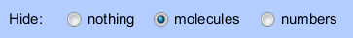

- Play all levels of the Game with “molecules” hidden and record your scores. Play a few times if you feel you need to.
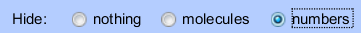

- How might using molecular images help you when you are doing real-world problem solving?

- Use examples to describe how you use the subscripts and coefficients while doing stoichiometry problems. Include examples that measure chemicals in grams, volumes of solution, and volume of gas.

