Build a Molecule Pre-lab Name: ___________

Using the atoms in the cups below: 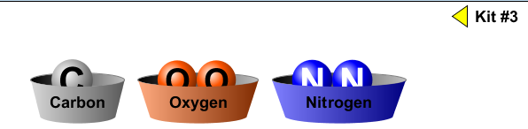
- How would you build a carbon monoxide molecule?

- How would you build a carbon dioxide molecule?

- What is the difference between the carbon dioxide molecule and the carbon monoxide molecule? __________________________________________________________

In two (2) molecules of ammonia – chemical formula = 2NH₃:
- How many nitrogen atoms are in there? _____________
- How many hydrogen atoms are there? ____________

