Balancing Chemical Equations Student Guide Name: ___________

**Start:**  1.

Google: PhET Balancing Chemical Equations

2. Click on the first link

1. Click on the  button.
2.  Explore the simulation. Be sure to click on everything.
3. Try both 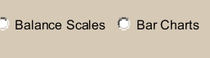
   1. Talk about how they may be useful in the activity.

Tell me what the scale and bar charts are helping you do? What is the purpose of these tools?

_________________________________________________________________________

_________________________________________________________________________

Which one does your group prefer **and** why? ________________________________________

_________________________________________________________________________

* 1. Fill in the box-



6. Is this equation balanced? Explain. _________________________________

__________________________________________________________________

Change the coefficients in the equation until you get a !

What does this smiley face mean?

__________________________________________________________________

**Teacher check-off**

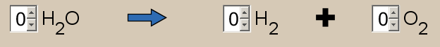

7. Is this equation balanced? Explain. _________________________________

__________________________________________________________________

Using the simulation- add coefficients so that the equation is balanced correctly.

______ H2O ______ H2 + ____ O2

8. 

Using the simulation- add coefficients so the equation is balanced correctly.

___ CH4 + ___O2 ___ CO2 + ____ H2O

List all reactants: List all products:

__________________ ___________________

__________________ ___________________

9. Discuss the maximum (highest number) of ammonia molecules the simulation will let you make? Draw them:   
In the product, ammonia (2NH3), What does the (2) tell you about the equation?

__________________________________________________________________

What does the (3) tell you?_____________________________________________

**Teacher check-off/check-in… Go on to  tab...**