Name: _____________________________
Grade: _____________________________
Sound Waves
Pre-lab
A wave is created on this string by moving the wrench up and down.
- What would change if the wave had a higher frequency and smaller amplitude?
Draw how the string would look for a higher frequency, smaller amplitude wave over this picture of the wave:

- What would change if the wave had a lower frequency and larger amplitude?
Draw how the string would look for a lower frequency, larger amplitude wave over this picture of the wave:

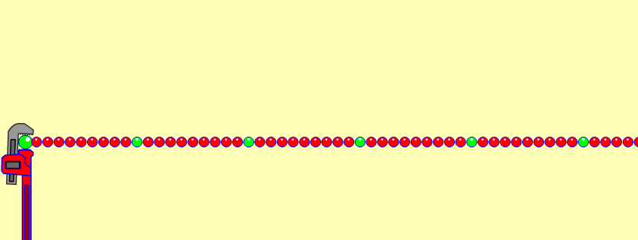
- If you were to create this wave by moving the wrench up and down, describe how you would move the wrench differently to make the high frequency, small amplitude wave compared to a low frequency, large amplitude wave?
Motion to make a high frequency, small amplitude?

Motion to make a low frequency, large amplitude?

- A student is listening to some pure notes that are produced using an electronic piano:
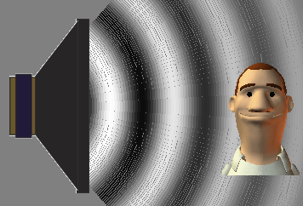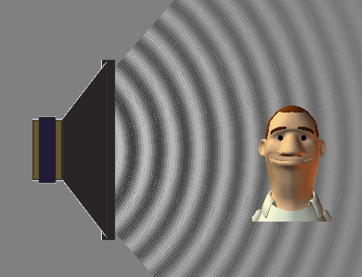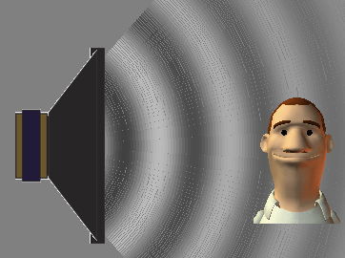
A B C

- Which picture or pictures (A, B, or C) would best show the student listening to a high-pitched sound?
Why do you think so?

- Which picture or pictures would best show the student listening to a loud sound?
Why do you think so?

- Which picture or pictures would best show the student listening to a low frequency sound?
Why do you think so?

