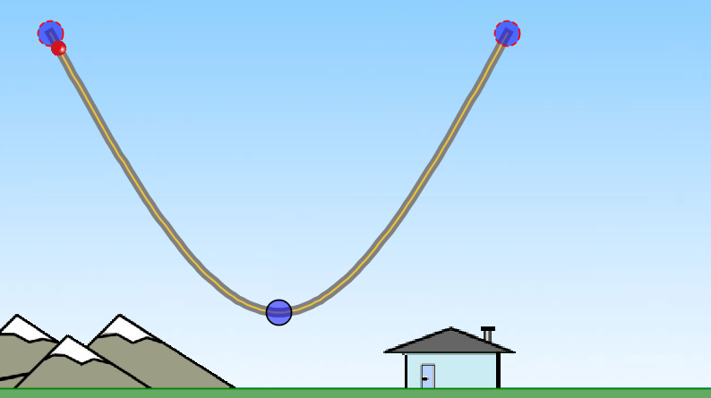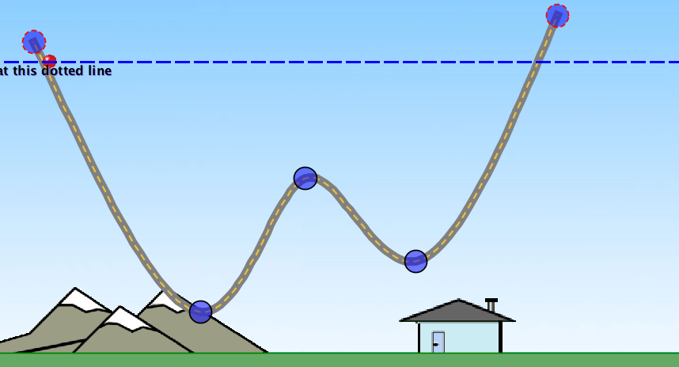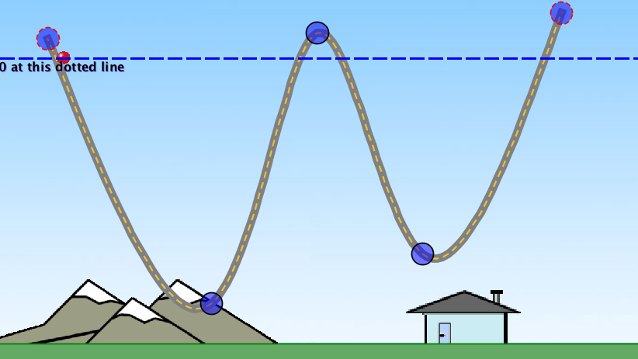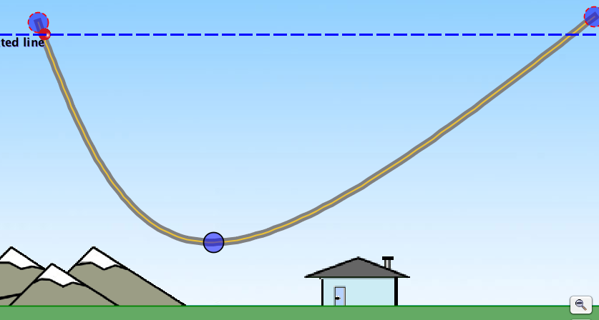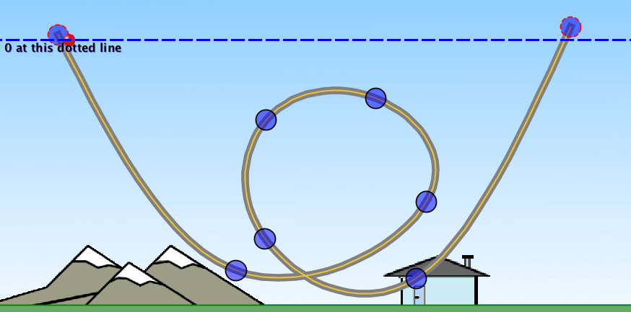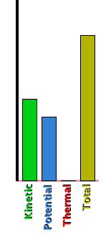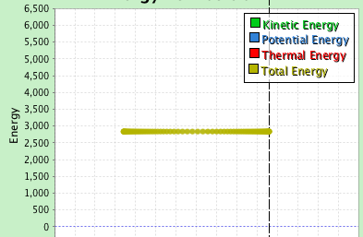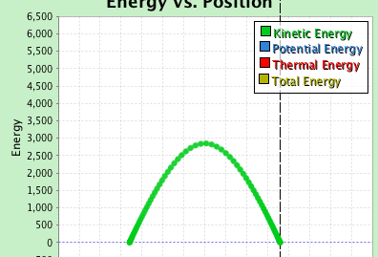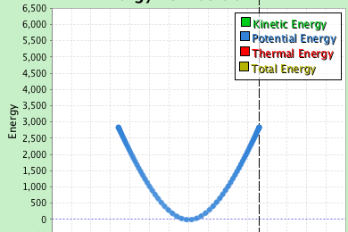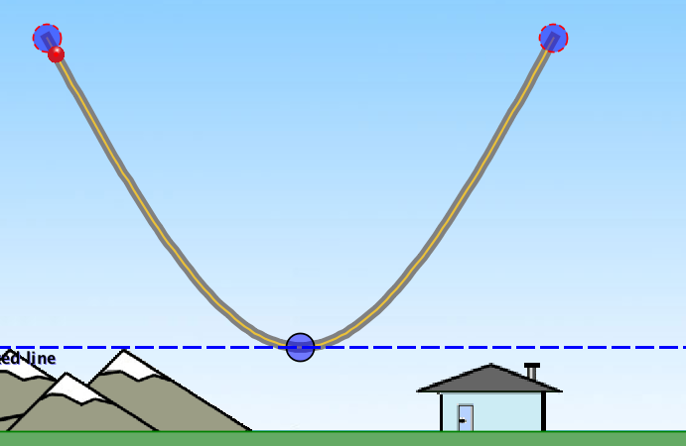

**Energy Skate Park:   
Intro to Energy Conservation**

1. Use menu to choose “double well roller coaster” track, pause animation, reselect ball.

Ask students to predict the path of the ball. Run demo and discuss.

1. Pause animation, reset ball to starting point, and drag track as shown.

Ask students to predict the motion of the ball. Run demo. What has changed from the previous demo?

1. Pause animation, clear path dots, reset ball at starting position, and drag track as shown.

Ask students to predict the motion of the ball now. Discuss possibilities, then run simulation.

Ask students to compare the speed of the ball at the bottom of the steep section (moving right) to the speed of the ball at the bottom of the gentler slope (moving left). Use the path dots to answer the question.

Ask students why the ball returns to the starting height. Does it depend on the path?

1. Use menu to select loop track, pause animation and choose ball. Reset ball to starting position.

Ask students to predict the motion of the ball. Run demo. Ask students: What condition must be met for the ball to make it over the loop?

Drag loop higher to demonstrate.

1. Open Energy Skate Park. Pause animation. Set skater to ball. Move ball to top left side of track.

Ask students to predict the motion of the ball when released. Predict motion diagram (position dots) for one cycle.

Release ball, run a few cycles, then show path for a single cycle. Discuss. Where is the speed greatest? How can you tell? Where is it least?

Ask students if friction is present. How can you tell? Turn on reference line and position at top of motion. How would the motion be different with friction?

1. Reset entire demo to original track, pause simulation, reselect ball, show reference line, and set line to lowest position of the track. Start animation on slower speed.

Ask students to describe the condition of the ball as it moves in terms of **energy**. Does it start with gravitational potential energy? Kinetic energy? What happens as the ball begins to move? Where is the gravitational potential at a minimum? At this location on the track describe the kinetic energy.

How would a graph of gravitational potential energy and ball position look?

Run animation, open the energy-position graph, deselect all but potential, then zoom in to see the graph. Discuss.

How would the kinetic energy-position graph look? Deselect potential and display only kinetic. Discuss.

Is this graph related in any way to the graph of gravitational potential energy? Display both graphs and discuss.

How would a graph of the total energy look? Display and discuss. How is the conservation of energy demonstrated in the graph? Explain.

How can you tell there is no friction using only the graph? Display with friction. Why is the total energy staying the same? Reveal thermal energy and discuss conservation of energy in terms of all relevant forms.

Turn off friction and open the animated bar graphs to give an alternate representation of the energy of the ball. Have students explain the graphic. Pause the simulation at various locations and discuss how the conservation of energy can be demonstrated by the graphs. This can be used to introduce energy bar graphs for analyzing energy problems.