Phet Simulation: Gravity and Orbits
Follow the directions carefully before answering the following questions while using the Phet Simulation “Gravity and Orbits”. http://phet.colorado.edu/en/simulation/gravity-and-orbits
- Run the Simulation, Keep all the default settings, but select the Earth and Satellite option. Turn on all of the options in the “Show” menu, then run and play with the simulation for a while. Which is experiencing a greater gravitational force: The satellite or the earth?

- Pause the Simulation. Hit “Reset”. (not “Reset All”). Alter the mass of the Satellite. Does the mass of the satellite have any impact on its Orbit? Explain.

- Pause the Simulation. Hit “Reset.” Click and drag the “v” at the end of the red velocity in order to decrease the satellite’s velocity.
  - What happens when you hit play? Why?

  - Why doesn’t this happen to satellites normally?

- Pause the Simulation. Hit “Reset.” Click and drag to increase the satellite’s velocity.
  - What happens when you hit play? Why?

- Pause the Simulation. Hit “Reset.” Click and drag the satellite itself to move it further away from earth.
  - What happens when you hit play? Why?

- Try to create another stable orbit that is further or closer to earth. Show your instructor or post a screenshot here. What other very important variable is altered with this new orbit?

- Just for fun. Click and drag earth to create a very small velocity for earth. Can the satellite still orbit a moving planet effectively?

- Pause the Simulation. Hit “Reset.” On the top left tabs, change your view so that you are to scale. In the Show menu, you can now also turn on the “Tape Measure”. Run the simulation, with the path shown.
  - How far out is the satellite?
  - How long does it take for the satellite to orbit earth?

- Switch modes, so that you are now looking at just the earth and the moon.
  - How far is the moon?
  - How long does it take for the moon to orbit the earth?

- Again Switch modes, so that you are now looking at just the earth and the sun.
  - How far is the earth from the sun?
  - How long does it take for the earth to orbit the sun?

- According to Kepler’s third law, The time it takes for one complete orbit is proportional to the mean distance between the centers of two bodies. T2 ≈ r3. When a constant is included, the equation is 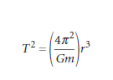Use the adjustable mass controls on the simulation of just the earth and sun to determine what mass the “m” in Kepler’s equation must refer to. Is it the mass of the orbiting object or the mass of the central object?

- Hit Reset All. View all three objects in Cartoon mode. Include a screenshot or Sketch showing their paths for one full year.

- Kepler actually proposed three laws.
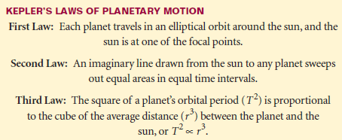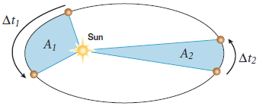
An Illustration of Keplers 1st and 2nd Laws is Shown here: A1=A2. In this case you can see that when a planet is closer to the sun then it must cover more distance in the same time. It must move faster.

Reset all. Select the Earth and Sun. Choose to show only the path and velocities. Manipulate the Simulation until you achieve an elliptical orbit. The speed of the earth increases slightly as it orbits closer to the sun but decreases slightly when it is further from the sun. (hint: move the sun itself.) Take and paste a screenshot or show your instructor for initialling your work here.

