Learning Goals:
- I will be able to describe the fundamental properties of waves.
- I will be able to explain how amplitude, frequency and wavelength are related.

Reflection on Pre-Lab Homework:
Before you played with the sim, you completed a pre-test. After playing with the sim, you should have recorded your observations and any questions you had. Think about those observations again and write any question you may have here:

We will take some time to answer student questions during the second part of the lab.

First Activity
Sign on and go to your class web page. Click on the Wave On A String link.
  - Set your controls to
  - The rest of your screen should be set up like this:
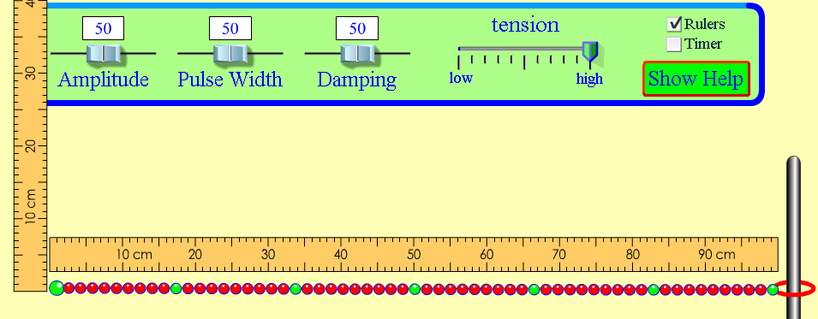
(You can change the position of the rulers by dragging them with the cursor. )
Change the amplitude slider settings and observe the resulting waves. ( moves the wave. )
- What setting makes the tallest waves? ___________________________________
- What setting makes the shortest waves? ______________________________
- Explain the wave property “amplitude” in your own terms.

Second Activity
Change your settings to observe wavelength and frequency:
  - Set your controls to and Fixed End
  - Set amplitude at 100 and frequency at 50.
  - Use the pause button to stop the wave for easier measurement.
- Use the ruler to measure the wavelength at the two points on this diagram and record your results. (Hint: Use the button after you hit pause to line up the large green ball at the end with the center line.)
wavelength = _______ cm
wavelength = _______ cm

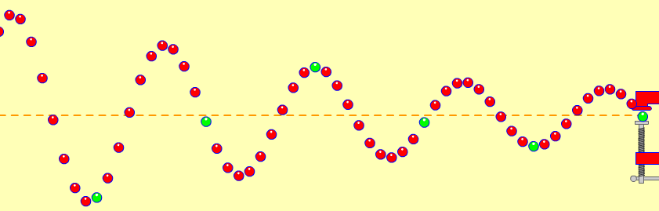
What did you discover about the wavelengths?
Did that match your expectations?
Why do you think this is true?
- Make a prediction about what you think will happen to the wavelength if you increase the frequency setting.

Change the frequency settings several times and observe the effect this has on the wavelength. Do you see a pattern?
Describe your observations:

- Now record some data as you change the frequency settings. (Remember to keep all the other settings constant!)

FREQUENCY | WAVELENGTH
Based on your data, write a statement about the relationship between frequency and wavelength.

Trade papers with someone else in your class and read each other’s statements. Discuss the similarities and/or differences in your statements. Revise your statement here if necessary.

BONUS: Investigate and describe the relationship between amplitude and wavelength.

