NSU Physics: Vector Walk Activity

Purpose  To see that resultant displacement does not depend on the order components are  added.  Required equipment and Supplies  Computer with web access | 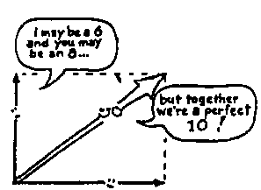

Discussion

You've just arrived in San Francisco to attend a physics teacher’s conference. You're staying at a hotel downtown, and you would like go to Carnelian Room for Sunday brunch. The hotel clerk gives you directions after you explain that you would like to go for nice long walk and end up at the Carnelian Room. On the way out you think it wise to double check yourself, so you ask the taxi cab driver for directions. They are completely different. Now what do you do? Are the directions the clerk gave correct? What about the cab driver's?

In this activity you will be given a set of directions several different times from the document “Taxi_Cab_Driver_Instructions_to_the_Carnelian_Room.pdf”. This document is found at:

http://www3.northern.edu/dolejsi/nsu_labs/Taxi_Cab_Driver_Instructions_to_the_Carnelian_Room.pdf

The document contains four sets of instructions, each marked with a group of distance (blocks) and a direction (N, S, E, & W) instructions.

Procedure

Randomly select a set of instructions. Start the PHET vector addition simulation at http://phet.colorado.edu/en/simulation/vector-addition .

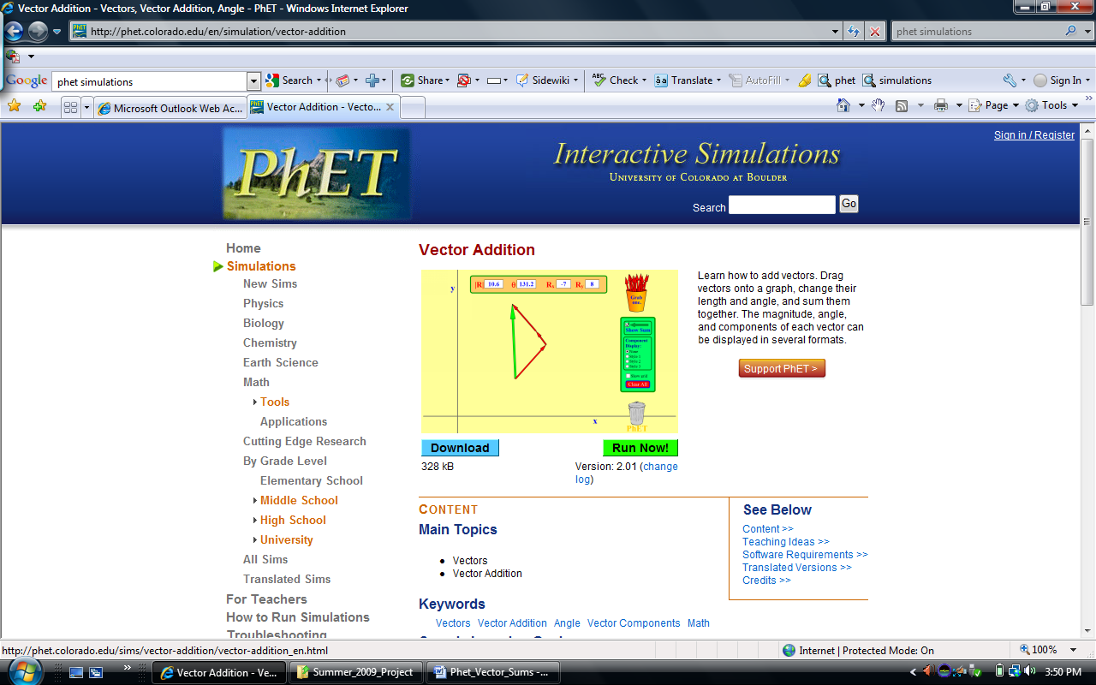

Select “Run Now” to start the simulation. Then, select show grid:

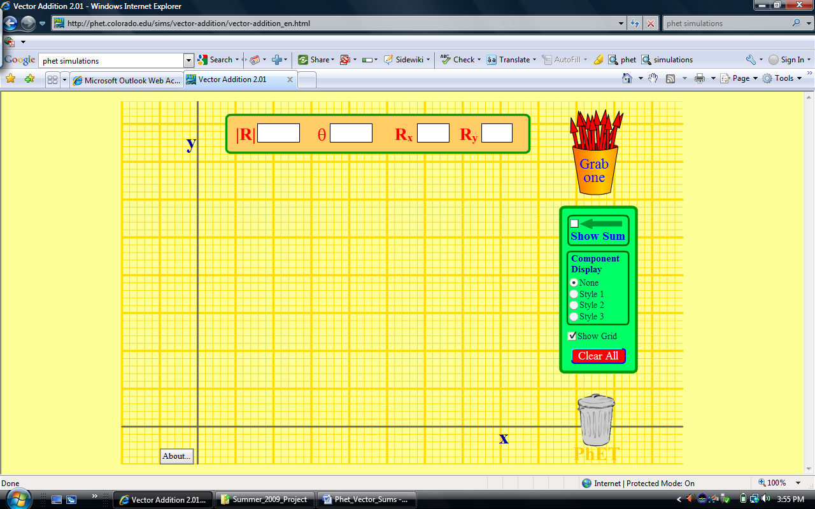

Grab the vectors and lay them out in a head to tail fashion according to the instruction set. An example is shown on the next page.

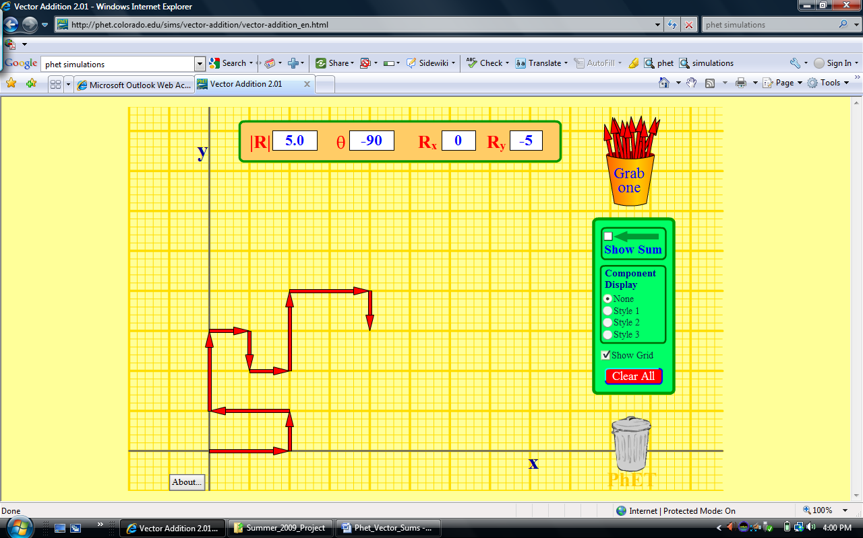

Click on Show Sum and drag the Resultant so that it points from start to finish as shown in the example below:

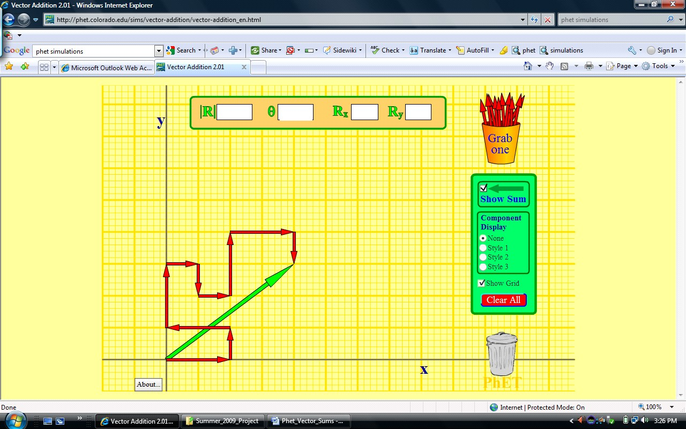

Use the “Print Screen” key on your keyboard to make a copy of your screen, and then paste your result below. Record your resultant displacement.

Resultant displacement = blocks @ degrees
(counter clockwise from the east) for instructions given by the Choose Taxi cab driver.

Pick a second set of instructions and repeat the above procedure to measure the resultant displacement.

Resultant displacement = blocks @ degrees (counterclockwise from east) for instructions given by the Choose Taxi cab driver.

Pick a third set of instructions and repeat the above procedure to measure the resultant displacement.

Resultant displacement = blocks @ degrees (counterclockwise from east) for instructions given by the Choose Taxi cab driver

Summing Up

1. How do your displacements compare?

The resultant displacements are .

2. How does the order that the vectors are combined affect the displacement?

The order the vectors are combined affect the displacement. This is because the resultant displacement = blocks @ degrees for all measurements.

