PhET Simulation - Beer’s Law
Go to: http://phet.colorado.edu/en/simulation/beers-law-lab

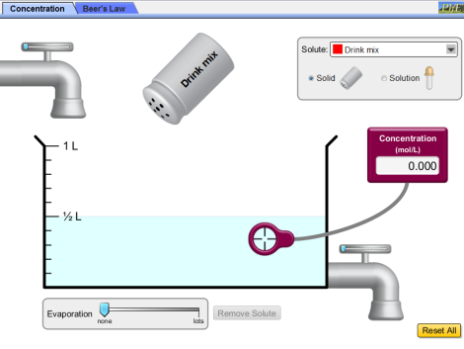
Warm up -- collecting and maintaining a sample:
Start with the Concentration tab, as shown at the right.
Drag the concentration meter into the solution and complete the table:
What impact does each variable have on the concentration of a solution?
Variable: | Adding a solid “pollutant” | Adding a liquid “pollutant | Adding more tap water | Draining off some water | Allowing water to evaporate.
Impact on concentration: (increase, decrease, unchanged)

Once a sample has been collected from the environment, it is important to preserve the concentration and get an accurate measurement later in the lab. Does the size of the sample matter? What steps should the researcher take to ensure the concentration measurement doesn’t change?

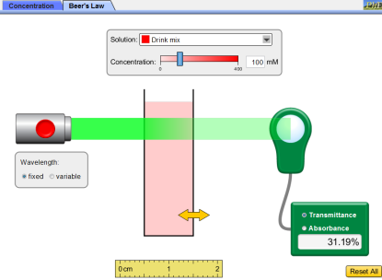
Part 1 – Transmittance and Absorbance.

Now click on the Beers Law tab, as shown at the right.
Reset all and turn on the light source.
The % of light that is transmitted through a sample depends upon four variables. First, just play around a bit. Manipulate these variables to see what their impact on % transmittance is.

The % of light transmitted will simultaneously tell us the amount of light absorbed. For example, what is the absorbance when the transmittance is “1”, 100%? _______________

For this investigation we will examine all measurements of light in terms of Absorbance.
Their relationship is mathematically expressed according to A = - log10 T

Remember: if you are testing/manipulating a variable and want to see the change it causes, then you must keep the other variables unchanged.
What impact does each variable have on the measured concentration of a solution, as given by Absorbance?
Variable: | Concentration,  c  (maintain the same “pollutant” and the same Length of sample to go through) | Length of Sample to go through,  l  (maintain the same “pollutant” and the same Concentration) | Type of “Pollutant” examined,  ε.  (maintain the same concentration and length of sample) | Wavelength of light used?  (maintain all other variables)
 | For all of these tests maintain the default fixed wavelength of light!
Relationship of this variable to Absorbance:
(direct “both go up/down” OR indirect “one moves in the opposite direction as the other” OR … Random “unique to each”
Part 2 – Beer’s Law.
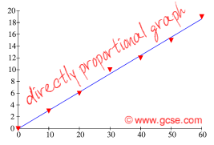
According to your observations, the measured absorbance will increase if you increase either the actual concentration or the sample cell length.

In fact, these measurements are directly proportional and should produce a straight line when graphed!

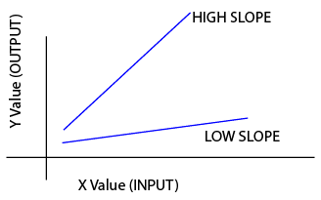
The rate of absorbance also depends upon the slope (type of pollutant examined), which is described by the “Molar Absorbance”, ε .
A substance that “absorbs a lot of light” will result in a steeper slope when graphed because of the greater “Molar Absorbance”, ε.

This also means that if you are looking at a particular(unchanging) type of pollutant, ε, using a particular(unchanging) sample length, l, the slope, εl, is constant.

Following the equation for a linear line, y = m x we get A = εl c. This is “Beer’s law”.

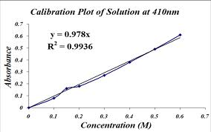
This equation can be applied to determine the concentration of almost any pollutant through its absorbance.

For example: if the following plot and equation of A vs c was obtained, then what would be the concentration of “pollution” for an unknown sample that has an absorbance of .55? ________
(hint: plug in .55 for the Absorbance value in the equation shown )

Based on your earlier observations, it shouldn’t surprise you that the graph above only applies to a particular wavelength of light, 410 nm. Although patterns of wavelength vs absorbance can be useful in identifying the substance, the pattern is so unique and random it is impractical for Beer’s Law.

Although Beer’s law can only applied to a “fixed” unchanging wavelength, it is a good idea to first determine which wavelength will be most suitable and then to conduct a Beer’s Law analysis with that wavelength.
Which wavelength would be the best to apply if you were to graph the A vs c for each of these substances?
