Computer Simulation: Drawing Electric Field Lines and Electric Field Intensities

Go to http://phet.colorado.edu/en/simulation/charges-and-fields and select the Charges and Fields Simulation. You will use this simulation to help you draw electric field lines for different scenarios.
Take a minute and familiarize yourself with the tools on the right hand side.
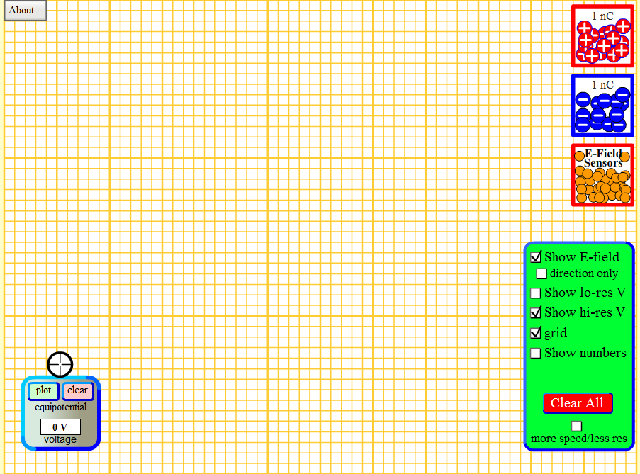

- Electric field lines of a single source charge
Draw the electric field lines around one (1) positive charge and one (1) negative charge separately. Be sure to include directions of electric field, charge, and proper notations.
Positive Charge | Negative Charge

- Electric field intensity per charge
- Draw the electric field lines for four (4) positive source charges and four (4) negative source charges
ELECTRIC FIELD AROUND POSITIVE CHARGES
+1 nC | +3 nC | +7 nC | +10 nC

ELECTRIC FIELD AROUND NEGATIVE CHARGES
-1 nC | -3 nC | -7 nC | -10 nC

- Describe, in your own words, how the electric field intensity changes for each charge
________________________________________________________________________________________________________________________________________________________________________________________________________________________________________________________________________________________________________________________________________________________________________________________________________

- Fill in the following statement

As the electric field ________________________ the magnitude of the charge ________________________.

- Drawing electric field lines for polar and non-polar charges
- Draw the electric field lines, for three cases of increasing intensity, around a positive and negative charge. Include the charge, electric field lines (including directions), and proper notations.
ELECTRIC FIELD LINES AROUND A POSITIVE AND A NEGATIVE CHARGE
First intensity | Second intensity | Third intensity
- Draw the electric field lines, for three cases of increasing intensity, around two positive charges. Include the charge, electric field lines (including directions), and proper notations.
ELECTRIC FIELD LINES AROUND A TWO POSITIVE CHARGES
First intensity | Second intensity | Third intensity
- Draw the electric field lines, for three cases of increasing intensity, around two negative charges. Include the charge, electric field lines (including directions), and proper notations.
ELECTRIC FIELD LINES AROUND A TWO NEGATIVE CHARGES
First intensity | Second intensity | Third intensity
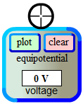
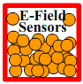
- Describe the nature of the electrostatic force surrounding the charges for each scenario above. Include in your discussion how the electrostatic force changes from each intensity and if/where there are any points of interest in the electric field worth mentioning.
(Hint: Use the electric field sensors and the equipotential voltage meter in your electric field)

________________________________________________________________________________________________________________________________________________________________________________________________________________________________________________________________________________________________________________________________________________________________________________________________________________________________________________________________________________________________________________________________________________________
________________________________________________________________________________________________________________________________________________________________________________________________________________________________________________________________________________________________________________________________________________________________________________________________________________________________________________________________________________________________________________________________________________________
____________________________________________________________________________________________________________________________________________________________________________________________________________________________________________________________________________

