Title: Electrical Circuits

Introduction:
In this activity you will investigate the physical science of electrical circuits. You will see how electrical current behaves in a parallel vs. series arrangement and what the relative brightness of bulbs in these circuits.
- Click on the link: http://phet.colorado.edu/
This is a screen shot of the website:
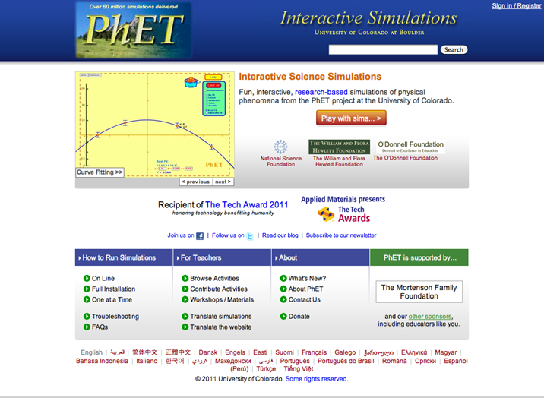
- Click the “Play with sims” button.
- Click “By Grade Level” > Click “Elementary School”>Click “Circuit Construction Kit (DC only)”
This is a screen shot of the simulation:

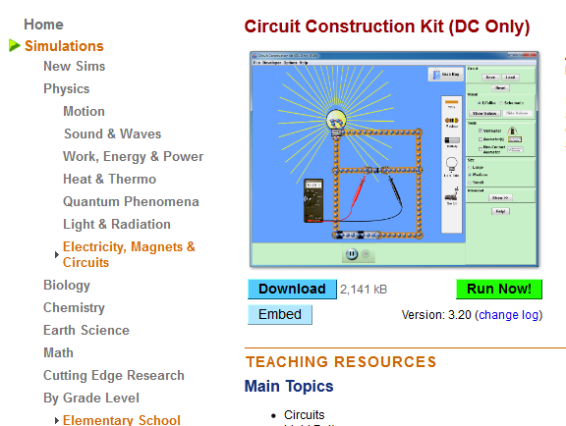
- When you see this screen you will then click on “Run Now!”
- Switch between this document and the simulation “Circuit Construction Kit (DC only)” to complete this activity.

Exploration Phase #1:
- Upon opening the sim, on the right hand side under ‘visual’ choose ‘lifelike’.
- Use the tools at the side to get a voltmeter and a Non-contact ammeter.
- Explore freely (using either the lifelike or schematic visual options). Play with the resistance and voltage of the battery. Make observations on how this changes the readings on the voltmeter and ammeter. Record your observations below. Be sure to record the changes you made and then the effects.
- Post a screenshot of your circuit below.

- Put the voltmeter near the battery and place the red tab at one end and the black at the other.
- Place the ammeter crosshairs over the moving blue dots.

Questions:
- What is the voltage? __________
- What is the non-ammeter reading? _______
- What seems to be making the light bulb turn on in your circuit?
Predict:
Do you think that the light bulbs will work the same in both a simple series circuit and a parallel circuit?

Explanation Phase:
Aim: What influence does voltage have on a circuit?
Complete graph:
Bulbs | Voltage (V) | Bulb Resistance (Ohms) | Bulb Brightness  (Dull/Bright) | Current (Amps)
1 | 9.00V
2

- Describe any possible patterns based on your findings:

Concepts to Know:
- A Simple Circuit Series is a circuit where the current runs through the same continuous circuit, lighting all components connected.
- A Parallel Circuit Series is a circuit where the components get their energy from the same voltage but have different circuits.

Application Phase:
- Click “Reset All”.
Simple Circuit Series:
- Light up 2 light bulbs using wires and one battery (voltage source)
- Set the light bulbs in a way that if one bulb connection is broken, all the light bulbs go out.
- Post a screenshot of the new circuit below:

- What happens to the circuit when connection to one bulb stops? Why?

- Use the voltmeter and non-contact ammeter to measure electron flow and push.
Voltage:_______ Ammeter:______

Now click “Reset All”.

Parallel Circuit:
- Create a parallel circuit that includes at least 4 wires, 2 light bulbs and 1 voltage source.
- Use the voltmeter and non-contact ammeter to measure electron flow and push.
- Voltage:_______ Ammeter:______

- What happens if you break the connection at one bulb?

- How do your findings compare with your prediction in the series circuit? Is this surprising? Explain.

