Title: Force

Introductions
In this activity you will investigate the physical science concept of force. A force is a push or a pull on an object.

1. Click this link: http://phet.colorado.edu/
This is a screen shot of the website:

2. Click the “Play with sims” button.
3. Click “New Sims” -> Click “Forces and Motion: Basics”->Click “Run Now!”
4. It will take time to load and then this screen appears:
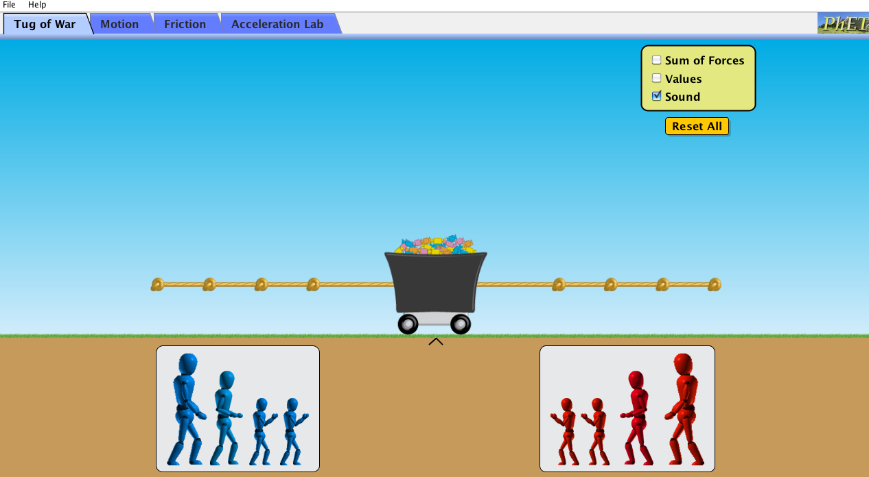

Switch between this document and the sim to complete the activity.

Exploration Phase

1. Click the “Tug of War” tab on the sim.

2. Place various objects on the rope.

3. Freely explore different combinations of objects and see what happens.

4. Try checking off “Sum of Forces” and “Values” in the yellow box.

Questions

- How do you make the rope move to the right?

- How do you make the rope move to the left?

- How do you make the rope stay still and not move?

Explanation Phase

Aim: Create a rule that describes the affect mass has on the applied force. Describe the rule here.

Click on the “Motion” tab and have your screen look like this:

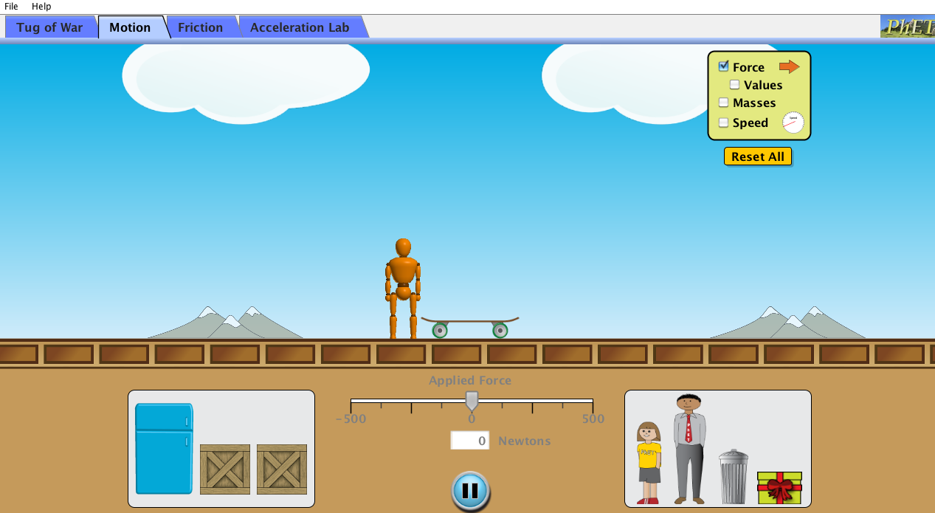

Here are some concepts:

An object in motion will stay in motion unless acted upon by an outside force.
An object at rest will stay at rest unless acted upon by an outside force.
When an object exerts a force on another object, the second object simultaneously exerts a force on the first object. In other words, F₁ and F₂ are equal in magnitude and opposite in direction.

Use the sim and fill in the blanks of the following table. Fill in whether the speed is fast or slow for the objects with the different applied forces. Check off different items in the yellow box such as “Force,” “Value,” “Masses,” and “Speed” to help you fill out the table. Use the “Reset All” button to reset if you need to start over.

If you have trouble finding the exact force values you need, you can type them into the white box next to the word “Newtons” and then hit “Enter” to get the exact force you want. This will also prevent the man from losing the skateboard because that can happen.

As a challenge, you can try to come up with the value for the Mystery Box and write your prediction in the table.

Object | Mass (kg) | Applied Force (Newtons) | Speed (Fast or Slow)
Refrigerator | 200 | 30
Refrigerator | 200 | 60
Refrigerator | 200 | 100
Man | 80 | 30
Man | 80 | 60
Man | 80 | 100
Girl | 40 | 30
Girl | 40 | 60
Girl | 40 | 100
Mystery Box |  | 30
Mystery Box |  | 60
Mystery Box |  | 100

Come up with a rule for the affect mass has on the applied force.

Write here:

How do you make the objects stay still and not move?

Application Phase

Click the “Friction” tab.
Your screen should look like this.

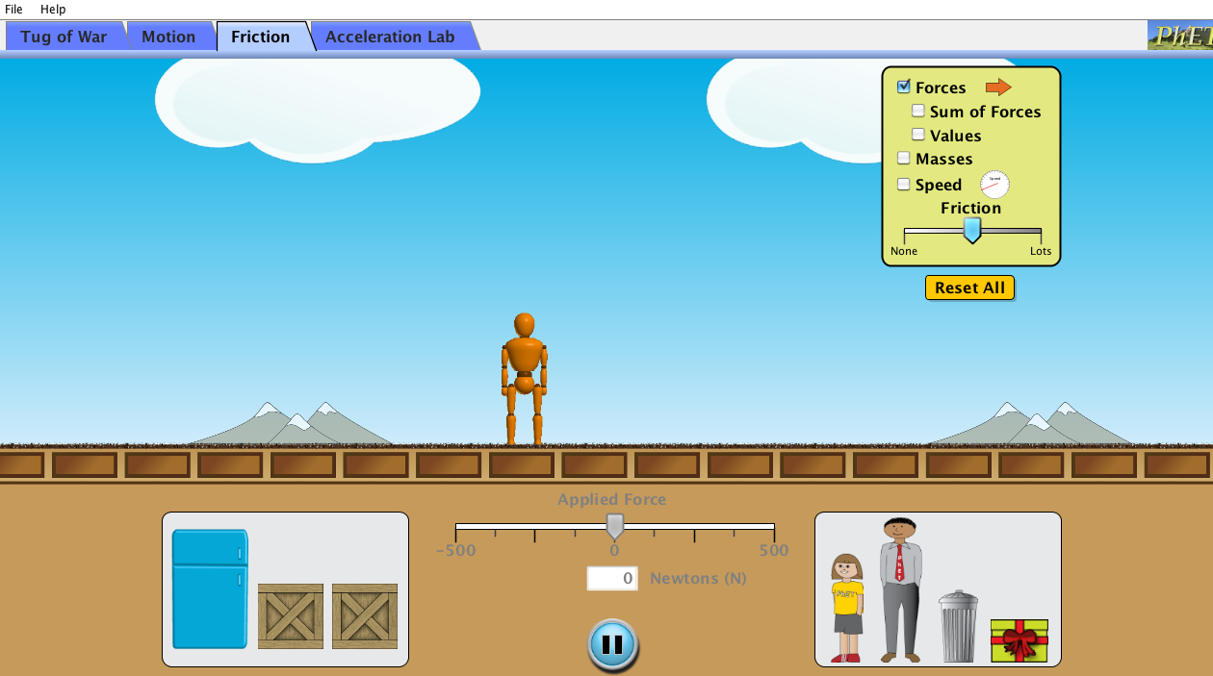

Play around with the “Friction” tab by experimenting with different amounts of force. Choose different objects to experiment with, as well. Try applying forces in both directions. Use the yellow box again and check off “Forces,” “Sum of Forces,” “Values,” “Masses,” and “Speed.” Adjust the “Friction” bar to see what happens when there is more friction or less friction.

Questions:

What do you notice about the sum of forces?

Come up with a rule for the sum of forces.

Write here:

Conclusion: Compare data from all experiments and explain how mass, friction, and speed affect force.

