ENKA HIGH SCHOOL
SCIENCE DEPARTMENT
11TH GRADES PHYSICS
Experiment name: Determination of Planck Constant and work function of a sample
Aim: To determine Planck constant and work function of a sample.
Theory: A freshly polished, negatively charged zinc plate looses its charge if it is exposed to ultraviolet light. This phenomenon is called the photoelectric effect.
Careful investigations toward the end of the nineteenth century proved that the photoelectric effect occurs with other materials, too, but only if the wavelength is short enough. The photoelectric effect is observed below some threshold wavelength which is specific to the material. Especially the fact that light of large wavelengths has no effect at all even if it is extremely intensive appeared mysterious for the scientists.
Albert Einstein finally gave the explanation in 1905: Light consists of particles (photons), and the energy of such a particle is proportional to the frequency of the light. There is a certain minimum amount of energy (dependent on the material) which is necessary to remove an electron from the surface of a zinc plate or another solid body (work function). If the energy of a photon is bigger than this value, the electron can be emitted. From this explanation the following equation results:
$${KE}_{max}=hν-ϕ$$
where
KE_{max} ... maximal kinetic energy of an emitted electron
h ..... Planck constant
$ν$ ..... frequency
$ϕ$ ..... work function

Procedure:
1. Go to the following address: http://phet.colorado.edu/en/simulation/photoelectric.
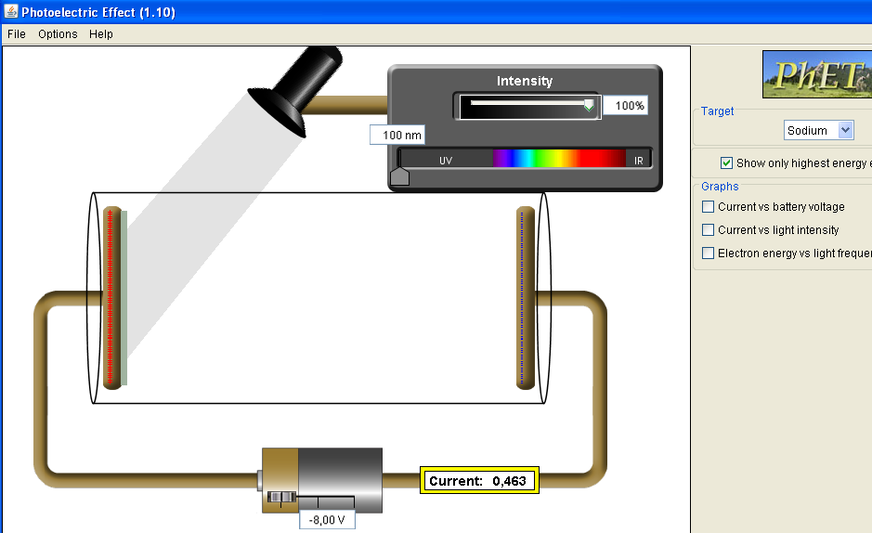
2. Choose cathode's material from the panel at the right side.
3. Increase the intensity to 100% from the the panel at the top.
4. Click the icon at the right panel which says “Show only highest energy electrons.”

Material | Working range (nm) | Material | Working range (nm)
Sodium | 125-430 | Platinum | 100-180
Zinc | 105-255 | Calcium | 140-280
Copper | 110-220 | Unknown | 120-250

5. Change the wavelength of light falling on the cathode material to any value specified for the
material you’ve chosen, using the button at the bottom on the cell to reach a current value
of zero, and record the wavelength and potential difference values to the table below.

Material | Wavelength  (x10⁻⁹m) | Stopping potential  (Volt) | KE_{max} (e.V_{stopping})  (eV) | $$ν=\frac{c}{λ}=\frac{3 {10}^{8}}{λ}$$

6. Draw KE_{max} - frequency graph.
7. Calculate the slope of the best fit line.
8. Calculate Planck constant (h) from the slope.
9. Find work function of the metal.
10. Calculate percentage error of your measurements in (8) and (9).

