Name:
Date:
Class/PD:

Crash?!
Introduction
In this activity, you will see how difficult it is to deal with the force of gravity; even gravity as low as that of the gravity on the moon. Remember, all objects have gravity in proportion to its mass. In other words, more massive objects have more gravity. Since you will be flying a space craft in this simulation, and the moon that you are landing on has more mass, the moon will pull the craft to it. You have to use the space bar and the arrow keys to maneuver the craft and to control the thrust.
Before you start, please review these helps provided by the site…

Play until you win and you win by landing and taking off three times in different places. Good luck…you are going to need it.

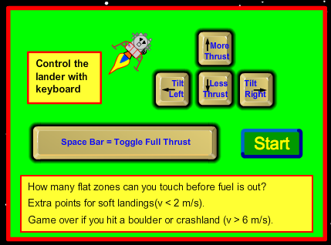

Procedure
- Look at the above diagram. Think about how you can control the ship.
- Log in and open up FireFox
- Go to http://phet.colorado.edu/simulations/sims.php?sim=Lunar_Lander and click the Run Now button (Green)
- When the program opens, click the green Start button.
- See if you can use your ideas to control the movement of the ship
- I know you are going to do this anyway, so let the craft crash once without pressing any keys…now you are done, move on.
- Remember, to be successful, you have to land and take off three times in three different places without running out of fuel, ruining your ship or spilling your fuel.

Your Results
- While you have unlimited tries to be successful, when you crashed the first time, what was your speed?
- The unit for speed in this activity was m/s. What does that stand for?
- How did you finally manage to be successful in this lab? Be specific.
- What was your best score?
- When you got your best score, how much fuel did your ship have remaining?

Questions
- How did you slow the ship’s descent?
- How did you make the ship go to the right? Be specific.
- What other controls would you have liked the craft to have to make this easier?
- How realistic do you think this activity was compared to real lunar landers of the past.

