Name_______________________________Date______________________________Period________________

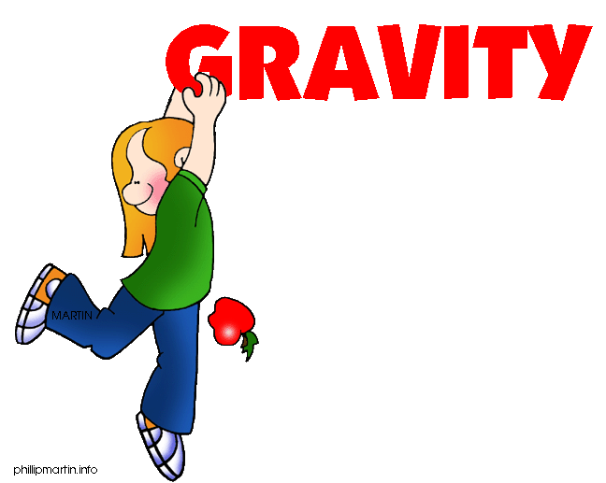

Learning Goal: Students will investigate the variables that affect the force of gravity on objects.

Background information:

Variable-A variable is any factor that can be changed or controlled

Independent Variable – something that is changed by the scientist
- What is tested
- What is manipulated

Dependent Variable – something that might be affected by the change in the independent variable
- What is observed
- What is measured
- The data collected during the investigation

INSTRUCTIONS: Open up the Gravity simulation on the PhET website.

- Get familiar with the simulation by moving the figures back and forth as well as changing the mass of the spheres.

- Circle the different variables that can be found in this simulation.

Distance between figures Mass of the spheres
Force Size of the figures
Strength of the figures Size of the meter stick

- What do you think the size of the arrows on top of each sphere represent?

- Pick a variable to manipulate (the independent variable). Summarize what you changed and what happened in the table below:

Manipulated (Independent) Variable | Dependent Variable

- Change a different variable and summarize what happens in the table below:

Manipulated (Independent) Variable | Dependent Variable

True or False

1. Gravity is a force that can be changed. T/F

2. The bigger an object is, the smaller the force of gravity. T/F

3. As one object gets closer to another object, the force of gravity will increase. T/F

4. The Sun has a greater gravitational force than Jupiter. T/F

Circle the Correct Answer

An object with more mass has more/less gravitational force than an object with a smaller mass.

Objects that are closer together have more/less of a gravitational force between them than objects that are further apart.

Teacher Notes

- Before I assigned this lab to my students, I did a quick review of variables. We practiced identifying independent and dependent variables after taking notes on the subject. There are many excellent Power Points and worksheets available online. The 8th graders I teach have had practice with variables, however I have found they usually need a review.

- This lesson was an introduction to the concept of gravity in astronomy.

