lac Operon Simulation
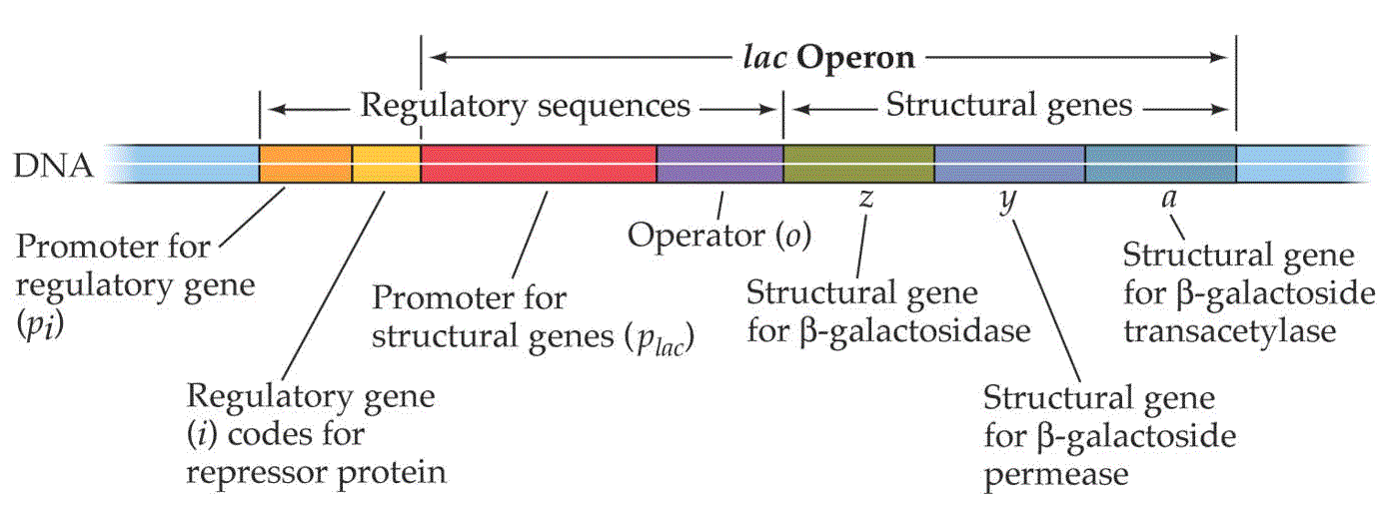
Function of Each Part
(please note the names of each part may be different between the picture above and the simulation)
- Promoter for regulatory gene/lacI gene

- Regulatory gene/lacI gene

- Repressor protein/LacI

- Promoter for structural genes

- Operator for structural genes

- lacZ gene

- LacZ protein

- lacY gene

- LacY protein
Make Predications Using the Simulation
- Some mutations can disable genes. What might happen if there is a mutation to the lacI gene? The lacZ gene? The lacY gene? Use the simulation and remove each gene from the DNA molecule and record what happens.

Next Steps…
Imagine you and your partner are researchers exploring the roles of the genes from the lac operon in prokaryotic E. coli. Use photos you cull from the Internet and photos you take of the simulation, along with your knowledge you gained from using the simulation, and create a Prezi. The Prezi should be about the role of each part of the lac operon and the effects mutations have on different parts of the lac operon. You will make your presentation in front of the class.

