Gravity Force Simulation
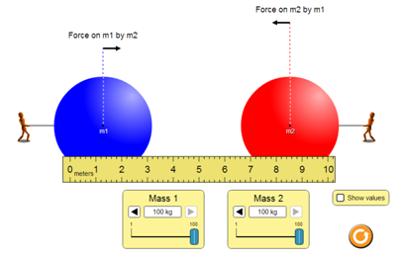
Directions: Use the “Gravity Force Simulation” to explore gravity. Record your responses in Notability.

Click HERE to access the online simulation.

Discover:
Identify two ways you can change the amount of force (gravity) the objects experience.

Complete the chart for each scenario below.
Mass of 1 | Location of 1 | Mass of 2 | Location of 2 | Force (1 on 2) | Force (2 on 1)
25 kg | 3 m | 25 kg | 7 m
25 kg | 1 m | 25 kg | 9 m
100 kg | 1 m | 100 kg | 9 m
100 kg | 1 m | 1 kg | 9 m

Summarize: Determine whether each statement about gravity is true.
____ The force of gravity increases as objects move closer together.
____ The force of gravity increases as an object’s mass increases.
____ If two objects have different masses, the more massive object pulls with a greater force.

Apply:
The earth’s gravity is pulling on you. Are you pulling on the earth? Explain your reasoning.

Gravity is a force of attraction between objects based on their mass and their distance apart. Why aren’t other objects, like your pencil, being pulled towards you? Explain your reasoning.

