Day 2: Ordering and Comparing Fractions

Target Group: Adaptable for 2-4th grades; Meets 3rd grade CCSS

Prior Knowledge: All pieces in a fraction are equivalent in size; Numerators are the top parts of fractions & tell how many equal parts are being considered; Denominators are the bottom parts of fractions & tell how many equal parts the whole is partitioned into.

Lesson Objective: Students will use their knowledge of numerators and denominators to order and compare fractions.
- CCSS.Math.Content.3.NF.A.1
Understand a fraction 1/b as the quantity formed by 1 part when a whole is partitioned into b equal parts; understand a fraction a/b as the quantity formed by a parts of size 1/b.
- CCSS.Math.Content.3.NF.A.3
Explain equivalence of fractions in special cases, and compare fractions by reasoning about their size.

Time: 45 minutes – 60 minutes
Materials:
- Activity Sheet for each student (see below)
- Laptop/Computer for each student
- Fractions Intro Simulation: http://phet.colorado.edu/en/simulation/fractions-intro
- Projector/document camera (optional)
- Food to represent a whole (candy bars/gum/crackers, etc) (optional)

Time | Procedure | Teaching Tips
5 minutes | - Review Previous Learning: Project the Fractions Intro tab and display a fraction. Have students turn and talk with a partner to share their understandings of fractions as you ask each of the following questions:  - What do you notice about the size of the pieces in the fraction? (all pieces are equivalent)  - What does the top part of a fraction mean? What about the bottom part?  - How does changing the numerator of a fraction change the amount? The denominator? | - As students share during the class discussion, project the sim so that students can demonstrate key concepts of equal parts, numerators, and denominators.
5 minutes | - Explore: Students will have 5 minutes to explore the Fractions Intro sim as teacher circulates and supports student exploration. | - If possible, set up student laptops with the sim prior to lesson to save time.
10 minutes | - Distribute Activity Sheets.  - Read today’s Learning Objective with students.  - Present the pie question and have students predict who ate more pie. You can set this up as a Think-Pair-Share/Turn and Talk or by a show of hands.  - Students test predictions by recreating the pies in either the Fraction Lab or Intro tabs (#1). Students will sketch their fractions on the Activity Sheet.  - Turn and Talk: Who ate more pie? What did you notice about the fraction that represented the larger portion of pie? | - Turn and Talk/Think-Pair-Share are interchangeable, depending on your classroom norms. Whatever terminology you use, it is assumed that the norms for effective partner discussion are in place.
10 minutes | - Order from least to greatest: Students will work on #3 by building the fractions and then ordering them from least to greatest.  - Monitor student discussion and work as they complete this task.  - Discussion: Students will first engage in a turn-and-talk conversation with their partner discussing the question: Is there a rule for ordering/comparing fractions when the bottom number, the denominator, is the same but the numerators are different? Encourage students to use examples as evidence to support their thinking.  - Whole Group Discussion: Share the learning with the class. Ask various partners to share their thinking/rule for ordering. Call on student pairs that you listened in on while monitoring conversations. Other students can piggy-back on these ideas.  - Concept Target: When the denominator is the same, the whole is cut into equal sized pieces. The larger the numerator, the greater the fraction because it represents a greater number of pieces of the whole. Once students have verbalized this learning, emphasize the concept using a real-life example. The cake representation is a good visual, or you can  bring in real food (candy bars, pieces of  gum, graham crackers, etc). For example, show (or pass out) a candy bar cut into 6 equal pieces. Show the size 1 out of 6, 2 out of 6, etc.  - Turn and Talk: Have students explain why the rule works. | - The discussion component of the lesson (partner talk and whole group) are essential components for solidifying student understanding & clearing misconceptions.  - Students can talk with their partner at their desks with the sim in front of them for Turn/Talk. When discussing with whole class, I like to pull the kids to a different part of the room. The change in location keeps kids from engaging with computer, allows them a quick moving break, & shifts their focus. We have a class meeting area where I have kids move to.  - If possible, project the sim while sharing so that students can demonstrate what they mean if needed.  - Post the rule (If the denominators are the same, the bigger the numerator, the greater the fraction) somewhere in your classroom for students to refer to.
10 minutes | - Ask: Will the rule “The greater the numerator, the greater the fraction” work for all fractions? Can you think of a time it won’t work? What if the numerators are all the same but the denominators are different numbers?  - Have students share predictions.  - Read #6 with the students and have students share their ideas of who ate more pie.  - Send students back to their desks to work on #s 6 - 8. Monitor student discussion and work as they complete these tasks.  - Whole Group Discussion: Share the learning with the class. Ask various partners to share their thinking/rule for ordering. Call on student pairs that you listened in on while monitoring conversations. Other students can piggy-back on these ideas.  - Concept Target: The greater the denominator, the smaller the pieces. Write the fractions ½ and ¼ on the board. Ask students if they’d rather share their food between 2 people or 4 people. Have volunteers break their food item into equal pieces based on their answers. Call students up to project their pieces under the document camera so students can see the size of ½ and ¼. Ask students to repeat the rule: With like numerators, the greater the denominator, the smaller the fraction.  - Turn and Talk: Have students explain why the rule works. Using the cake representation or food will help students know that the bigger denominator means that the whole is cut into more pieces, so the pieces are smaller.  - Write ½ > ¼ on the board and read the phrase together. Referring again to the food (or the sim cake representation!), emphasize that ½ is the larger fraction and it represents more of the whole because it is divided into fewer pieces. ¼ is smaller because it represents less of the whole, since the whole is divided into more pieces.  - In #9, students will apply their knowledge of comparing/ordering fractions independently. They may use the sim to help if needed!  - Early finishers may choose to play Build a Fraction or Matching Game. | - Post rule in the classroom.

Name _____________________________________________________________ Date_____________________

II. Ordering and Comparing Fractions
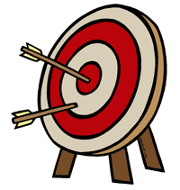
Lesson Objective: We will use our knowledge of numerators and denominators to order and compare fractions.

Mrs. Hixson & Mr. Huey have apple pies that are the same size. Mrs. Hixson eats $\frac{2}{8}$ of her apple pie. Mr. Huey eats $\frac{5}{8}$ of his. Who ate more pie?

- Choose the Intro Tab. Build Mrs. Hixson’s & Mr. Huey’s pies and sketch them below.
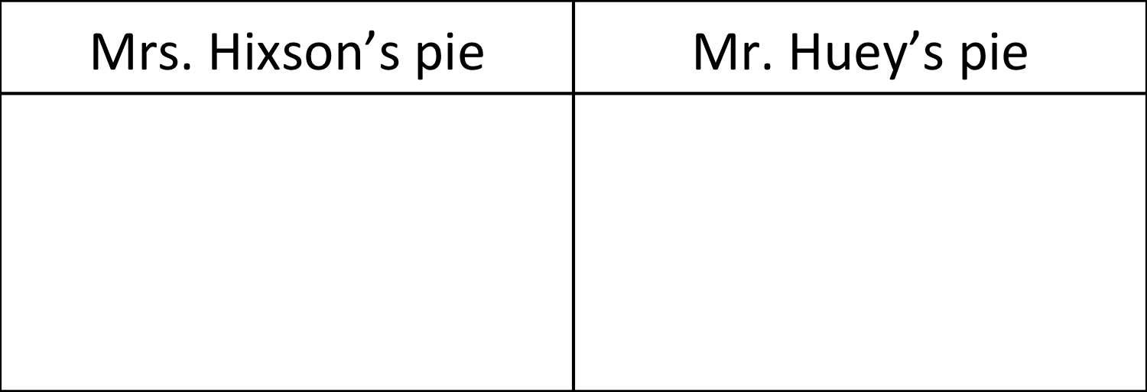

- Turn and Talk: Who ate more pie? What did you notice about the fraction that represented the larger portion of pie?

- Build the following fractions and sketch them in the table below.

2  6 | 1  6 | 5  6 | 3  6

- Put the above fractions in order from least to greatest. ___, ___, ___, ___

- Turn and Talk: Is there a rule for ordering/comparing fractions when the bottom number, the denominator, is the same? Write down your thinking!

- Mrs. Hixson & Mr. Huey have apple pies that are the same size. Mrs. Hixson eats $\frac{1}{8}$ of her apple pie. Mr. Huey eats $\frac{1}{2}$ of his. Who ate more pie?

Build Mrs. Hixson & Mr. Huey’s pies and sketch them below.

- Try out these fractions.
2  4 | 2  3 | 2  8 | 2  5

7. Put the fractions above in order from least to greatest. ___, ___, ___, ___

- Turn and Talk: With your partner, come up with a rule for ordering and comparing fractions if the numerators are the same but the denominators are different.

Application:
Ava and Mia are comparing the fractions$\frac{ 2}{3}$ and $\frac{2}{6}$.

Ava says that 2/3 is greater, but Mia says that 2/6 is greater. Using this number line, help the girls figure out who is right. Explain your thinking.

0
1

Write a fraction that is between 2/3 and 2/6.

