Forces and Motion
Lab #2
- Find today’s date on my calendar. Click on the Forces Lab 2 and then click simulation. Open the file that downloaded.
- Click on the acceleration tab at the top of the simulation
- Click the forces, masses, speed, and acceleration boxes so they are checked
- Slide the friction to none.
- Drag a box onto the track.
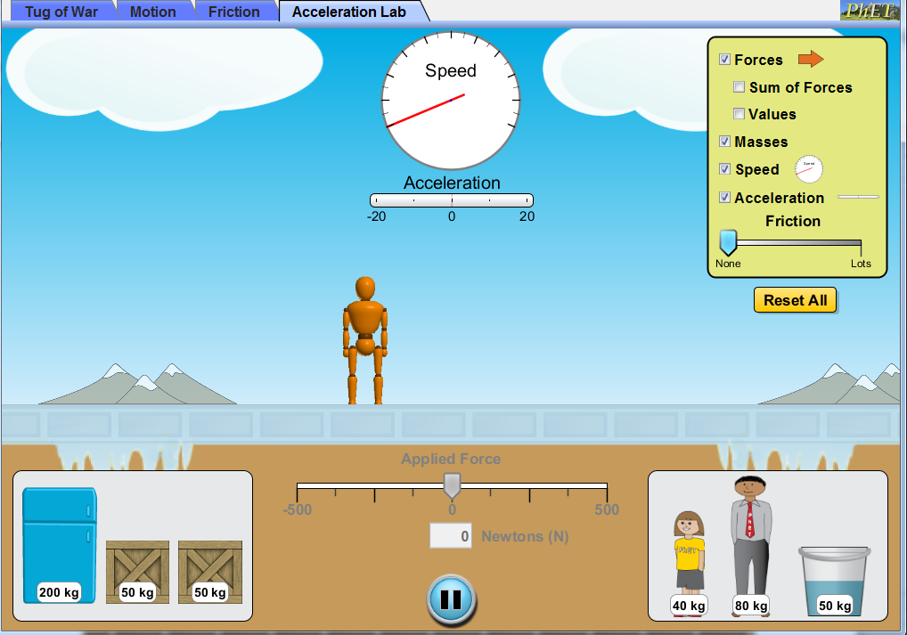
- Use the slider under the frozen track to push the box (See below):
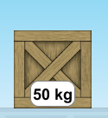
10 m/s²

- Use the simulation to answer each of the questions below (Use complete sentences to answer each question:
  - How do you make the box speed up?

I make the box speed up by _________________________________________

_____________________________________________________________________
  - How do you make the box move at a constant speed?

I make the box move at a constant speed by _________________________________________

_____________________________________________________________________
  - Once the box is moving how do you make it stop?
_____________________________________________________________________
_____________________________________________________________________
  - Once the box is moving how do you make it change direction?
_____________________________________________________________________
_____________________________________________________________________
  - Describe the motion the box undergoes when you make it change direction.
_____________________________________________________________________
_____________________________________________________________________
- Any change in motion is called acceleration. When does the box accelerate?
_____________________________________________________________________
_____________________________________________________________________
- What is the acceleration of each item?
I did the first one. Check my answer. Then find the acceleration of all the others.

Object | Mass | Acceleration | Force
Young Woman | 40 kg | 10m/s² | 400 N
Man in Suit | 80kg |  | 400N
Bucket | 50 kg |  | 500N

- Use the table above.
- How do you find force?

Force = ________________ x _______________________

- How do you find acceleration?

Acceleration =
- How do you find Mass?

Mass =
- How much force would the orange man need to use for the 200kg Fridge to accelerate at 5m/s²?

