TITLE
Intermolecular forces and states of matter

AUTHORS
Ted Clark (The Ohio State University)
Julia Chamberlain (University of Colorado Boulder)

COURSE
General Chemistry

TYPE
Interactive Lecture Demonstration Guide

TEACHING MODE
Lecture Demonstration

LEARNING GOALS
Students will be able to:
- Distinguish between kinetic energy (KE), potential energy (PE) and total energy.
- Apply the terms low and high PE for objects attracted to each other.
- Identify electrostatic interactions – which are of great interest to chemists – as the force affecting the PE of atoms and molecules.
- Apply the terms low and high PE for atoms attracted to each other, resulting in bonds with different bond enthalpies.
- Describe, at the particle-level, what happens during a phase change.
- Apply the terms KE and PE for states of matter.
- Connect particle-level descriptions of matter, including different phases, with macroscopic observations/properties.

COPYRIGHT
This work is licensed under a Creative Commons Attribution 4.0 International License.
This license allows users to share and adapt the materials, as long as appropriate attribution is given (with a link to the original), an indication if changes have been made, and an indication of the original licensing.
Intermolecular Forces and States of Matter

States of matter and phase changes are examined at the particle-level and in terms of kinetic and potential energy.

Placement in course
- This activity precedes the PhET lecture demonstration activity “Intermolecular Forces and Molecules” and revisits content in the PhET lecture demonstration activity “Nature of Energy”.
- End of 1st semester or start of 2nd semester of General Chemistry.

Prior knowledge
- Physical and chemical changes
- Energy, heat, exothermic and endothermic processes
- Molecular substances
- Bonds and bond energy

Learning objectives
Simulations | Format | Objectives, concepts
Energy skate park | Instructor-led | - Distinguish between kinetic energy (KE), potential energy (PE) and total energy.  - Apply the terms low and high PE for objects attracted to each other.  - Identify electrostatic interactions – which are of great interest to chemists – as the force affecting the PE of atoms and molecules.
Atomic interactions | Instructor-led | - Apply the terms low and high PE for atoms attracted to each other, resulting in bonds with different bond enthalpies.
States of matter | Instructor-led | - Describe, at the particle-level, what happens during a phase change.  - Apply the terms KE and PE for states of matter.  - Connect particle-level descriptions of matter, including different phases, with macroscopic observations/properties.

Resources
Energy Skate Park: http://phet.colorado.edu/en/simulation/energy-skate-park
Atomic interactions: http://phet.colorado.edu/en/simulation/atomic-interactions
States of Matter: http://phet.colorado.edu/en/simulation/states-of-matter-basics

Keywords
Intermolecular forces, potential energy, kinetic energy, electrostatics, states of matter, phases and phase changes, density, bonding.
ACTIVITY DESCRIPTION

Benchtop Demonstration- Boiling Water
Set-up a beaker of water and bring to a boil. Have the class consider a particle-level description of the water (Slide 1, inset shown), and then select what is in the bubbles.

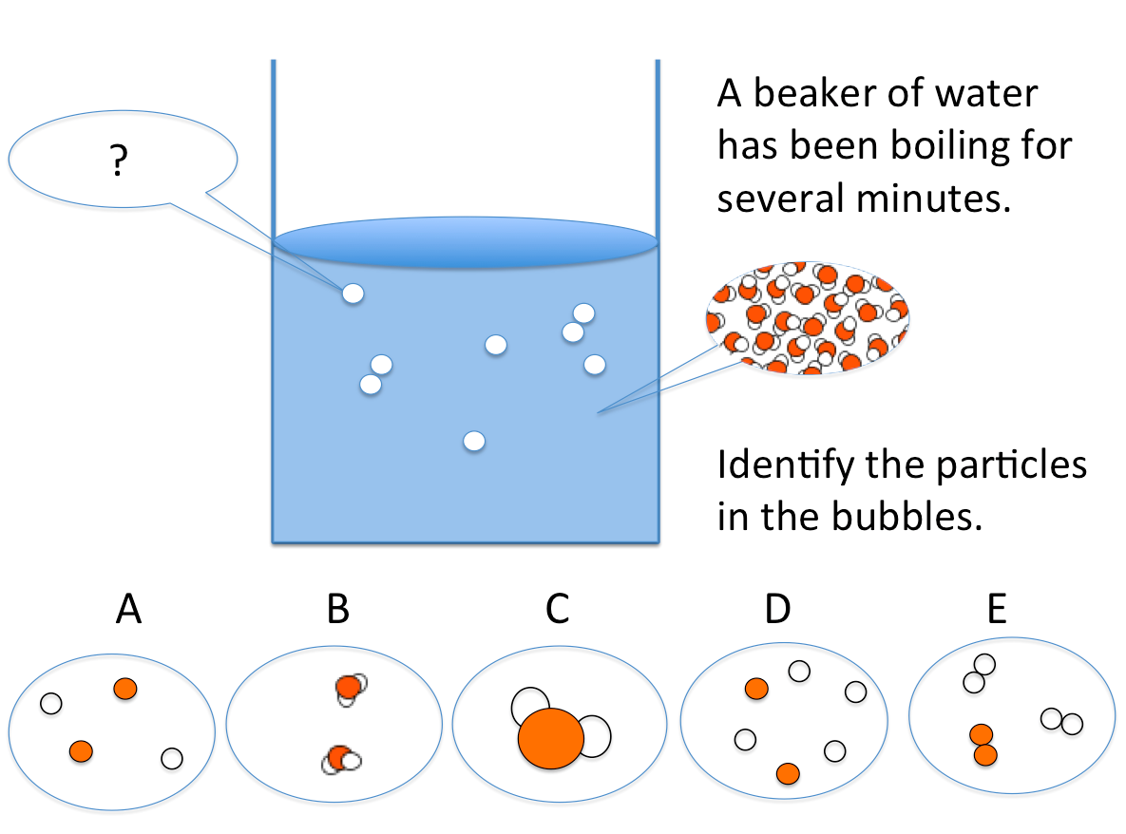
Slide 1. What Particles are in Boiling Water? (Polling Question)

The most common misconception among undergraduates is that hydrogen gas and oxygen gas are produced. For younger students a common misconception is that the water molecules change size or shape with a phase change. It is reasonable to re-visit this question after the activity.

Energy Skate Park Part I

The sim Energy Skate Park shows a skater on a frictionless track. Using the sim is very helpful for establishing the terms potential and kinetic energy before we apply them to atomic / electrostatic interactions.

- Start the skater in motion and use the bar graph to show the kinetic energy (KE), potential energy (PE) and total energy.
- Have the class look at the skater in motion for several moments, attending to how the KE and PE changes and how these are related to the position and motion of the skater.
- With a slide (Slide 1) check for student understanding (answers shown in red).

Additional points to make:
- For this isolated system, the total energy is constant and is described as potential energy and/or kinetic energy.
- Potential energy decreases when objects that are attracted to each other move closer together; kinetic energy increases.
- The force acting on the skater is gravity. The force acting on atoms, molecules, & ions is electrostatic (“opposites charges attract”).

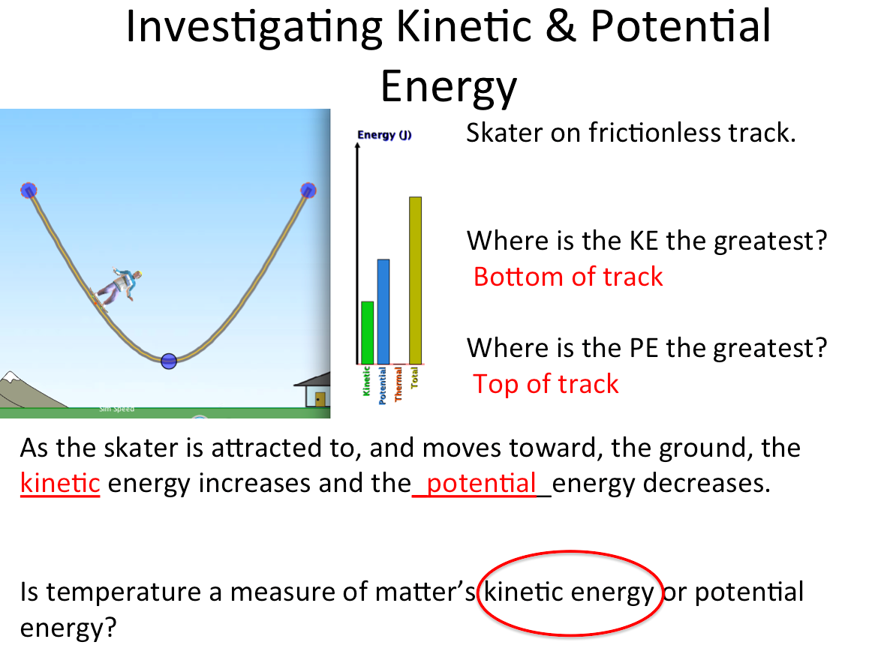
Slide 2: Identifying Kinetic and Potential Energy for a Skater.

Energy Skate Park Part II

- Return to the sim and consider what happens if the skater is placed at the bottom of the track versus the top.
- It will be obvious to students that a) a skater placed at the bottom of the ramp will not move; b) a skater placed at the top of the ramp moves downward; 3) it takes energy to move the skater from the bottom to the top of the ramp.
- Return to a slide (Slide 3) and check for understanding. The motion of the skater, or lack thereof, is connected to kinetic and potential energy.

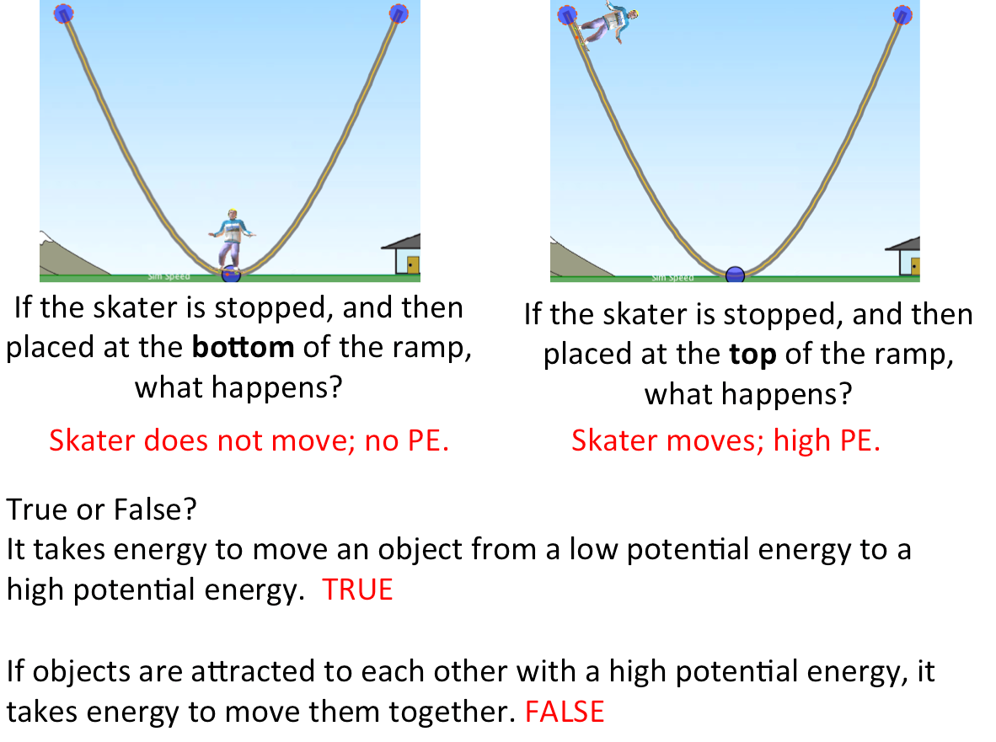
Slide 3: Relating Position to Potential and Kinetic Energy.

Atomic Interactions

The sim Atomic Interactions shows the potential energy accompanying bond formation. Bonding and bond energy are topics introduced before intermolecular forces.

- Use the sim to illustrate how the PE changes during bond formation. Atoms can be shown first with a large separation, and then the subsequent attraction leads to a decrease in PE. Emphasize that the potential energy decreases as the atoms are attracted to each other, moving to a closer distance.

- Connect “chemistry” terms with what we have learned by observing the skater in the sim and the energetics of bond formation. A large bond enthalpy corresponds to a “strong” bond and this is paired with a low potential energy. Placing the neighboring atom at the bottom of the potential energy well is comparable to placing the skater at the bottom of the ramp.

- Check for understanding with a slide (Slide 4, answers shown in red). An extremely common misconception is that a strong bond has a high potential energy, and that this energy is released when the bond is broken.

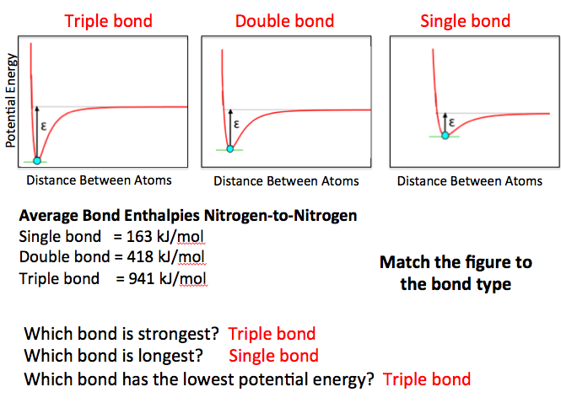
Slide 4: Potential Energy and Bonding

A chemical reaction may be introduced to consider where energy comes from in an exothermic reaction. “ Why is the combustion of methane, CH₄, in oxygen to produce carbon dioxide and H₂O exothermic? Where does the energy come from? Use the terms reactant, product, potential energy, and bond enthalpy in your answer.”
States of Matter – Solid, Liquid, Gas Screen Part I

The sim States of Matter shows particle-level representations of different substances in different phases. Heat may be added or removed.

- Begin with oxygen as a solid. Add heat to change the phase. Direct the students to identify what stays constant and what changes as heat is added (“what is the heat doing?”) at the particle-level.

- Test for understanding with a slide that includes images from the sim (Slide 5). Consider what is occurring at the particle-level, and also energetically; the solid has the lowest potential energy and the lowest kinetic energy (lowest temperature).

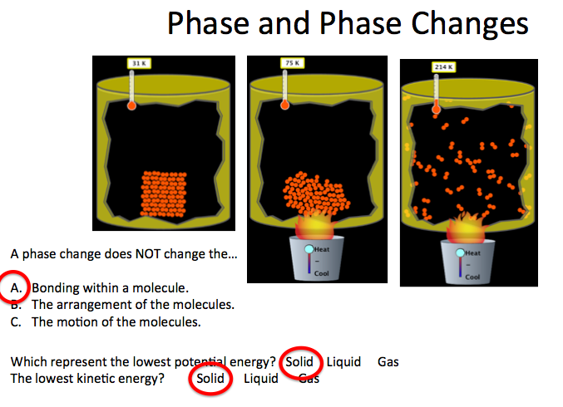
Slide 5: Phase Changes at the Particle-Level for Oxygen.

States of Matter – Solid, Liquid, Gas Screen Part II

- Students make predictions for what will happen when substances like Ne(s) and H₂O(s) are heated (“what will be the same/different at the particle-level when compared with oxygen?”) and these are tested within the sim.

- A discussion may follow for substances not in the sim, e.g. Kr, F₂, Cl₂, CO₂, NaCl.

- The term intermolecular force is introduced, as well as their relative strength, i.e. weak intermolecular forces correspond to a low melting point. “In the sim, which substance has the weakest intermolecular force? How do you know?”

- Return to a slide (Slide 6) to check for understanding.

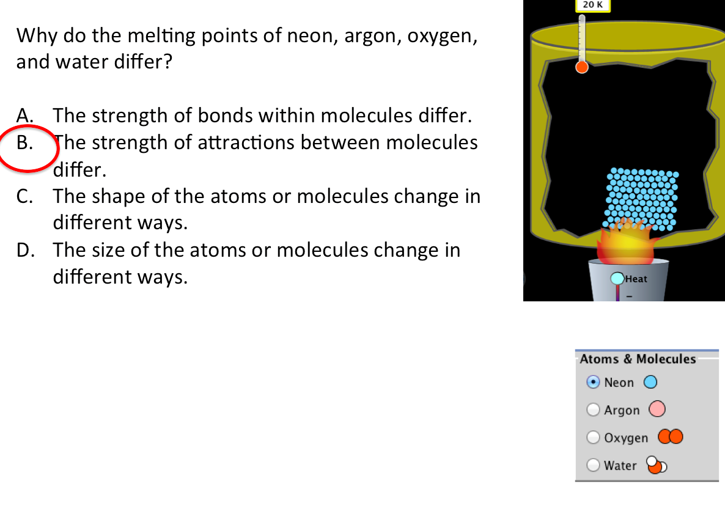
Slide 6: The Strength of Intermolecular Forces Affects Properties like Melting Point.

States of Matter - Solid, Liquid, Gas Screen Part II

How is the property of density explained at the particle-level? A common misconception is that the density of the molecule (or atom) equals the density of the entire substance.

- Initial understanding may be probed with students ranking the phases of H₂O based on experience (Slide 7).

- Start with H₂O(s) and add heat to produce a phase change, or click on each phase. The number of molecules is not changing in the sim. Does the volume seem to change? If so, then the density will change too.

- The novel density ranking for H₂O is introduced, and can be compared with the other substances at the particle-level. A good point to discuss is why the ranking for H₂O is different. Does it have more to do with the arrangement of molecules in the solid or the liquid phase?

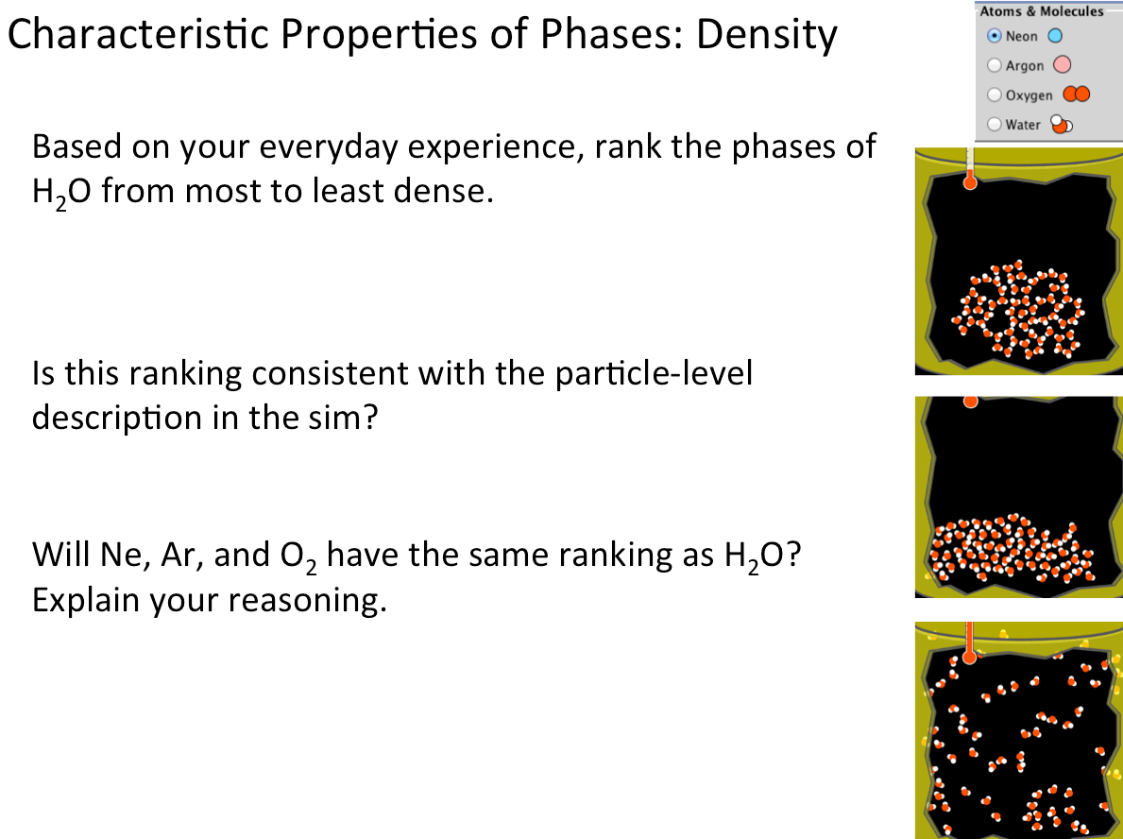
Slide 7: Examining Density at the Particle-Level.

Benchtop Demonstration – A bulb of Br₂(l) placed in a container of N₂(l)

Interactive demonstrations for phase changes allow discussion of observations and explanations at the particle-level that incorporate energy.

- Students make an initial prediction as to what will be observed, and sketch a particle-level description for the process. The demonstration then takes place and a consensus is reached regarding the observations; particle-level sketches are revised and discussed. Follow-up polling then takes place (Slide 8, answers in red).

- Scientists refer to the transfer of energy, not the transfer of “coldness”.

- If energy may enter or leave the system then its total energy is not constant. This is different than the Skater in the Skate Park sim.

- Another good example is the sublimation of dry ice, CO₂(s) CO₂(g).

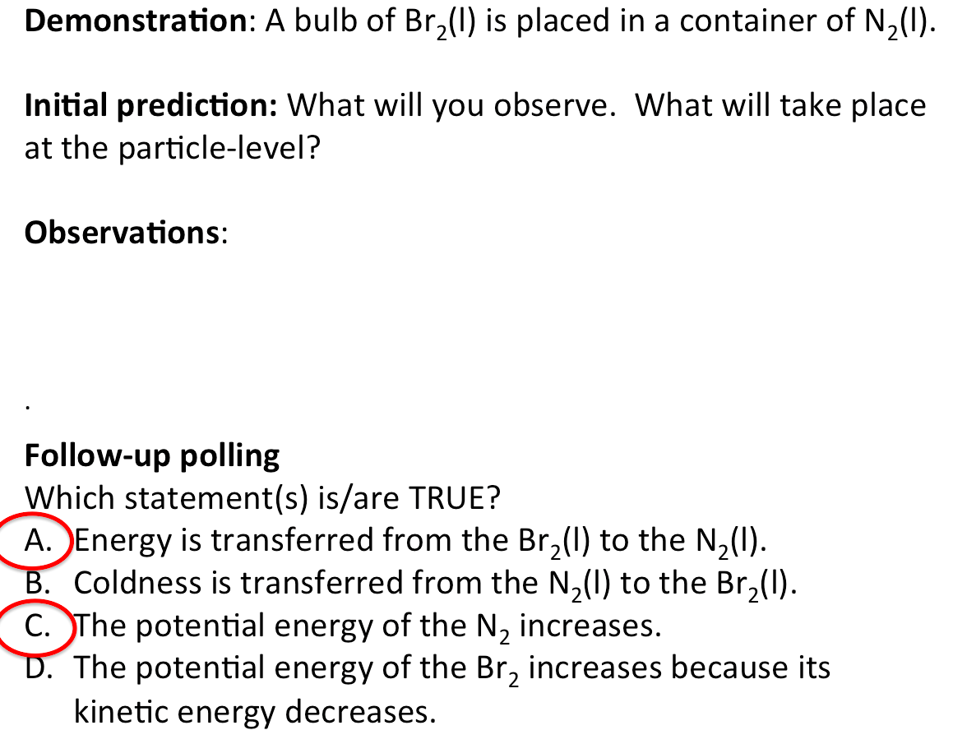
Slide 8: Interactive Demonstration Involving Phase Changes Described at the Particle-Level and Energetically.

Discussion – Heating Curves

Heating curves are usually introduced when discussing intermolecular forces and states of matter. Heat is added to a substance at a constant rate and the temperature is measured (Slide 9). Analysis of the curve can be related to the concepts of kinetic and potential energy.

- Identify the phase(s) present in each segment (AB, BC, etc.).
- Is the kinetic energy changing during segment AB? (Yes, temperature is increasing and particle motion is increasing).
- The temperature is constant during segment DE even though energy is being added. What does this mean in terms of potential energy? (The potential energy is increasing as the molecules are being moved apart).
- Compare the length of segments BC and DE. Discuss differences in terms of potential energy. (The potential energy difference between a gas and a liquid is greater than that between a liquid and a solid).

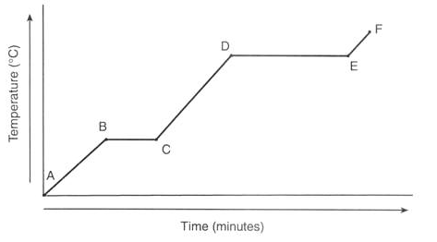
Slide 9: A Representative Heating Curve.

