Energy forms and changes PHET Lab Name:
https://phet.colorado.edu/en/simulation/energy-forms-and-changes
Students will be able to:
Describe how heat flow from hot to cold.
Explain that some materials hold and release more energy than others (specific heat)
When in doubt, add a thermometer!

- Is it possible to boil the water? Is it possible to freeze the water? (Make sure to attach the temperature gauge so you have a guide.) What do you need to do to make these changes?

- Chill the water as much as possible- then add heat and observe. List below at least three things you noticed (Make sure the energy symbols box is checked.)

- Add heat to the Iron and heat to the brick at the same time. Which one can hold more energy? How/where do they lose their energy?

- Add a heated up bit of iron to room temperature water. Describe in detail what happens below.

- Place the brick on top of the iron and add heat. Describe what is happening in at least three sentences.

- Take the same set up from #5, an instead of heating it up, cool it down. Describe what is happening in at least three sentences.

- Once the brick and the iron are cooled down, do they have the same thermal energy? Do they have the same temperature? Does the room temperature water have more or less thermal energy?

Energy Systems Tab
Students should be able to:
Describe different types of energy
Recognize that energy transforms from one version to another.
- Click around and explore what the symbols mean make sure to click on the Energy symbols tab. What to the different symbols mean? What are the different types of energy circulating? For the source of energy- describe the picture and if there is any energy transfers that happen. Example: the teapot goes from thermal to mechanical. Make your lists below:

- Compare the two types of light bulbs. How are the CFL’s (compact fluorescent lamps) different than the incandescent bulbs? Which one releases more thermal energy- how is the process different?

- In the teapot energy source, __________ energy transforms into ____________ energy.
- In the image below there is a E with a dotted line. (or look at what is happening inside the wheel/motor) Using your knowledge of how an motor/engine works, what do you think it stands for/represents?
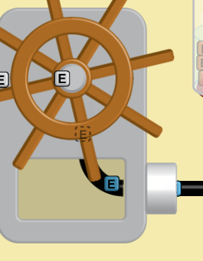

Teacher Page:
From energystar.gov:
CFLs produce light differently than incandescent bulbs. In an incandescent, electric current runs through a wire filament and heats the filament until it starts to glow. In a CFL, an electric current is driven through a tube containing argon and a small amount of mercury vapor. This generates invisible ultraviolet light that excites a fluorescent coating (called phosphor) on the inside of the tube, which then emits visible light.
CFLs need a little more energy when they are first turned on, but once the electricity starts moving, CFLs use about 70% less energy than incandescent bulbs. A CFL’s ballast helps "kick start" the CFL and then regulates the current once the electricity starts flowing.
Classroom discussion:
From the first Tab, What material can hold the most heat? Which take the longest to cool down? (Is it the same order?
How does heat flow? What evidence did you experience to justify that answer?

