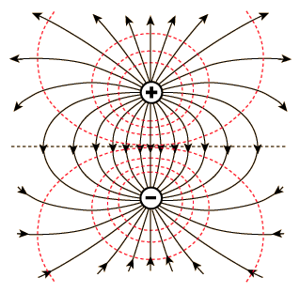ELECTRIC FIELD HOCKEY

**Purpose:** Develop a visual understanding of electric fields by exploring the effect that charged particles have on one another.

**Procedures:**

-Google: phet electric field hockey

- Click on the first link

-Click Run Now

-Complete the simulation as instructed below.

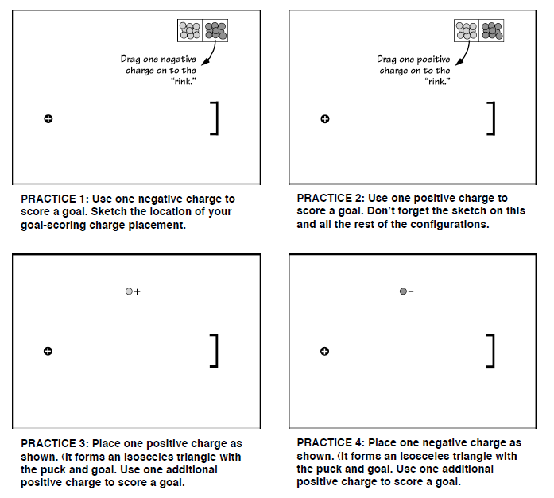

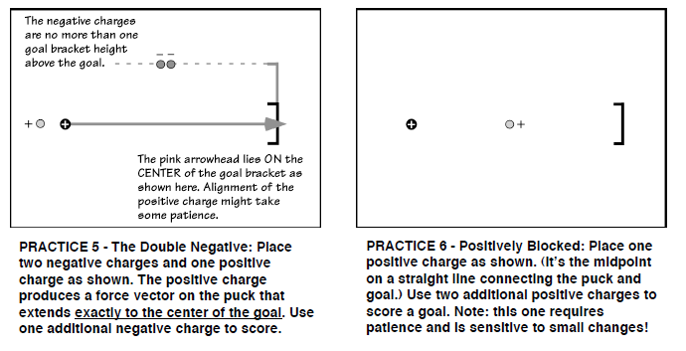

Once you have completed the practice exercises above, select Difficulty 1 from the choices at

the bottom of the Electric Field Hockey window. As you proceed through the following exercises, pay

particular attention to the difficulty level and stated restrictions, if any.

**Difficulty 1 – Freestyle:** Use as many charges as you like to score a goal. Sketch your charges and the puck’s path below.



**Difficulty 2 – Freestyle:** Use as many charges as you like to score a goal. Sketch your charges and the puck’s path below.

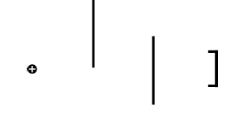

**Difficulty 1 – Limited:** Use only two positive charges to score a goal. Sketch your charges and the puck’s path below.



**Difficulty 1 Qtip**

**Dipole –/+:** Arrange charges as shown below. Use as many additional charges as you like. Sketch your solution.

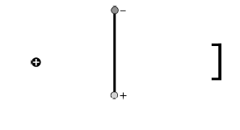

**Difficulty 2 – Exclamation Double Point Limited:** Arrange the charges as shown in Figure 3. Then use no more than two positive and two negative charges to score a goal. Sketch your solution.



**Difficulty 3 Freestyle:**

Use as many charges as you like to score a goal. Sketch your solution.

**Electric Field Hockey Post-Game Analysis**

(You may need to explore some of the additional features of this simulation in order to answer these questions.)

1. Which direction do electric field lines point for positive charges?
2. Which direction do electric field lines point for negative charges?
3. What do the direction and strength of the field lines indicate for the (positively charged) “puck?”
4. Did the (positively charged) puck always move in the same direction as the field lines it was passing over?
5. What happened (or would happen) if you changed the charge of the puck from positive to negative?
6. Increase the mass of the puck. Explain what happened.
7. How did the distance between the puck and the particles affect the motion of the puck?