Name Date

C.A.S.T.L.E. PHET UNIT 2 LAB 1 & 2

Define the following terms:

Capacitor:
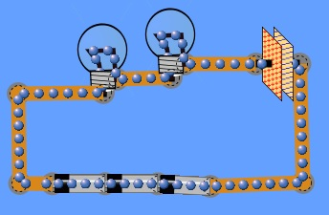
LAB: Build the circuit as shown to the right: 3 batteries, 2 bulbs, and one capacitor. NOTE also shown is a Schematic view that will also be used.

- Do the electrons flow clockwise or counterclockwise?

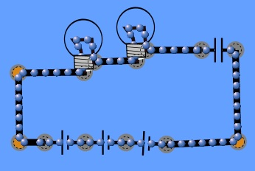
- What happens to the speed of the electrons when a capacitor is present? If you need to watch again, right click on the capacitor and hit “discharge”.

- Make sure you are in VISUAL LIFELIKE:
What builds up on the one sheet of the capacitor on side of the circuit connected to the long grey negative side of the battery?

- What builds up on the one sheet of the capacitor on side of the circuit connected to the short black positive side of the battery?

- The electrons stop, what happens to the bulbs when the electrons stop moving?

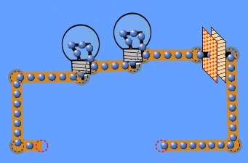
LAB: DELETE all three batteries and use a wire to complete the circuit.
CONNECT WIRES WHEN READY

- What way do the electrons flow when you complete the closed circuit path without batteries?

- What happens to the red (+) and blue (–) charges on the yellow plates of the capacitor?

- Try making it work again without adding batteries. Can this happen without ‘Charging’?

- Charge the capacitor again using batteries, then discharge, repeat a few times.

CONCLUSION:

C.A.S.T.L.E. PHET UNIT 2 WORKSHEET

Define the following terms:

Charging:

Discharging:

Conventional Current:

Electrons, as in the lab, move from the negative end of the battery to the positive. However when current is drawn it is drawn as coming from the positive end going towards the negative (conventional current as you hopefully defined above). If this is confusing it is due to a nice piece of history in that the positive-negative naming system for batteries was largely established by Benjamin Franklin roughly a hundred years prior to the discovery of the electron by J.J.Thompson. So the electricity description and battery system was established more than a century before people knew what actually was occurring internally in a circuit with the electron.

Below draw the conventional current (positive to negative) for either the battery powered or discharging capacitor circuit. You will need to use a key concept about how charges move during a discharge from the lab.
SCHEMATIC
Battery:
+
-
+
-
Example
Capacitor:

Light Bulb:
Wire:
+
-

- Who discovered the electron?
- Who set up the positive and negative names for charges?
- Conventional current goes from what end of the battery into the other?
C.A.S.T.L.E. PHET UNIT 2 LAB 3

-Google ”PHET GENERATOR” (http://phet.colorado.edu/en/simulation/generator) and run the lab.
-Insure you are on the GENERATOR tab.

Define the following terms:

Generator:

Motor:

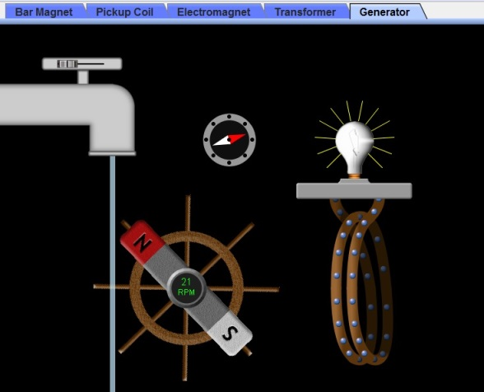
This lab will experiment with how moving a magnet relative to a wire in a circuit can generate electricity. This simple concept is the foundation to almost all the electricity we use today and was developed by Michael Faraday in 1831-1832. A lot of what we are learning with circuits and electricity and a lot of our modern electric world is based off of his work.

LAB:
-Turn the faucet on just a little as shown in the image to the right.
-Increase the faucet gradually to maximum, decrease back down, repeat and observe.

- Describe what happens to the brightness of the light when the generator (magnet on the Ship’s Wheel) is spinning at a slow rate.

- As the generator spins faster and faster what happens to the brightness of the light?

- Describe how the electrons move?

- Regardless if you are set to fast or slow do the electrons ever have a NET displacement or do they just move around the same point?

- How is this electron movement different from what we have seen with a battery in previous labs?

- Who developed the first generator?

Define the following terms:

Alternating Current (AC):

Direct Current (DC):

C.A.S.T.L.E. PHET UNIT 2 WORKSHEET 2
Define the following terms:

Voltage:

Current:

Resistance:

Review:

- A current of 30 A has 120 C pass through the section of wire, how much time has passed?

- 450 mC passes through a section of wire in 9 seconds. What is the current?

- Draw the Convectional Current for the charging and discharging situation shown.
+
-

Voltage has the symbol V and the unit Volts (V) OHM’s LAW
Current has the symbol I and the unit Ampere (A) Voltage = Current x Resistance
Resistance has the symbol R and the unit Ohms (Ω) V = IR

- If a 9 V battery is in a circuit with a resistance of 10 Ohms, what is the current?

- A 10 Ohm light bulb has a 5 A current. What is the voltage?

- A 9 V battery is in a circuit with 3 Amperes and what amount of resistance in the circuit?

- If a 12 V power source runs current through a 6 Ω resistor, how much charge passes through in 30 seconds?

