Build a Fraction

Topic: Comparing and Ordering Fractions

Introduction:
In this investigation you will compare and order fractions using models and pictures. You will be able to explore level 1 to understand how this simulation works. Next, you will create a data table based on the investigations you complete at Level 3 on the build a fraction exploration. From the data table, you will explain if it is possible to compare and order fractions thinking whether or not the fraction is closer to 0, ½, or 1 using your evidence. If you can compare and order fractions with different denominators, explain why you think this is possible.

Prediction Phase:

1. Click this link: http://phet.colorado.edu/
This is a screen shot of the website:
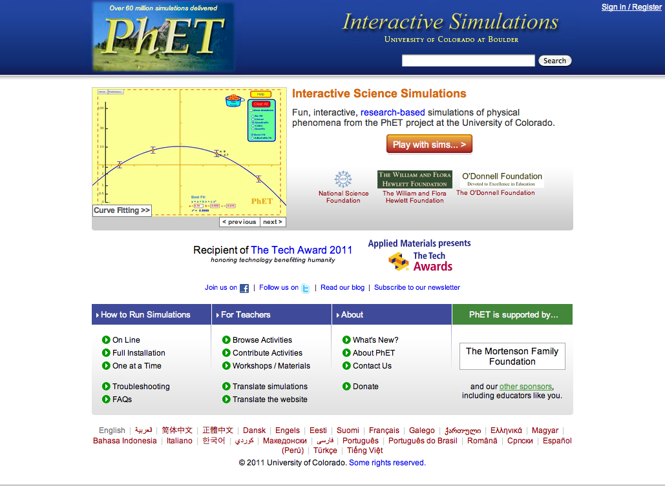
2. In the search bar type in: build a fraction
3. Click on Fractions Intro -> Click “Run Now!”
4. It will take time to load and then this screen appears:

Switch between this document and the sim to complete the activity.

Using your knowledge of ordering and comparing fractions, place these fractions in order from least to greatest using the number line below:

0 ½ 1

2/4, 2/3, 3/5
Write these fractions from least to greatest: _________________________________

Exploration Phase: Now you will begin to explore the sim you will be using for this activity

1. In the search bar type in: build a fraction
2. Click on Build a Fractions -> Click “Run Now!”
3. It will take time to load and then this screen appears:

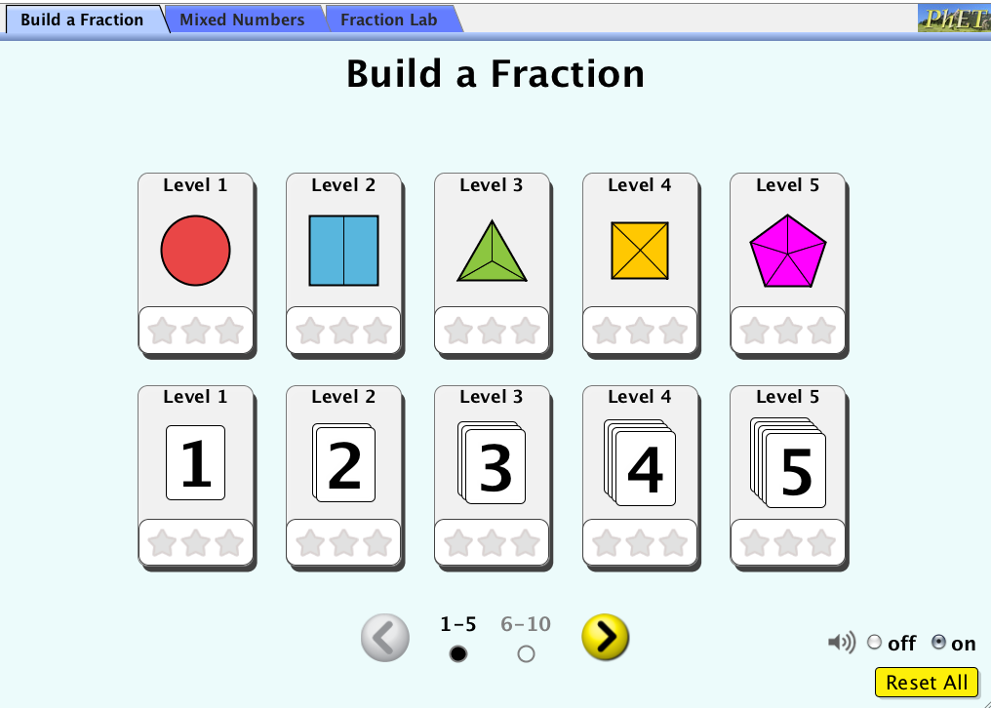

4. Choose level 1 under the Build a Fraction tab
5. Move the fraction models to create the given fractions that appear on the right side of this sim
6. After you have completed level 1, follow the same steps for level 2

Question:

- How do you use the pictures that are given to create the fractions in level 1 and 2?

- What do you notice about the fractions that each level uses?

Explanation Phase:

Aim: to create a rule that compares and orders fractions with unlike denominators.

You will now begin using this simulation:

1. Start at level 1 under the Build a Fraction tab.
2. Continue your exploration to level 4.
3. Make sure to fill in the data table below:

Level: | Fraction 1: | Closer to 0, ½, or 1? | Fraction 2: | Closer to 0, ½, or 1 | Fraction 3: | Closer to 0, ½, or 1?

Order the fractions in level 1 from least to greatest:

_________________________________________________________________________________

Order the fractions in level 2 from least to greatest:

_________________________________________________________________________________

Order the fractions from level 3 from least to greatest:

__________________________________________________________________________________

Order the fractions from level 4 from least to greatest:

__________________________________________________________________________________

Come up with a rule for comparing and ordering fractions with unlike denominators.

Write here:

How has thinking about where a given fraction is in relation to 0, ½, or 1 help you to order fractions?

Application Phase:

Order the following fractions from least to greatest:

2/4, 2/3, 3/5

________________________________________________________________________

2/6, 1/3, ¾

________________________________________________________________________

2/8, 4/5, 1/6

___________________________________________________________________________

