Title: Area Builder

Introductions
In this activity you will investigate the mathematical science of area and the different ways to calculate and find area. Area is defined as the amount of space a 2-D object takes up, measured in unit squares.

1. Click this link: http://phet.colorado.edu/
This is a screenshot of the website:

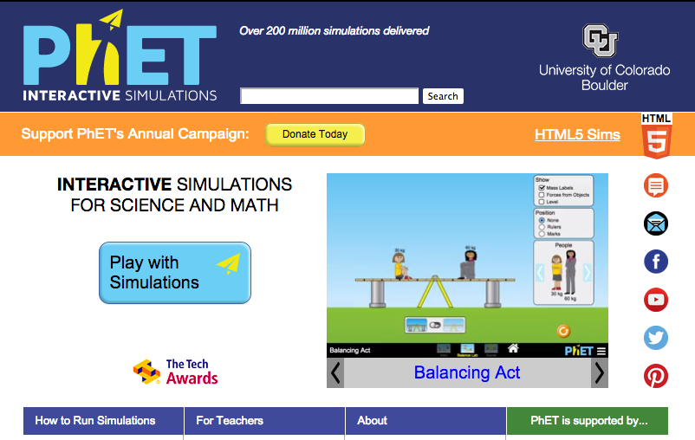

2. Click the “Play with sims” button.
3. Click “New Sims” -> Click “Area Builder”->Click “Run Now!”
4. It will take time to load and then this screen appears:
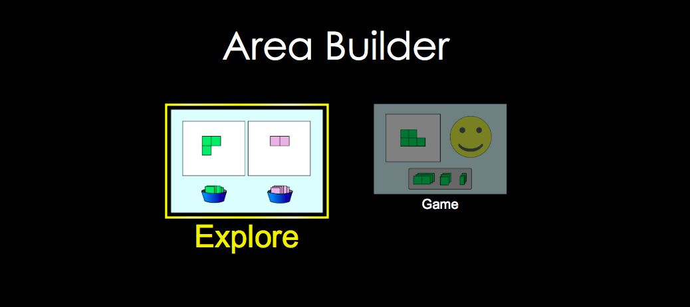

Exploration Phase

1. Click the “Explore” picture on the sim

2. Place the square units on the grid to create various shapes.

3. Freely explore different shapes and notice the area and perimeter on the top of the screen.

4. Try using and hiding the “values” and the grid or numbered aids.

Unit squares going horizontal are called “wide” or “width”
Unit squares going vertically are called “long” or “length”

Questions

- What happens to the area when you increase the number of unit squares?

- What happens to the area when you decrease the number of unit squares?

- How would you find the area of the letter H using unit squares?

Explanation Phase

Aim: Is there a relationship is between the dimensions given and the area?
Write your hypothesis here (and have it checked by the instructor):

Click the box where it says perimeter and area to hide. Your screen should look like this.

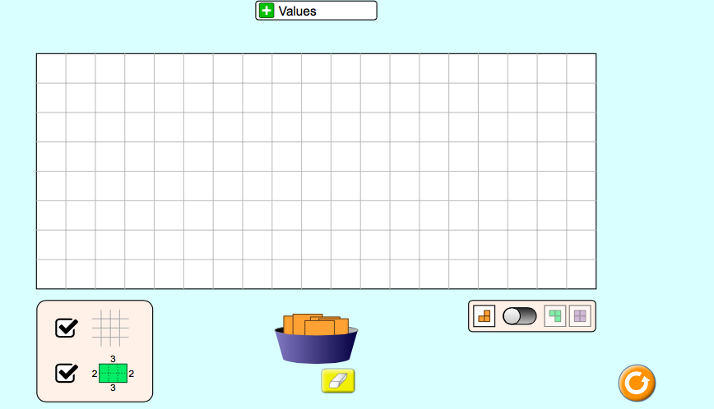

Use the sim and fill in the blanks of the following table for these various shapes.

Width | Length | Area
4 | 6
5 |  | 25
 | 8 | 56
6 | 7
10 |  | 30

Come up with a rule about the relationship between dimensions and area.

Write here:

Use your rule on the following question:
If I build a shape that has a width of 4 square units and a length of 7 square units, what would the area be? Calculate.

Check your answer on the grid on the simulation.

Application Phase

Click the “Game” tab and play—only play level 1!
Be sure to record your area, width, and length in the table below.

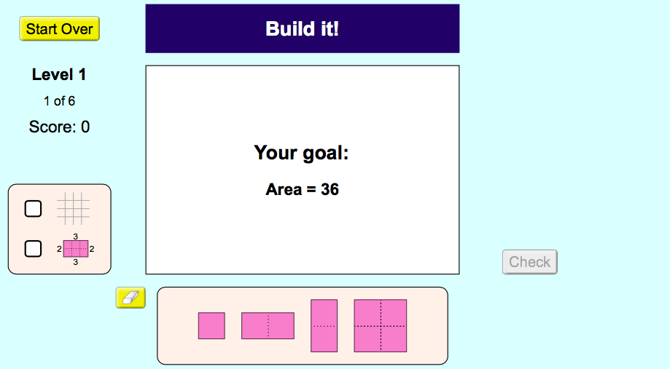

 | Width | Length | Area
Problem 1
Problem 2
Problem 3
Problem 4
Problem 5
Problem 6

Conclusions: Compare the data from different problems and explain the relationship between width, length and area.

