Molecular Geometry Flash Cards
The flash card template is designed to be used with the PhET simulation “Molecule Shapes.” This activity guides students to build the 13 molecular geometries taught in an introductory chemistry course, and the end product doubles as a study tool and quick reference for students.

Learning objectives
- Identify how covalent bonds (single, double, or triple) and non-bonding electron pairs influence molecular geometry
- Build 13 different compounds with unique molecular geometry
- Use the 3-D structure to visualize bond angles and orientation of bonds in space

Instructor Notes
Before performing this activity, students were given a brief introduction to the five electron domain geometries (linear, trigonal planar, tetrahedral, trigonal bipyramidal, and octahedral). Bond angles were identified for these structures, and wedges and dashes were used to show dimensionality.
After the introduction to the electron domain geometries, students were given the flash card templates and an iPad and instructed to use the simulation to fill in the information for the 13 different molecular geometries. The 3-D structure can be drawn on the front, and the geometry and bond angles are listed on the back
Note: students should select the boxes “Molecule Geometry”, “Electron Geometry”, and “Show Bond Angles” in the simulation. The bond angles in the simulation do not reflect distortions due to lone pairs, so the instructor may choose to have students consult their textbook for bond angles.
When printing the flash cards, select duplex and “flip page on long edge.” The flash card template is easiest for students to use if each sheet is cut in half (to prevent confusion when the paper is turned over). The individual cards do not need to be cut apart in order to be used. See the next page for an example of the front and back side of the first column.
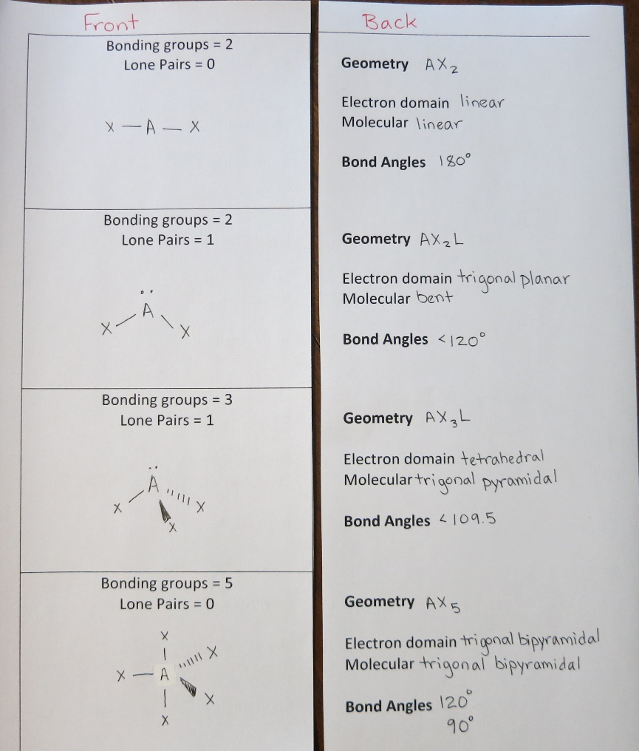

Assessment
Assessment of this activity was done through instructor observation. This activity was successful in helping students realize that bond order does not influence geometry about a central atom and also that the electron domain and molecular geometries are the same if no non-bonding electrons are present.
After the activity was complete, many students chose to use the flash cards to study for exams and as a reference tool during a model-building activity in the laboratory.

