AP Physics 1 Hooke’s Law Take-Home Simulation Lab
Name:

Part I. Exploring Hooke’s Law

- Open a browser and go to: https://phet.colorado.edu/en/simulation/hookes-law

- Click on the “play” button triangle and start the sim. Then choose “intro”.

- Check all five boxes on the right hand side (applied force, spring force, displacement, equilibrium, values). Play around with the red slider control for the applied force.

Q1. What can you say about the size and direction of the applied force, and the size and direction of the spring force, also sometimes called the restoring force?

A1.

- Leave the red slider control for the applied force maxed out at +100 N. Then play around with the blue slider control, which affects the spring constant, also sometimes called the constant of elasticity, but always abbreviated with k.

Q2. What are the units for k? In 2-3 sentences, explain.

A2.

Q3. Is a higher value for k result in a stiffer/less stretchy spring, or a less stiff/more stretchy spring? In 2-3 sentences, explain.

A3.

- Return the value for k to 200 N/m and again play with the red slider control for applied force.

Q4. What relationship exists between the applied force and the green displacement vector for a constant k? Is it linear or quadratic?
Complete the table below and then answer this question in 2-3 sentences.
Trial | Applied Force (N) | Displacement (m)
1
2
3
4

A4.

In 1678 English Physicist Robert Hooke published that "As the extension, so the force". He established that most solids behave (at times) with elastic properties; even very "inelastic" materials like steel will behave elastically under large loads.

In short he resolved that F_{s} = -kx where:

F_{s} is a "spring force" or "restoring force" (as the spring tries to return to its original or unloaded form) (Units: N)

k is the "constant of elasticity" or basically a number that describes how elastic or stretchy a material is. (units: N/m)

x is the elongation or the deformation of the spring. Basically the difference in length of the spring when stretched from its unstretched length. (Units: m)

The negative sign indicates that the Spring Force is in the direction opposite that of the displacement (elongation).

Q5. Predict the deformation or elongation of a spring that has a constant of elasticity of 400 N/m when a force of 75 N is applied in the rightward direction. Show your work for full credit.

A5.

Q6. What is the direction of the restoring force, or spring force, from Q5?

A6.

- Check your answers from Q5 and Q6 with the PhET simulation.
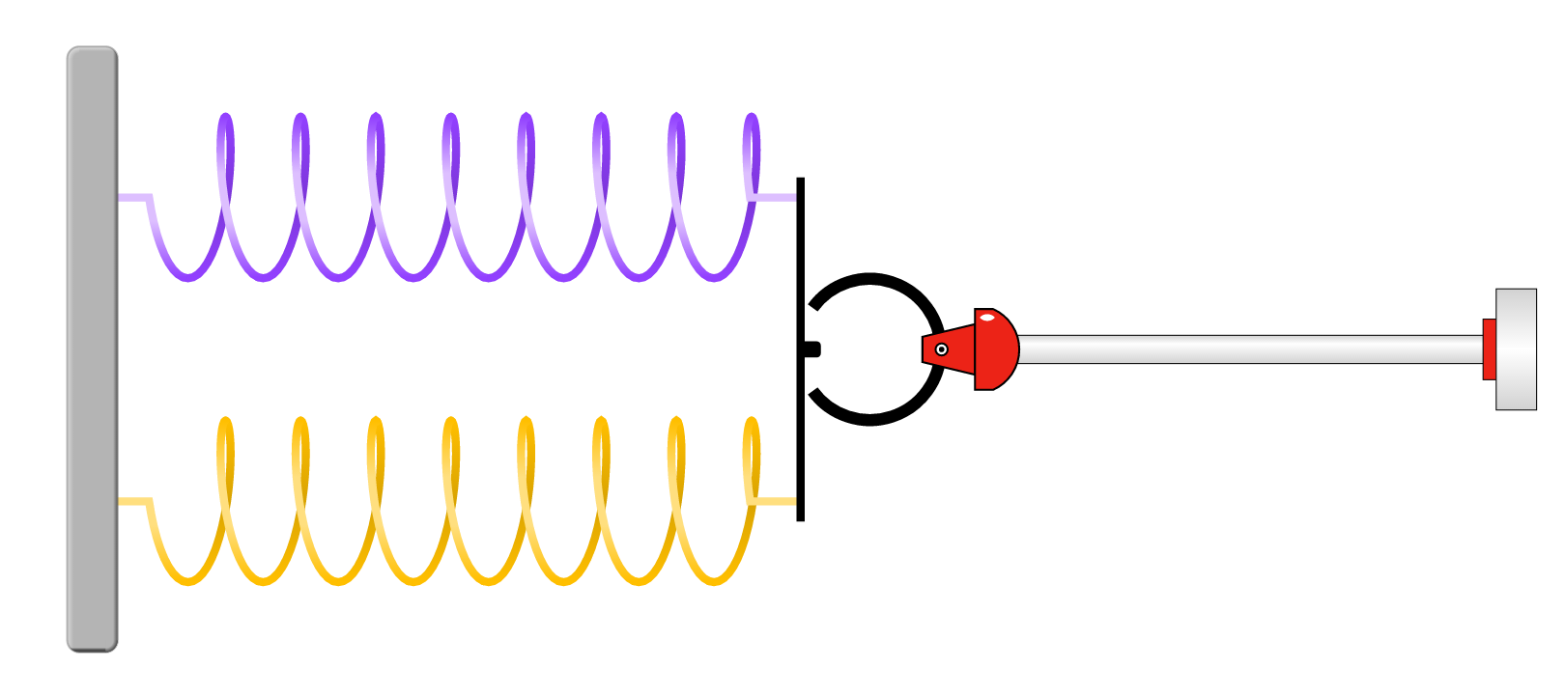
Q7. Predict what do you think will happen to the deformation when two springs are now working in parallel, each with a constant of elasticity of 400 N/m when a force of 75 N is applied in the rightward direction? In parallel assumes a “side by side” orientation as shown to the right. There are no wrong answers here!

A7.

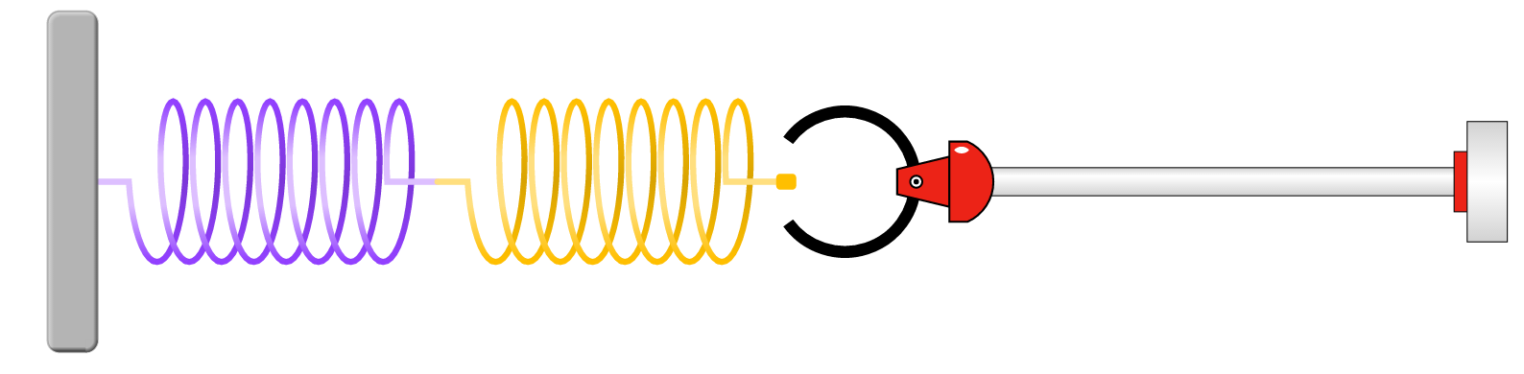
Q8. Predict what do you think will happen to the deformation when two springs are now working in series, each with a constant of elasticity of 400 N/m when a force of 75 N is applied in the rightward direction? In series assumes “end to end” orientation as shown to the right. There are no wrong answers here!

A8.

- Click on the “systems” icon at the bottom of the PhET simulation. Now test your predictions.

Q9. What adjustments will you make to your “parallel” prediction from Q7? Explain this phenomenon.

A9.

Q10. What adjustments will you make to your “series” prediction from Q8? Explain this phenomenon.

A10.

Part II. Application of Hooke’s Law, Virtual Lab
- Now lets go to a different simulation: https://phet.colorado.edu/en/simulation/mass-spring-lab

Q11. Use the known masses on the left hand side (50g 250g) and the ruler to determine the spring constant of spring #1 in units of N/m. Make a table and graph your results, with Spring Force on the Y-axis and elongation on the X-axis. Show your work in the space below.

A11.

Q12. What is the significance of the slope of the line from Q11?

A12.

Q13. Now that you know the constant of elasticity of spring #1, use that information to determine the unknown masses and complete the table below.

A13.

Color | Mass (kg)
Green
Tan
Red

