Color Vision Virtual Lab

Pre Lab Questions

- Do lighting filters use additive or subtractive properties to bring light of a certain color to our eyes? Explain to your best ability.

- Do different color lights use additive or subtractive properties to bring light of a certain color to our eyes? Explain to your best ability.

- What are the primary colors of light?

- Give an example of additive color from a place you see colors.

- Give an example of subtractive color from a place you see colors.

Color Vision Virtual Lab

Go to : https://phet.colorado.edu/en/simulation/color-vision and click on the simulation.

- Click on the single bulb flashlight on the first screen.

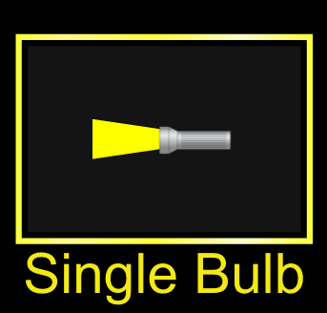

- Play with the controls of this part to gain understanding of how things work
(2-3 minutes, max, should get you familiar with the controls).
Here is a brief list of options:

This thought bubble shows the color she sees The bulb color changes the bulb when using the light option on the right (yellow bulb)

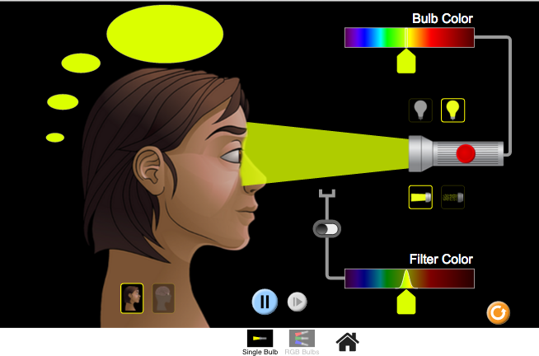
The face and brain pictures This changes from single bulb to This changes the toggle between surface and RGB combo of lights. he filter color.
how the brain gets signals from Make sure the our eyes. filter is switched on at the white
switch.

- After becoming familiar with the controls, get ready to investigate how the eye sees color

when using lighting filters. Click on the reset button (bottom right corner). Using the colored (yellow) bulb, switch the beam representation to photon particle mode.

- What color light is coming from the flashlight?

What color does the person see?

- Try adding a green colored filter to the yellow bulb color, What happens? Make sure you

switch the beam to light particles 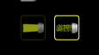 to see what gets through the filter (if anything).

- Now try these combinations:
 | Color of  Light | Color of  Filter | Color Observed
a. | Red | Yellow
b. | Red | Magenta
c. | Blue | Blue
d. | Blue | Cyan
e. | Blue | Red
f. | Yellow | Red
g. | Yellow | Blue

- Why do we call the use of filters and dyes subtractive coloring?

- Now switch to the white light bulb. What colors do you see coming from the flashlight?

- Do the filters affect the white light differently than they affect the yellow bulb? If so, what do you observe that is different?
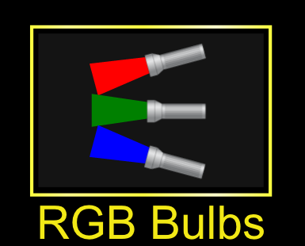

Click on the RGB Bulbs icon at the bottom of the screen.

- What are the primary colors of light?

- What color does the person see when all of the sliders are all the way up?

- Leave the red and green sliders up and turn the blue off. What is the color?

Now turn the green off and blue back to max power. What is the color?

Turn the red flashlight off and the green back to max power. What color is this?

4. The colors you just made are complimentary colors to the primary ones, meaning they are blends.
Now try to make the following colors based on sliding the power levels of each color to the correct position. Record your results in the table below. You can use percentages or fractions to estimate the power level

COLOR | Red Slider Position | Green Slider Position | Blue Slider Position
Orange | 100% (1/1) | 50% (1/2) | 0% (0/1)
Brown

Gray

Pink

Violet (darker than magenta)
Black

Why do we call coloring from light emitted by the flashlights additive color?

Color Vision Virtual Lab

Post Lab Questions

- Do lighting filters use additive or subtractive properties to bring light of a certain color to our eyes? Explain to your best ability using evidence from your lab.

- Do different color lights (RBG) use additive or subtractive properties to bring light of a certain color to our eyes? Explain to your best ability using evidence from your lab

- What are the primary colors of light?

- Give an example of additive color from a place you see colors.

- Give an example of subtractive color from a place you see colors.

