ROTATIONAL EQUILIBRIUM SIMULATION ASSIGNMENT
DIRECTIONS: For this activity, you will be using the pHet website http://phet.colorado.edu/sims/html/balancing-act/latest/balancing-act_en.html (linked on my website). When you open it, select the “Balance Lab” tab and select “Mass Labels”, “Rulers”, “Forces from Objects” and “Level” under the “Show” box. Your screen should look like this one: 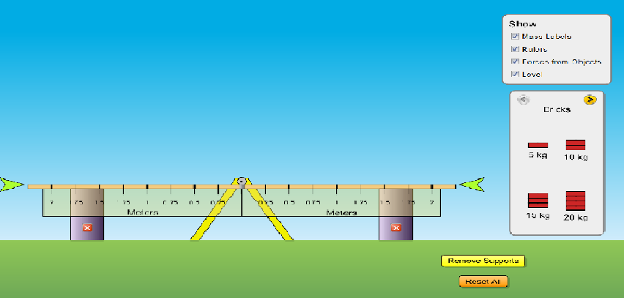
Notice the yellow arrow above the word “Bricks” in the second box. Click this arrow. You will see other objects (like people and mystery packages) that you will use for various parts of this activity. For now, we will use the bricks. Also notice the “Remove Supports” button. We will use this button frequently. Click this button now. Does anything happen?
PART A. ROTATIONAL EQUILIBRIUM CONDITIONS.
Select the 5 kg brick and place it 0.25 m from the center of rotation (called the fulcrum). Place another 5 kg brick at the opposite 0.25 m position. Remove the supports. Does the seesaw move? Why/why not?

Put the supports back. Now move one of the 5 kg bricks to the 0.5 m position. Remove the supports again. Does the seesaw move? Why/why not?

Move the same 5 kg brick to the 1.0 m position. How does the position of the seesaw compare to its position when the brick was at the 0.5 m position? Why is this the case?

Put the supports back in place and remove one of the 5 kg bricks. Place the other at the 0.25 m mark and then add a 10 kg brick to the 0.25 m mark on the other side. Remove the supports. Does the seesaw move? Why/why not?

Replace the 10 kg brick with a 20 kg brick. How is the motion of the seesaw affected? Why does this happen?

What does it mean to be in a state of rotational equilibrium?

PART B. SIMPLE ROTATIONAL EQUILIBRIUM.
In this part of the activity, you will be placing objects at various positions to balance the seesaw. You will be told a starting mass (brick or person) and position and then will determine where a second mass should be placed in order to balance it out. To do this, you will be required to do a torque summation. The first one has been done as an example. Check your answer by placing the objects on the seesaw and removing the supports.

Mass 1 (kg) | Position 1 (m) | τ_{Right} = τ_{Left} | Mass 2 (kg) | Position 2 (m)
20 | 0.5 | (20)(9.8)(.5) = (5)(9.8)x  x = 2.0 | 5 | 2.0
20 | 1.0 |  | 10
80 | 0.25 |  | 20
30 | 0.5 |  | 10
10 | 1.0 |  | 20
5 | 2.0 |  | 20
15 | 1.0 |  | 60

PART C. COMPLEX ROTATIONAL EQUILIBRIUM.
For this part you will be working with situations with multiple objects on the same side of the fulcrum. For example:
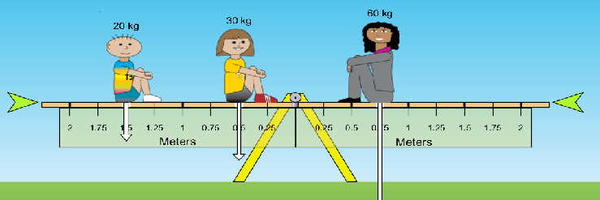
Mass 1 (kg) | Position 1 (m) | Mass 2 (kg) | Position 2 (m) | τ_{Right} = τ_{Left} | Mass 3 (kg) | Position 3 (m)
20 | 1.5 m Left | 30 | 0.50 m Left | (20)(9.8)(1.5) + (30)(9.8)(0.5) = (60)(9.8)x  x = 0.75 | 60 | 0.75 m Right
20 | 1.0 m Left | 60 | 2.0 m Left |  | 80
80 | 1.5 m Left | 30 | 0.5 m Right |  | 60
60 | 1.0 m Left | 80 | 0.25 m Right |  | 20

PART D. MYSTERY PACKAGES.
For this part, you will determine the masses of the mystery packages based on known objects and distances.
Known Mass 1 (kg) | Position 1 (m) Left | τ_{Right} = τ_{Left} | Mystery Package | Position (m) Right | Mass of Package (kg)
60 | 0.5 | (60)(9.8)(0.5) = (x)(9.8)(1.5)  x = 20 | A | 1.5 | 20
30 | 1.0 |  | C | 2.0
30 | 0.25 |  | D | .75
60 | 0.25 |  | H | 2.0

Known Mass 1 (kg) | Position 1 (m) | Known Mass 2 (kg) | Position 2 (m) | τ_{Right} = τ_{Left} | Mystery Package | Position (m) | Mass of Package (kg)
20 | 1.75 m Left | 80 | 0.5 m Left |  | F | 1.5 m Right
60 | 0.5 m Left | 15 | 1.75 m Right |  | E | 1.25 m Right
20 | 0.25 m Left | 5 | 1.0 m Left |  | B | 2.0 m Right

If you are trying to balance a seesaw and you have a higher mass on the left, should the mass on the right be placed at a greater distance or lower distance to balance it? Why?

