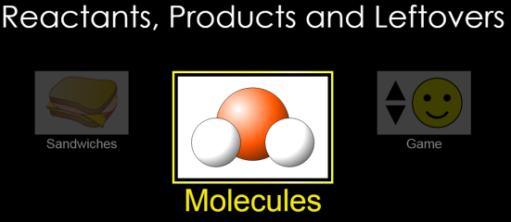
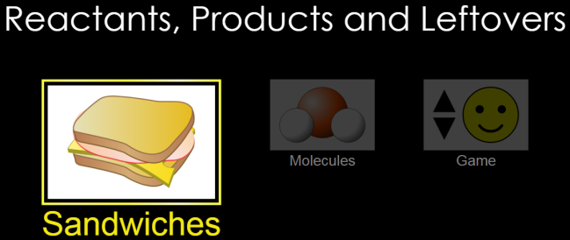
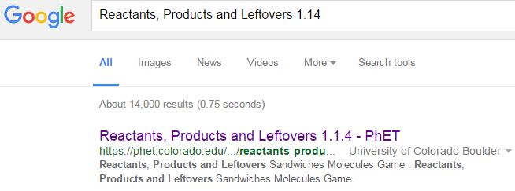
Part 1 Directions: Choose “Sandwiches”
1A. Select type of sandwich to build and choose one of the balancing tools.
1B. Make each coefficient “1” to see reactants.
1C. Change coefficients until there are no leftovers.
AA31 Labs
CLICK!

Part 2 Directions: Choose “Molecules”
2A. Select type of molecule to build and choose one of the balancing tools. 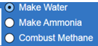
2B. Make each coefficient “1” to see reactants.
2C. Change coefficients until there are no leftovers.
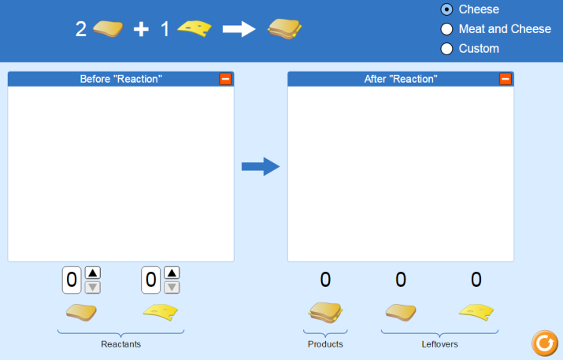

2
2
3
1D. Make 3 sandwiches, no leftovers. Draw. pictures
PhET Leftovers html5
2D. Make 4 waters, no leftovers. Draw. pictures
0

0
2
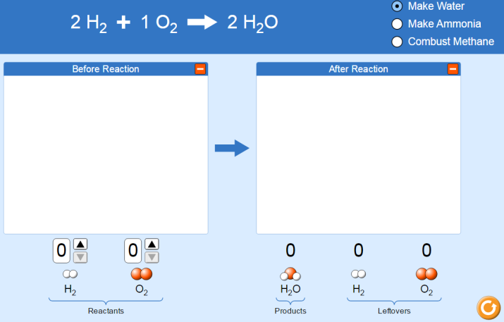
1E. Draw pictures of reactants and products and add coefficients for three sandwiches, no leftovers.
1E. What is the relationship between bread and cheese?
3

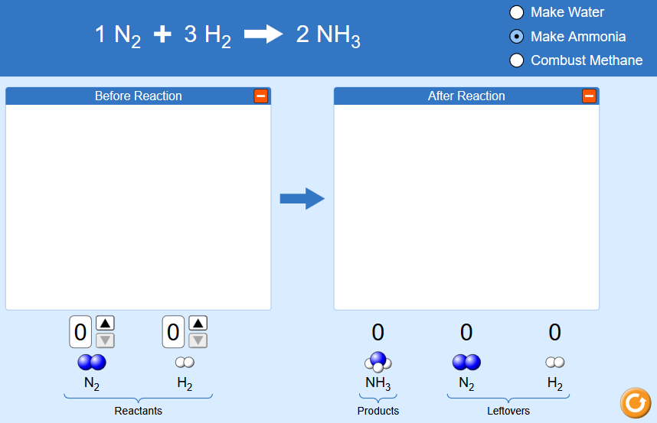
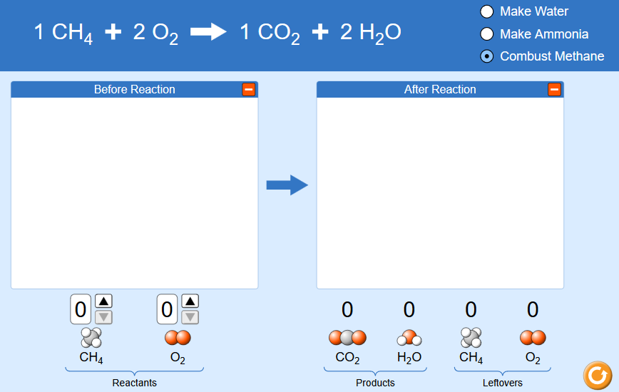
2F. Make 2 CO₂’s, no leftovers. Draw. pictures
2E. Make 2 NH₃’s, no leftovers. Draw. pictures

Part 2 Question: What is the key to getting no leftovers?
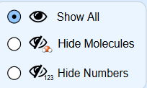
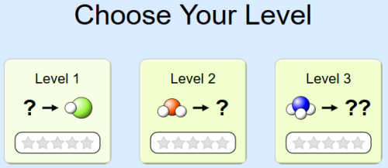
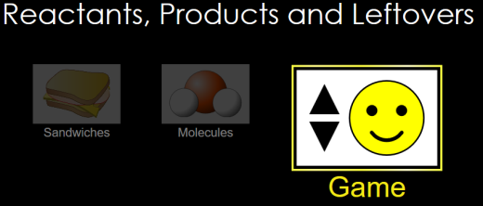
Part 3

Directions: 3A 3B 3C
Game: Level 1
Fill in the chart and include the correct formulas, no leftovers. Play for time after first time.
 | Reactants |  | Products | Best time
#1
#2
#3
#4

#5

Game: Level 2
Fill in the chart and include the correct formulas, no leftovers. Play for time after first time.
 | Reactants |  | Products | Best time
#1
#2
#3
#4

#5

Game: Level 3
Fill in the chart and include the correct formulas, no leftovers. Play for time after first time.
 | Reactants |  | Products | Best time
#1
#2
#3
#4

#5
AA31 Labs

