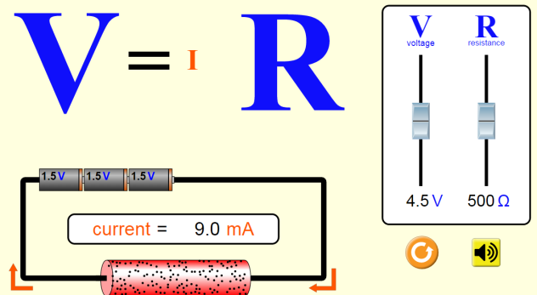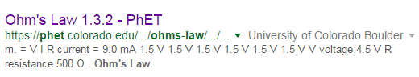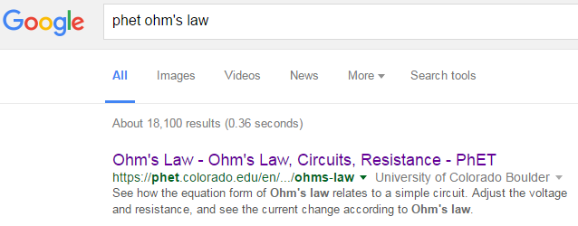

**CLICK!**

**PhET Ohms Law html5**

***Set up***: If asked to open app, click on the html5 logo:

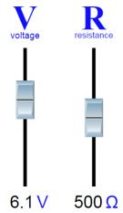***Part 1 Directions***: Move the sliders up and down until the values in the table are achieved. Fill in the rest of the table, below.

|  |  |  |
| --- | --- | --- |
| **Voltage** | **Current** | **Resistance** |
|  | ÷1000A/mA = 0.009 A |  |
| V | ÷1000A/mA = A | Ω |
| V | ÷1000A/mA = A | Ω |
| V | mA ÷1000A/mA = A |  |
| V | mA ÷1000A/mA = A |  |
|  | mA ÷1000A/mA = A | Ω |
|  | mA ÷1000A/mA = A | Ω |

***Part 1 Questions***:

1. What happened to the letters V, I and R as you moved the sliders?
2. There is a mathematical relationship (like multiply/divide/add/subtract) between V, I and R. Using the values in the table, can you find it? Circle the correct mathematical symbol in the table, below.

|  |  |  |  |  |
| --- | --- | --- | --- | --- |
| **V** |  | **I** |  | **R** |
| **4.5** |  | **0.009** |  | **500** |

1. How can you get current to be as large as possible?

AA31 Labs

AA31 Labs