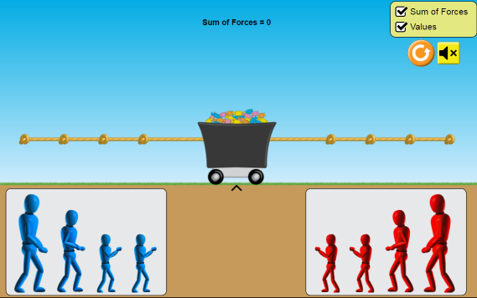
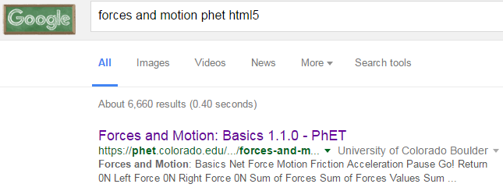
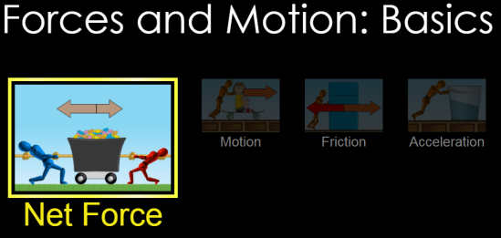
Part 1 Set-up: Choose “Net Force”
- Check boxes:
- Drag some blue guys and some red guys on the rope. Notice how the Sum of Forces changes.

CLICK!
PhET Forces Motion html5

Part 1 Directions: Draw 4 different pictures below showing the guys on the rope and give the left force, right force and sum of forces for each picture. Then hit and describe what happens to the cart in the space provided.
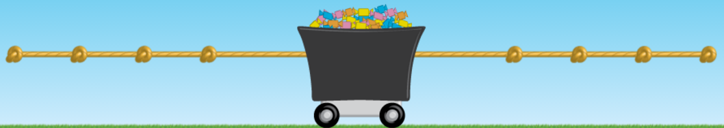
Left Force: | Sum of Forces: | Right Force
What happens when you hit GO?

Left Force: | Sum of Forces: | Right Force
What happens when you hit GO?

Left Force: | Sum of Forces: | Right Force
What happens when you hit GO?

Left Force: | Sum of Forces: | Right Force
What happens when you hit GO?
AA31 Labs

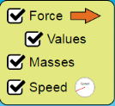
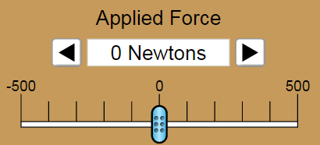
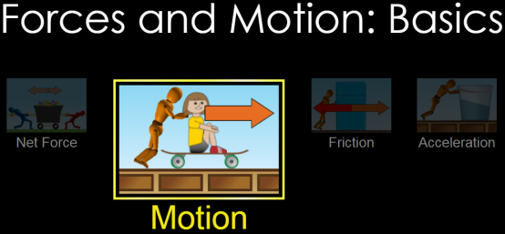
Part 2 Set-up: Choose “Motion”
- Check boxes:
- Move the Applied Force sliders.
- Change the masses.

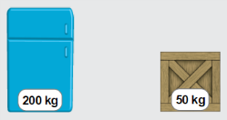
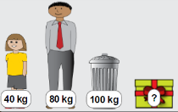

Part 2 Directions: How does the mass affect the speed? For 4 different masses record the top speed.
Masses:  Total: | Top Speed: 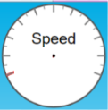
Masses:  Total: | Top Speed:
Masses:  Total: | Top Speed:
Masses:  Total: | Top Speed:
In a few sentences, compare and contrast what you found in the table above for each of the different masses, including any observations you had about how you arrived at the top speed. (examples of observations: It was easier/harder to get to top speed? Top speed was slower/faster? It took longer/shorter to get tot top speed, etc.)?

How can you find out what the “mystery mass” is? Write down your ideas (steps to follow?) on how to find the mass here:

What is the mass of the mystery mass? (Show math or give word support for your answer)

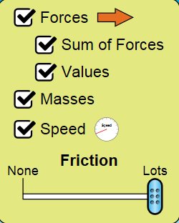
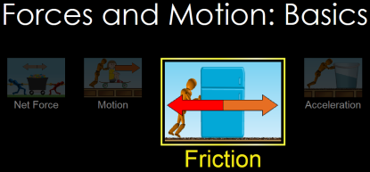
Part 3 Set-up: Choose “Friction”
- Check boxes:
- Try sim out: Push the weight. Move the Friction slider. Change the masses. Repeat.

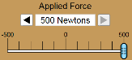
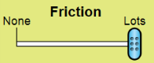
Part 3 Directions: Click reset, recheck all the boxes as in set-up, Select “Lots” of Friction
Describe what happens when you apply a 500N force to the following masses:
Mass (kg) | Sum Force (N) | Top speed? | What happens when you reach top speed and stop pushing?
 |  | 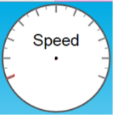
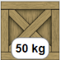
+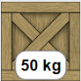
Based on what you saw in the simulation, what is the mass of the mystery mass? (in kg!)

Some of the masses would NOT move with a 500N force. Which ones and Why?

What parameter could you change to get the masses in the previous question to move? Does it work?

Going Further:
What is the difference between a 500N force and a - 500N force in the simulation?

What are some jobs/industries that need to account for things found in this simulation (like applied forces, friction, etc.)?
AA31 Labs
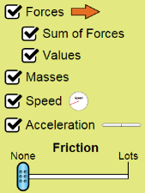
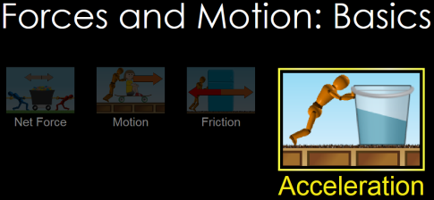
Part 4 Set-up: Choose “Acceleration”
- Check boxes:
- Try sim out: Push the weight. Move the Friction slider. Change the masses. Play

Part 4 Directions:
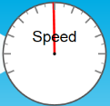
- Reset . Check boxes. Move Friction slider to “None”. Apply a force to a mass to get it moving until the speed is: Can you get the mass to be completely stationary again? If so, how did you do it? If not, why not?

- Change the mass so that is significantly different than in #1 (more or less!). Repeat the steps in #1. Can you get the mass to be completely stationary again? Y / N Was it harder / easier than in problem #1? Why do you say that?

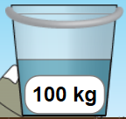
- Put the bucket on the ice. Move the friction slider to “None”. Apply a force to the bucket until it reaches top speed. The guy will fall off the screen. When at top speed, draw what you see below:
Fill in the acceleration | Draw top speed | Sum of Forces | Applied force | Water level in bucket
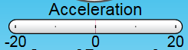 |  |  | 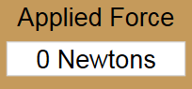
- What happened to the water in the bucket as you accelerated to top speed?

- Add some friction. What happens to the water in the bucket? Draw observations in the table below:
Fill in the acceleration | Draw top speed | Sum of Forces | Applied force | Water level in bucket
Part 4 Questions:
How are mass and acceleration related (if you change one of them, what happens to the other one)?

How are Force and mass related (if you change one of them, what happens to the other one)?

How are acceleration and speed related if you change one of them, what happens to the other one)?

AA31 Labs

