PhET Simulator: Name: ________________________
Energy Changes Activity Date: ____________ Period: ______

1) Type in the web address: https://phet.colorado.edu/en/simulation/legacy/energy-forms-and-changes and click the
“Play” button.
- At the top of the simulator, click on the “Energy Systems” tab. Then, click “Energy Symbols” on the top right.
- Look at the FOUR buttons on the bottom left side of the simulator window. Explore with these four buttons to complete the chart below:

Type of Energy Source | Symbol | When this type of energy is at its maximum output, does it turn the wooden wheel? | If (and only if) the wheel is spinning, what happens to the water that is sitting on the electric burner?

- Why does the bicyclist need to be fed in order for the wheel to turn?

____________________________________________________________________________________________________________________________________________________________________________________________________

- For each of the energy sources that causes the wheel to spin, create an Energy Chain from start to finish. (The energy symbols should help you GREATLY in determining how energy is being transformed into different types!):

a)

b)

c)
- Click “Reset All” on the bottom right, then click “Energy Symbols” on the top right again.
- On the bottom, in the center, click on the Solar Panel button.
- Explore with the four energy source buttons to see any energy transformations.

- a) Which is the only energy source that heats the water using the Solar Panel option? ________________________

- Create an energy chain for all of the energy transformations from start to finish using the Solar Panel:

- Click “Reset All” on the bottom right, then click “Energy Symbols” on the top right again.
- On the bottom right, switch from the beaker of water on the electric burner to the incandescent light bulb (middle option). Turn the faucet on high to make the wheel spin.

- Which types of energy are created when electrical current runs to the incandescent bulb?

_______________________________________________________________________________________________

- Switch to the fluorescent bulb on the bottom right. Notice what types of energies are created as electrical current runs to the fluorescent bulb and how it differs from the incandescent bulb.

- On the diagrams below, clearly illustrate the difference in type and amount of output energies for the incandescent vs. fluorescent bulbs for when electricity is flowing to the bulb (see energy symbols). Assume that the bulbs below are attached to an electrical circuit even though it is not shown.

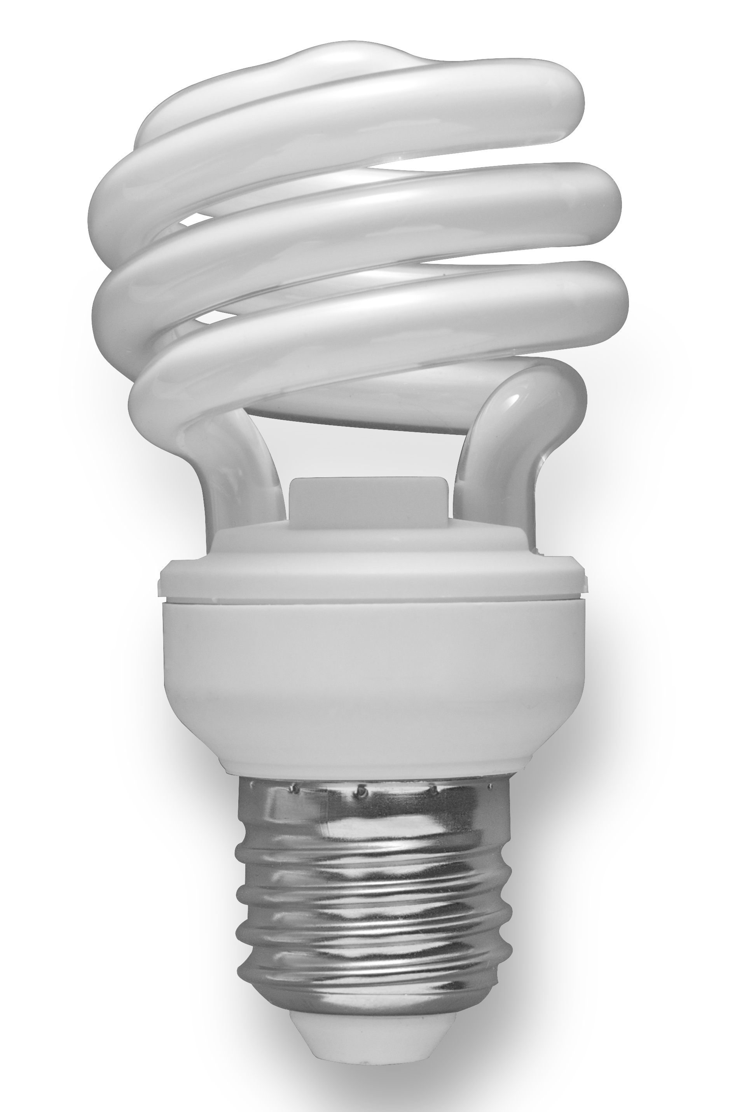
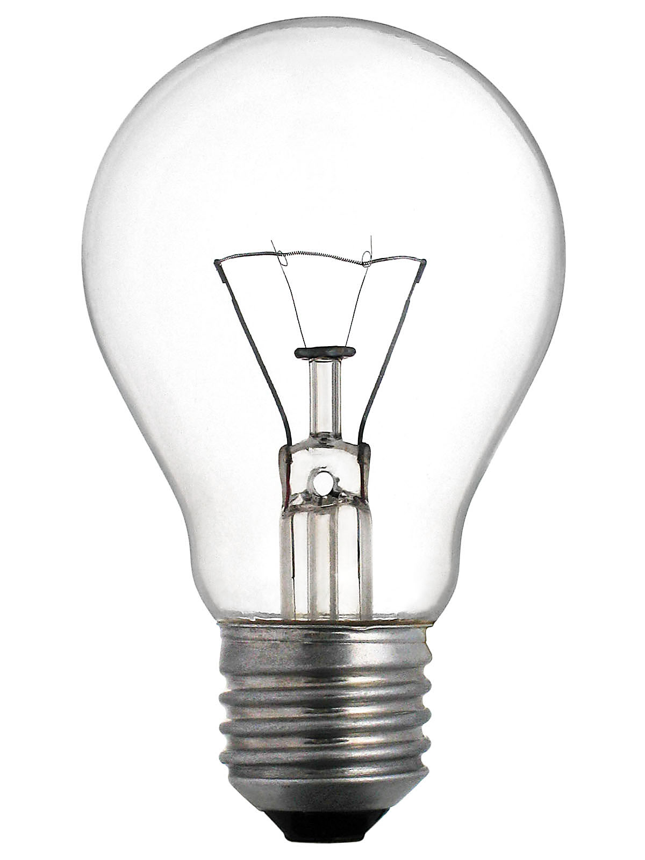
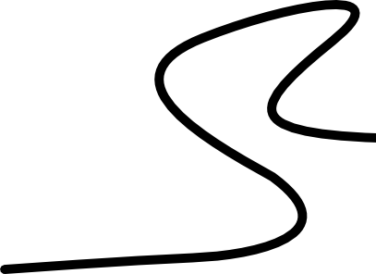

- Do a quick online search for how LED lights compare to incandescent and fluorescent light bulbs. Summarize why LED bulbs are considered to be superior to other types of bulbs.
_____________________________________________________________________________________________________________________________________________________________________________________________________________________________________________________________________________________________

