Name_____________________________________________Date___________Period________
Acid Bases PhET WebLab for Chromebooks BE SURE TO USE HTML 5 Version
https://phet.colorado.edu/en/simulation/acid-base-solutions Click <Introduction> to begin.
Part 1: Procedure
1. The lab has 2 tools that allow you to test for pH values: A probe , and pH paper 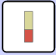. Use each one by dipping it into the solution to be tested. Try all the given types of solutions and fill in the Data Chart with the pH value 0-14.
2. The circuit with a battery and bulb as shown: is the tool used to test for conduction of a solution. By dipping the wire leads into the solution, the bulb with either remain unlit, be dimly lit, be somewhat bright or very bright. Test each solution and record your observation for the bulbs brightness in the chart below.

Part 1: Data | pH Value from Probe | Color & pH Value from pH Paper | Observations from Circuit Tool  Describe the brightness

Part 1: Analysis
1. What pH value range is observed: a. for acids?______________b. for bases?____________

2. Why are some solutions better conductors of electricity?
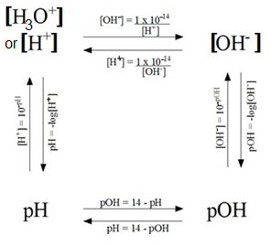

Part 2 Procedure, Data & Analysis:

Recall: The amount of ionization or dissociation of ions determines the strength of an acid or base. The concentration of [H₃O⁺], hydronium ion and [OH⁻], hydroxide ion, can be used to calculate pH and pOH as shown on the diagram here:
Note: we use [H₃O⁺] and [H⁺] interchangeably.

1. Click on Water Solution, Graph View, Probe Tool. Insert the probe in the water. Notice that the initial concentration of the solution is given before any ionization or dissociation takes place.
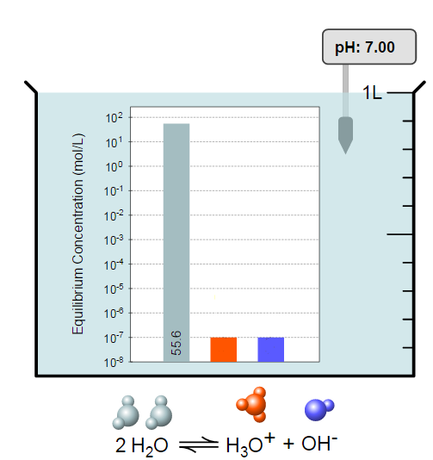
2. Fill in the missing concentration values for the hydronium and hydroxide ions on the chart here: Use the concentration value for [H₃O⍅] to calculate the pH. Show work:

3. Use the concentration value for [OH⁻] to calculate the pOH. Show work:

4. Did your answer to #2 match the pH given in the simulation? _________________________
5. Is the answer to #3 equal to: (14 - pH)? ___________ Show work: _____________________
6. Is the solution an acid, a base or neutral, based upon the calculated pH?_________________

HONORS ONLY: Attach notebook paper to show calculations for the pH and pOH for the other solutions.

HONORS ONLY: Part 3 Procedure, Analysis, Conclusion: My Solution
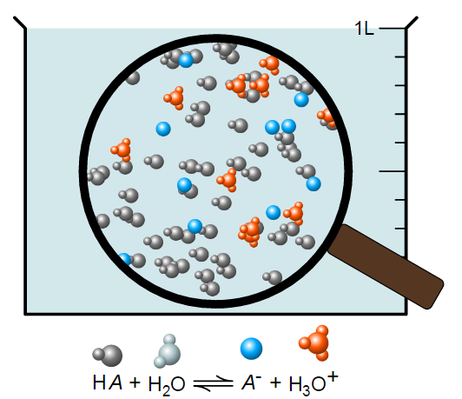
Across the bottom of the screen, click the button. The default setting shows a weak acid with a concentration of 0.010 M. Insert the pH probe to show an initial pH of 4.50. The beaker is shown below:
1. Slide the initial concentration bar to the right to increase the number of solute molecules and then slide it to the left.
What effect does changing the concentration (Moles of HA/Liters of Soln’) have on the pH value? (Be specific without giving values)

2. Return to your default setting and insert the probe. Now slide the strength to the right to make the acid stronger.
- As you increase the strength, describe the change in the number of blue A⁻ ions, orange H₃O⍅ ions and the original HA acid molecule:
- As you increase the strength, describe the change in the concentrations of both ions in the solution? Hint: Click <Graph> to see how the concentrations rise and fall.

3. Yes or No? Does the pH seem to depend upon the concentration of [H₃O⁺] ions?
4. We always assume that strong acids will 100% ionize in water. Click reset and move the slider to strength: strong. Insert the probe. Record pH. Observe the number of ions in the beaker and click <Graph> to observe the concentrations.
- pH Value = _________________
- YES or NO? Did the beaker contain a particles that now has 0% concentration? If so, what particle seems missing? ______________________________. Why is it likely missing?

5. Click reset and change to a base. Repeat 1-4 above and answer the questions.
#1: What effect does changing the concentration of the base have on the pH? Be specific.
#2: a. How do the # of OH⁻ and BH⍅ and B change as you increase strength? Be specific.

b. How does the concentration of OH⁻ and BH⁺ change as you increase strength? Be specific.
#3: Yes or No? Does the pH seem to depend on the concentration of [OH⁻]? Explain & Be specific:

#4: We always assume that strong bases will 100% ionize in water. Click reset and move the slider to strength: strong. Insert the probe. Record pH. Observe the number of ions in the beaker and click <Graph> to observe the concentrations.
a.pH = __________ b. Is there a particle missing? __________ If so, what is it? ________________

HONORS ONLY: Conclusions: If the answer is no, explain why not.
6. YES or NO? Can a weak acid be concentrated?

7. YES or NO? Can a strong acid be dilute?

8. YES or NO? For acids, can increasing the initial concentration increase the pH?

9. YES or NO? For Bases, can increasing the initial concentration increase the pH?

Extension: In <My Solution>, Try at least 4 combinations of initial concentration and strength, be sure to try a minimum of 2 acids and 2 bases. Click on <Graph> to find the ion concentration. Make a data chart to record ion concentration, initial concentration and strong/weak and acid/base. For each, use the concentration to calculate pH. Dip the probe to verify pH.

