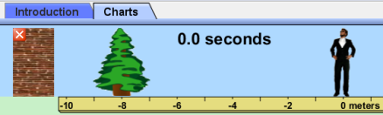
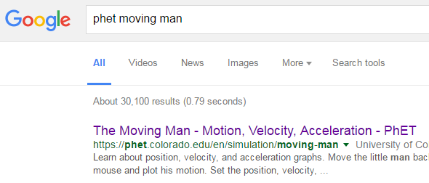
A.Select “Charts”
PhET Moving Man
CLICK!
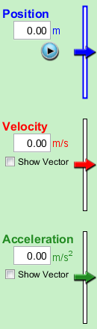
B. Move all sliders and watch what happens to the graphs!
Part 1 Directions: Before each run hit the button, set values and to make the man move Then DRAW the Position, Velocity and Acceleration graphs!

6. Set velocity to 10.00m/s
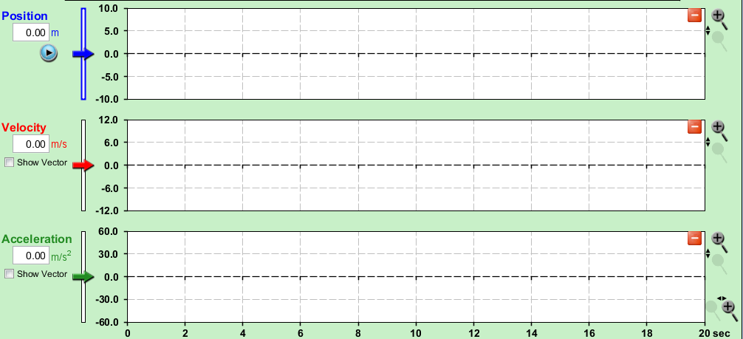
5. Set velocity to 4.00m/s
4. Set velocity to 3.00m/s
2. Set velocity to 1.00m/s
3. Set velocity to 2.00m/s
1. Set velocity to 0.50m/s

MOST IMPORTANT PART OF THIS PAGE! What do you notice about the slopes of the lines as you move down the page for:
Position?
Velocity?
Acceleration?
Part 2 Directions: Change the sliders to the given values. Draw the resulting graphs.
8. Set position to 2.00m
7. Set acceleration to 0.50m/s²

10. Set position to 4.00m
9. Set acceleration to -0.50m/s²

12. Set velocity to -2.00m/s
11. Set acceleration to 2.00m/s²

MOST IMPORTANT PART OF THIS PAGE!
What happens to each of the “lines” in the position and velocity graphs when the acceleration is not 0?
AA31 Labs

What does the negative sign do to the graphs for:
Position?
Velocity?
Acceleration ?
Let’s extend this! Try these out and draw the graphs!
13. Set velocity to 0.50m/s and position to -4m
14. Set velocity to 1.00m/s, position to -3m, acceleration to -0.50m/s²

15. Set acceleration to 0.50m/s2 and position to -4m
16. Set velocity to -1.00m/s, position to -3m, acceleration to 0.50m/s²

17. Set velocity to 10.00m/s, position to -3m, acceleration to -5.00m/s²
18. Set velocity to 4.00m/s, position to -8m, acceleration to -0.50m/s²

MOST IMPORTANT PART OF THIS PAGE!
What do you notice about the velocity and position graphs when the man changes direction?
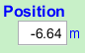
Position: Velocity:

What happens when position, velocity and acceleration are all zero?
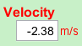
Can you get all three graphs to give lines with slopes not 0? If so, give the values here:
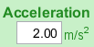
If not, why not?

A.Select “Charts”
PhET Moving Man
CLICK!
B. Move all sliders and watch what happens to the graphs!
Part 1 Directions: Before each run hit the button, set values and to make the man move. Then DRAW the Position, Velocity and Acceleration graphs!

6. Set velocity to 10.00m/s
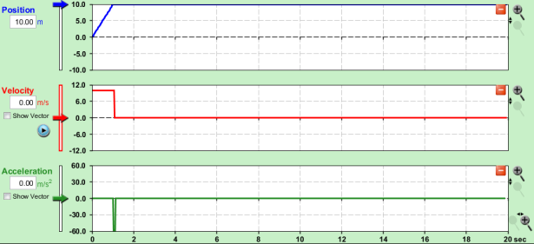
5. Set velocity to 4.00m/s
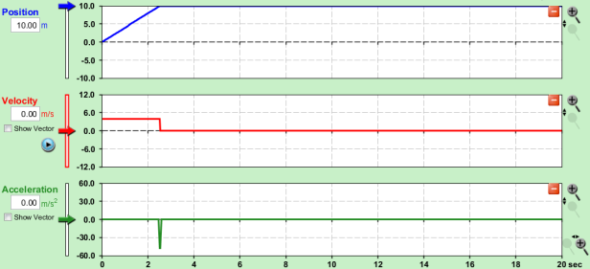
4. Set velocity to 3.00m/s
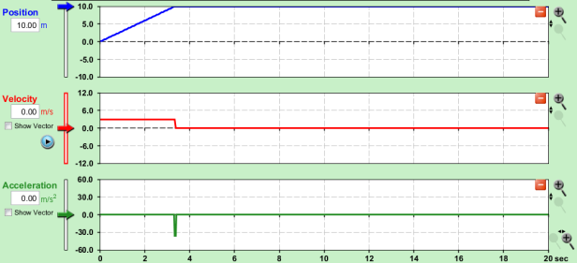
2. Set velocity to 1.00m/s
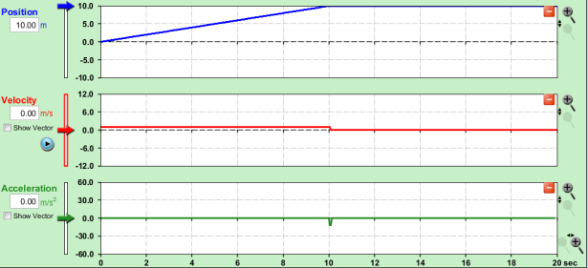
3. Set velocity to 2.00m/s
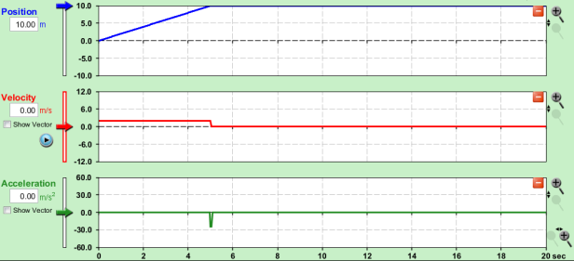
1. Set velocity to 0.50m/s
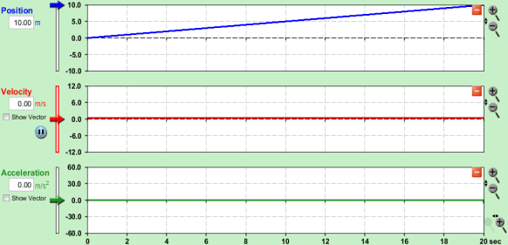

MOST IMPORTANT PART OF THIS PAGE! What do you notice about the slopes of the lines as you move down the page for:
Position? The position v time graph got steeper as the velocity increased.
Velocity? The velocity started higher, stayed flat then fell farther to get to zero as the velocity increased.
Acceleration? As the velocity increased, the negative acceleration blip got bigger.
Part 2 Directions: Change the sliders to the given values. Draw the resulting graphs.
8. Set position to 2.00m
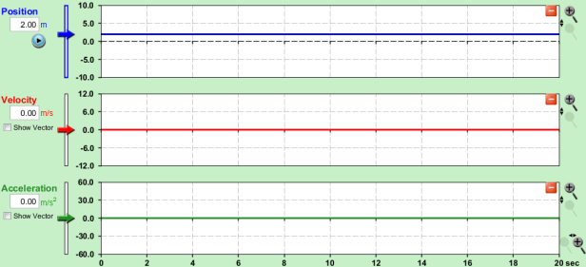
7. Set acceleration to 0.50m/s²
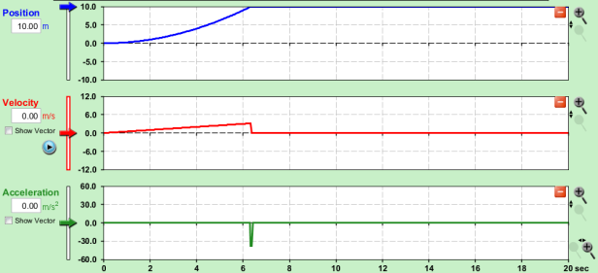

10. Set position to 4.00m
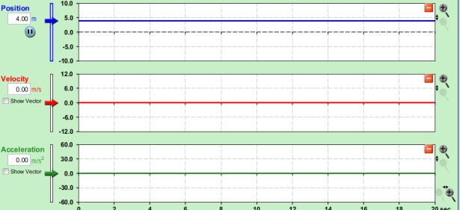
9. Set acceleration to -0.50m/s²
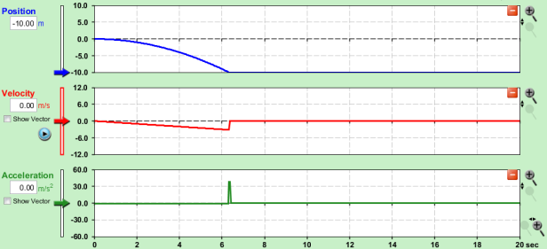

12. Set velocity to -2.00m/s
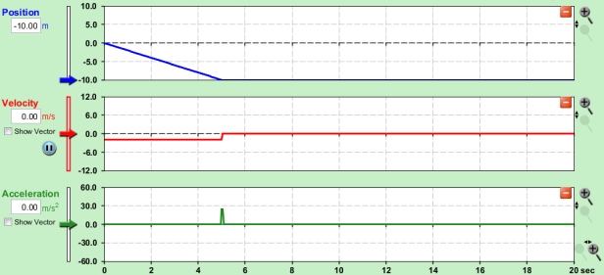
11. Set acceleration to 2.00m/s²
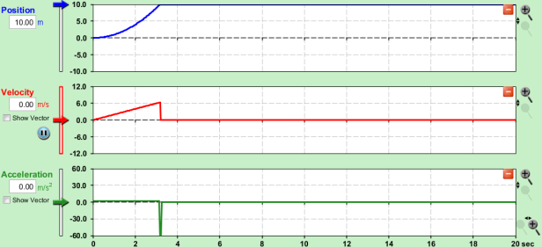

MOST IMPORTANT PART OF THIS PAGE!
What happens to each of the “lines” in the position and velocity graphs when the acceleration is not 0?
AA31 Labs
The position graph is a curve and the velocity graph is not flat.
What does the negative sign do to the graphs for:
Position? Starts the man to the left of the zero mark closer to the tree.
Velocity? Moves the man to the left instead of right.
Acceleration ? Speeds the man up towards the left.
Let’s extend this! Try these out and draw the graphs!
13. Set velocity to 0.50m/s and position to -4m
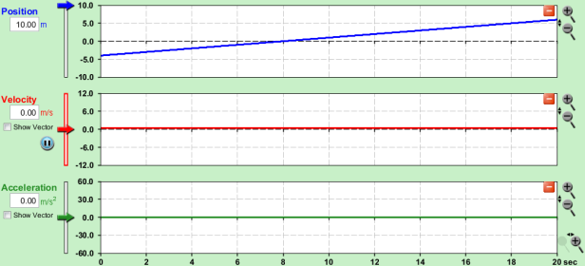
14. Set velocity to 1.00m/s, position to -3m, acceleration to -0.50m/s²
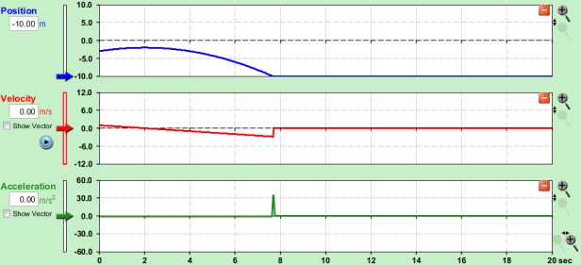

15. Set acceleration to 0.50m/s2 and position to -4m
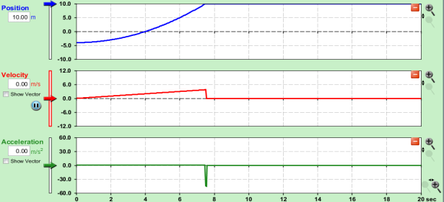
16. Set velocity to -1.00m/s, position to -3m, acceleration to 0.50m/s²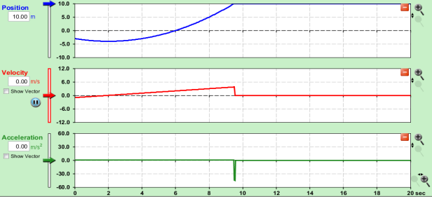

17. Set velocity to 10.00m/s, position to -3m, acceleration to -5.00m/s²
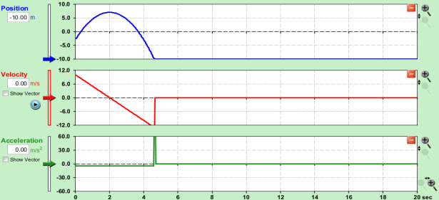
18. Set velocity to 4.00m/s, position to -8m, acceleration to -0.50m/s²
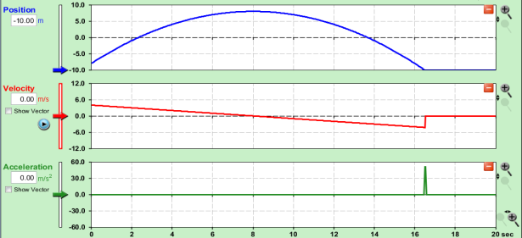

MOST IMPORTANT PART OF THIS PAGE!
What do you notice about the velocity and position graphs when the man changes direction?
Position: The position graph hits a maximum Velocity: The line crosses the zero line
or a minimum.

What happens when position, velocity and acceleration are all zero? All lines are flat.
Can you get all three graphs to give lines with slopes ≠0? If so, give the values here:
If not, why not? Because if acceleration is changing (slope≠0), which means speed is changing and position is changing squared in relation to acceleration, not a line!

