**Activity Card 6**

BD19827_

**Parallel Connection**

**Introduction**

Having recognized the disadvantages of a series connection, we know it is inconvenient to have all the lights in the house go out every time one bulb or an appliance burns out. It would be more practical if each lamp and each appliance were connected on a separate branch in the circuit to keep each resistance independent of each other. Such a connection is said to be in parallel. PARALLEL CIRCUIT is an electric circuit with two or more components connected across two common points to allow separate conducting paths.

**Objectives**

1. draw circuit diagrams of simple electrical setups and make simple electrical connections.

2. measure the voltage using the voltmeter.

3. measure the amount of current using an ammeter.

4. identify the types of connections in some electrical appliances.

**Materials**

9 volts battery, 2 bulbs, ammeter, voltmeter, connecting wires, switch

**Procedure:**

1. Setup the circuit with 2 bulbs and 9 volts battery as shown below.

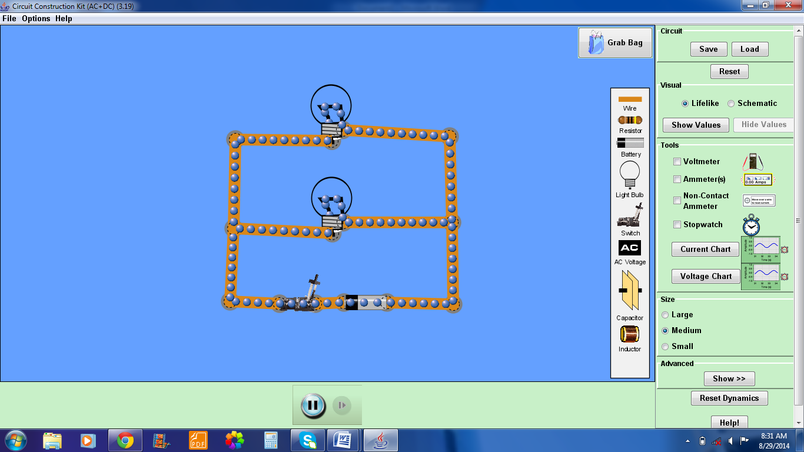

2. Close the circuit. What do you observe?\_\_\_\_\_\_\_\_\_\_\_\_\_\_\_\_\_\_\_\_\_\_\_\_\_\_\_\_\_\_\_\_\_\_\_\_\_

3. Remove one bulb. What do you observe this time? Return the bulb and switch off the circuit.

4. Connect the ammeter at position A and B as shown below. Take note the current reading.

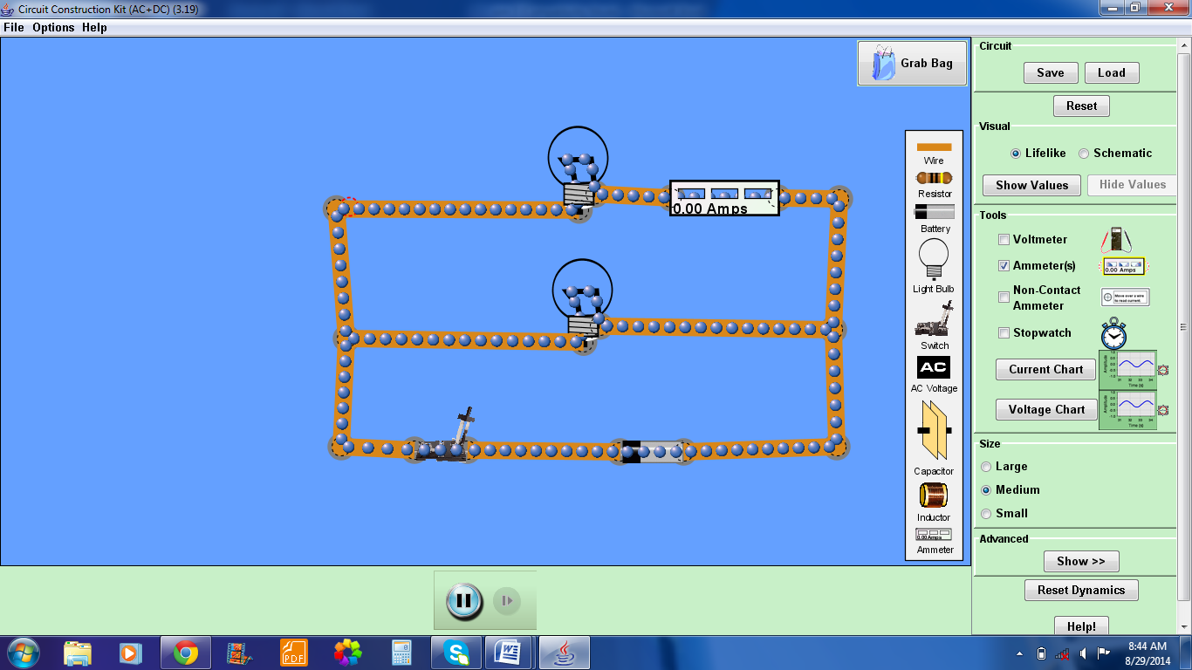(A)

(B)

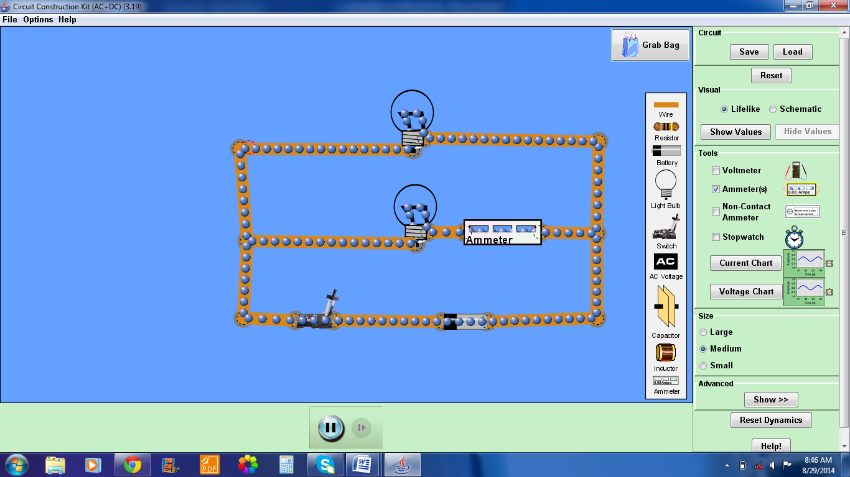

5.Switch on the circuit and record the measured values. How does the current readings compare?

6. Show your calculation in getting the individual current (9 volts, right click the bulb, show R value).

7. Increase the voltage of the battery into 50V. Observe. What happen to the brightness and the values for currents as voltage increases (right click the battery, increase voltage)?

8. Connect the voltmeter at Position A, B, and C. Switch on the circuit and record the measured values (voltage=50V , click the voltmeter button which is found on the right).

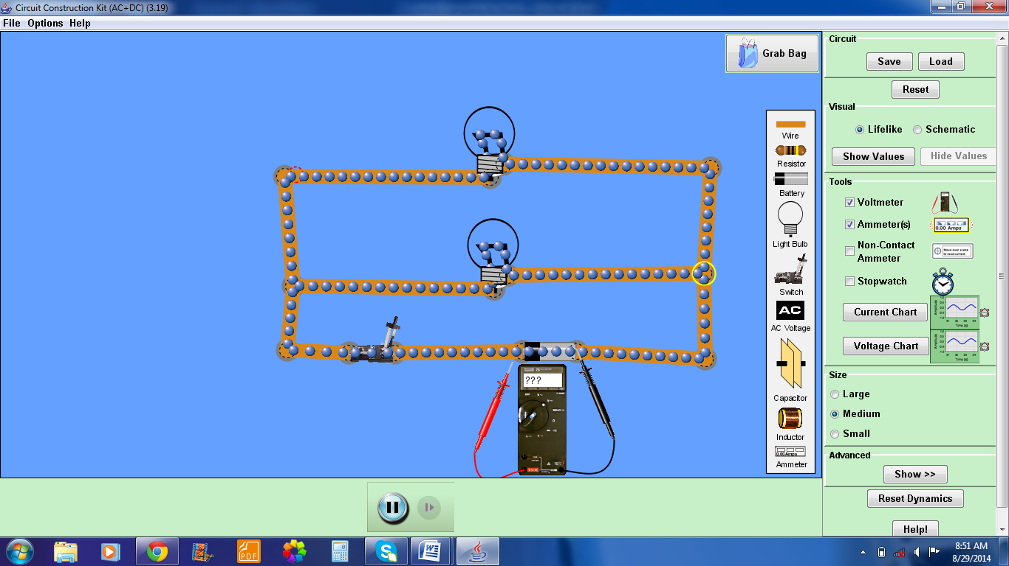

Position (A)

Position (B)

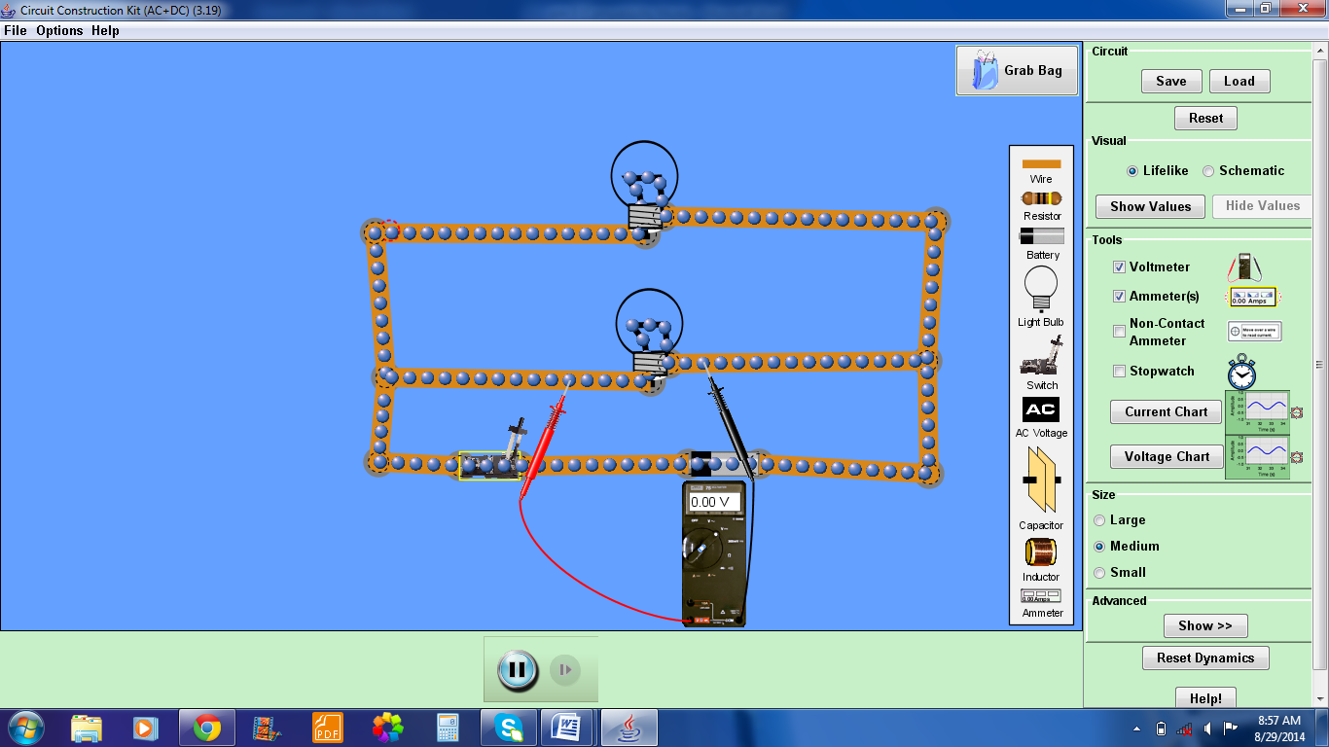

Position (C)

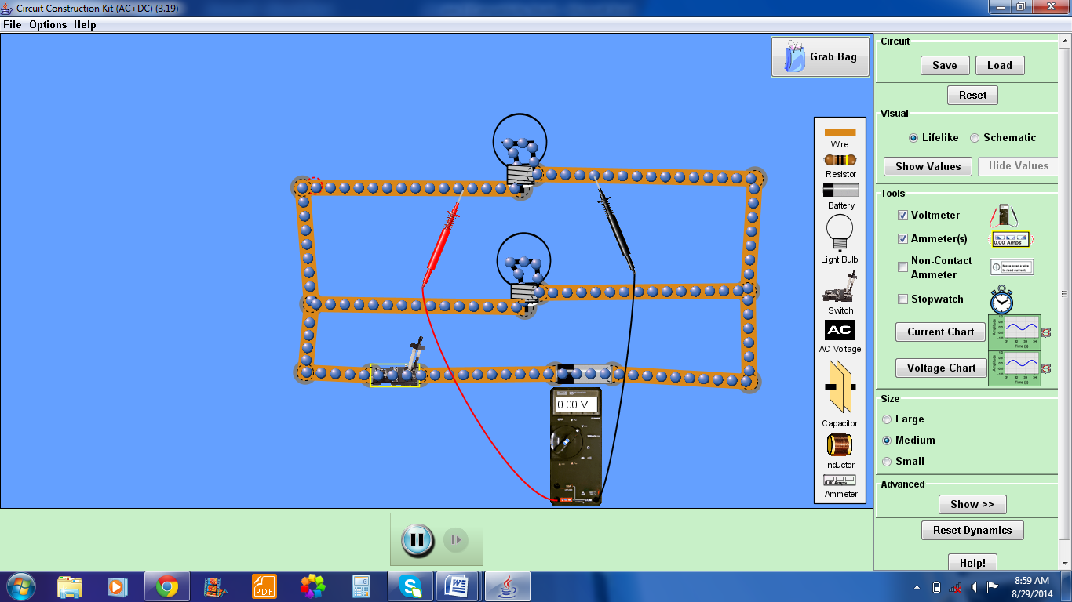

Show your solution in calculating voltage.