Title: Eating and Exercise

Important Questions:

- What can we do to lead and maintain a healthy lifestyle?
- How can we balance our eating (intake) and exercise (calories burned) to keep us healthy and maintain our weight?

Instructions:

In this activity, the above questions are investigated. Complete this document by filling in data tables and writing complete responses. This investigation has three phases: Exploration, Explanation and Application. Work between this document and the simulation (sim).

1. Click the picture below to access the Eating and Exercise Simulation

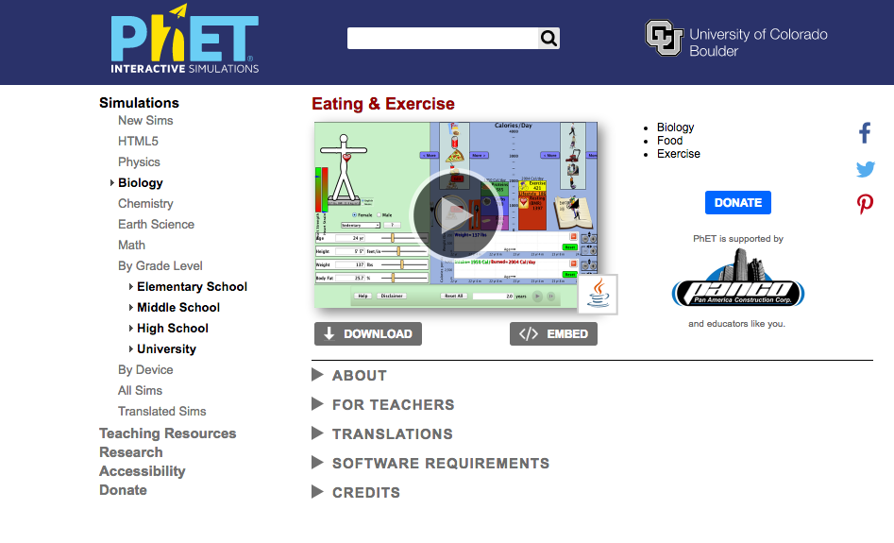

Exploration Phase:
(5-7 minutes)

- Briefly explore this sim.
Drag pictures to the notebook to add exercise

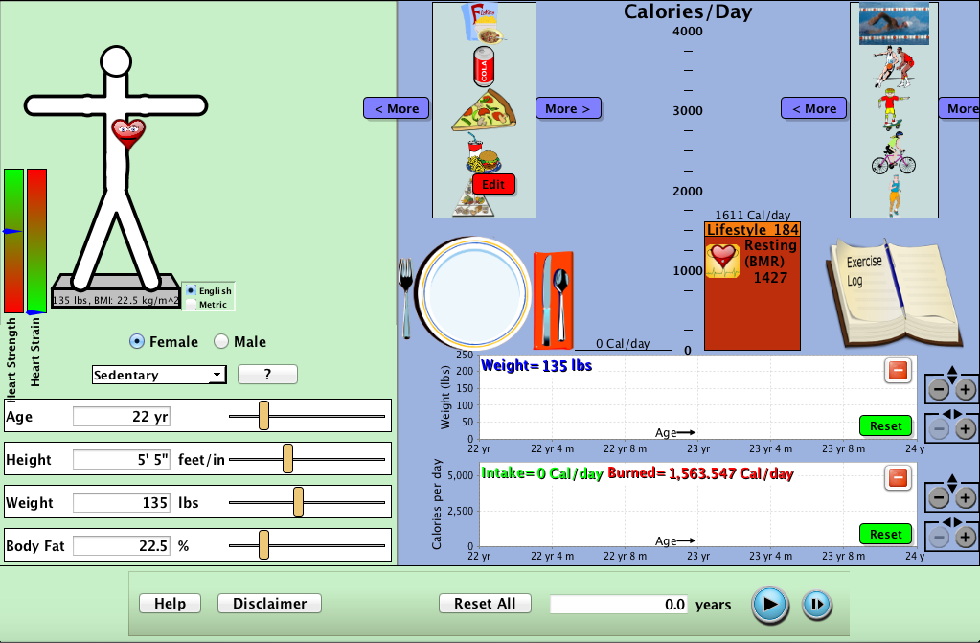
Drag pictures to the plate to add food
Heart Icon

Hit play and observe how the graphs change over time
Adjust age, height, weight, and body fat

2. Input your own age, height, and weight on the left side of the simulation underneath the body. The computer will input your body fat.

3. Explore different combinations of meals and exercise by using the arrows to scroll through. Drag the foods onto the plate and the exercise onto the notebook. Observe how it affects your weight.

4. Try putting in a lot of food and no exercise. Observe how it affects your weight.

5. Try putting in a lot of exercise and no food.

Questions

1. What can you eat and do to exercise to decrease your weight?

2. What can you do to increase your calories burned?

3. What are possible ways to reach the starvation level?

** If it says “Game Over” start again.

Explanation Phase:

This Phase has an investigative goal.

Aim: Create a rule for a healthy intake of food and calories burned during exercise that makes your “heart” happy and maintains your weight.

Here are some concepts:
Adding food to the plate increases the intake (Calories).

Adding exercise to the notebook decreases Calories.

The heart icon on the body changes based on your intake, calories burned, and body type.

Click on the “Reset All” button.

Below there will be different types of people varying in gender, age, height, and weight. Input the given details of the person. Follow the directions in the chart and fill in the empty spaces.

Person A:

Female
Age: 30
Height: 5’5
Weight: 140
Very Sedentary

Drag food to feed Person A breakfast, lunch, and dinner. (Do not add any exercise)
Record the food you fed Person A below:

Play the simulation. Use the graphs at the bottom of the simulation to record what happens to her weight and calories per day.
 | AGE | Age,4m | Age,8m | +1year | Age, 4m | Age,8m | +2years
Weight
Calories per day (intake/burned)

Take a screenshot of the body including the person’s heart at the end of the 2 years:

Reset everything.

Repeat the steps above and add the same food from before.

Now add exercise to maintain the weight of Person A.

Record what exercises you add:

Look at the two graphs at the bottom right of the screen. Fill in the chart:
 | AGE | Age,4m | Age,8m | +1year | Age, 4m | Age,8m | +2years
Weight
Calories per day (intake/burned)

Take a screenshot of the body including the person’s heart at the end of the 2 years:

Come up with a rule to keep the heart healthy and happy.
Write it here:

Application Phase:
(10 minutes)
Reset everything.

Input a person of your choice and give them input/output to help them maintain their weight.

Age:
Height:
Weight:
Body Fat:

Record the food you provide:

Record the exercise you provide:

Use the two graphs to record what you see:
 | AGE | Age,4m | Age,8m | +1year | Age, 4m | Age,8m | +2years
Weight
Calories per day (intake/burned)

Take a screenshot of the body including the person’s heart at the end of the 2 years:

Congratulations you finished the simulation!

