Title: Color Vision
Important Questions:
- How do we perceive specific color combinations?
- What are the primary colors of light?
- How is white light created?

Instructions:
In this activity, we will be using the deflection of RGB bulbs to determine what color a person sees when different combinations of lights are used.
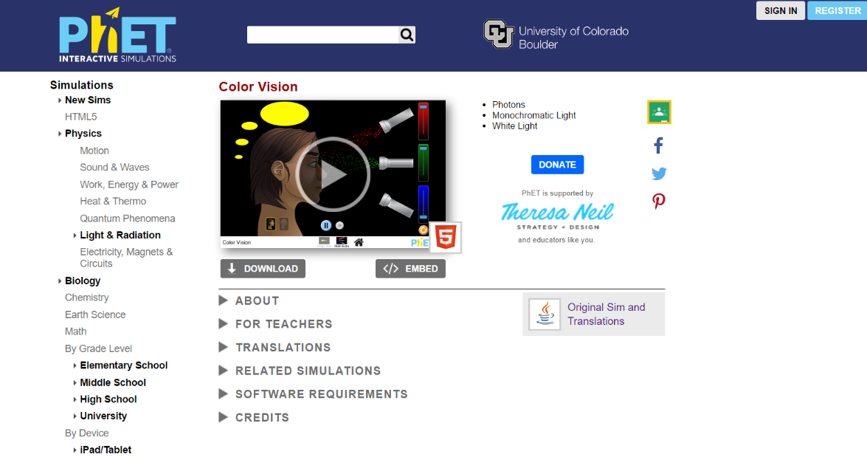
- Click the embedded photo below to go the simulation:

Exploration Phase:
- Briefly explore this simulation.
- Click on “RGB Bulbs”.
- Explore applying different combinations of each light.

Questions:
- What color does the person see when no color is applied?

- What color does the person see when one color is raised to the maximum level?

- What color does the person see when all three colors are at the maximum level?

Explanation Phase:
Aim: Create a rule that explains what primary light bulbs are needed for a person to see specific colors.
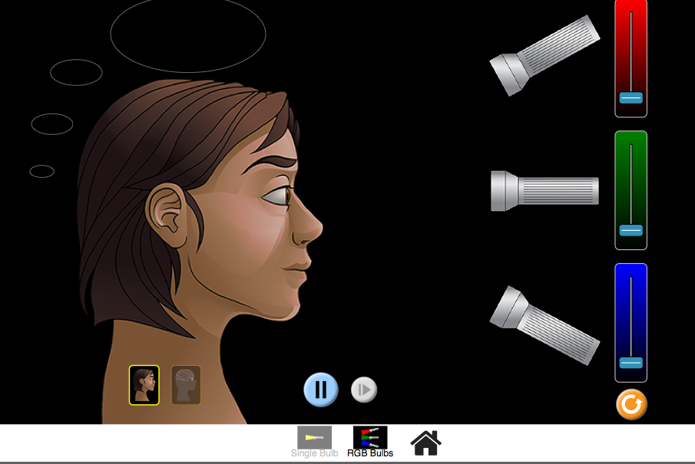

When different amounts of light are applied, a person will see a specific color.

Predict the secondary color a person will see when two primary colors are raised. Make sure that both colors are at the maximum deflection.
Primary Color | Primary Color Added | Predicted Perceived Color (Secondary Color)
Red | Green
Green | Blue
Blue | Red
Test your predictions.
Primary Color | Primary Color Added | Perceived Color  (Secondary Color)
Red | Green
Green | Blue
Blue | Red

What colors went into the eye and what color was seen?

How were your predictions similar or different to your actual results?

Application Phase:
What primary color and secondary color make white? These color combinations are known as complementary colors.

Secondary Color | Complementary Color Added | Perceived Color
Cyan |  | White
Yellow |  | White
Magenta |  | White

Create a rule that explains what happens using the words: secondary and complementary color.

