Buoyancy!

Definition:
The power of a fluid to put an upward force on an object placed in it.

Objective:
To understand the role of gravity and buoyancy when an object sinks and when an object floats.

Instructions:
Follow the steps to complete this lesson on buoyancy!

Click on the picture to follow the link to simulation. If clicking the picture does not work, right click on the picture and select “open hyperlink.”
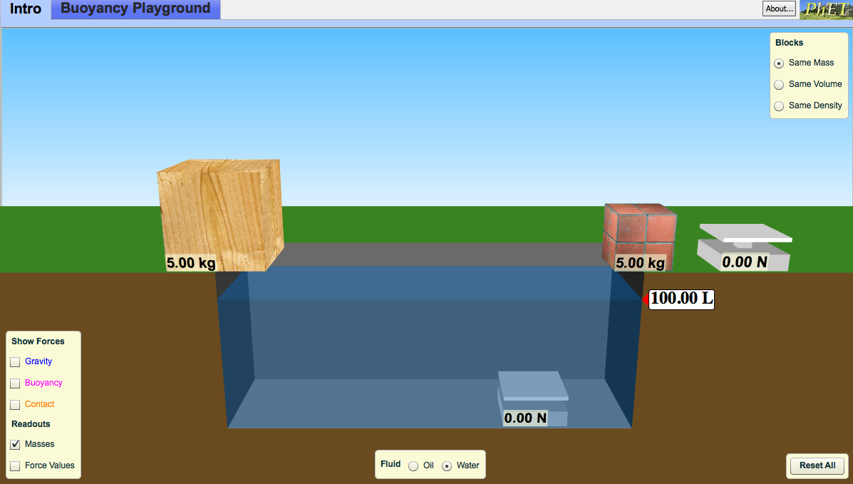
You should see this screen
Exploration Phase:
- Take a few minutes to explore the simulation
- Try placing both the wood and the brick in the water
- What do you notice when you click on gravity and buoyancy?
- Notice what happens if you drag and hold both objects at the bottom of the tub
- What does the purple arrow show?
- What does the blue arrow show?
- Click “Reset All” at the bottom of your screen

Questions (Make sure buoyancy and gravity are checked)
- Looking at the wooden block, when is the buoyancy greater than gravity?
  - Was it sinking or rising?
- Looking at the wooden block, when is the buoyancy equal to the gravity?
  - Was it sinking or floating?
- Looking at the brick, when is the gravity greater than the buoyancy?
  - Was it sinking or floating?

Explanation Phase:
Aim: Understand the role of buoyancy and gravity when objects of different density sink or float.
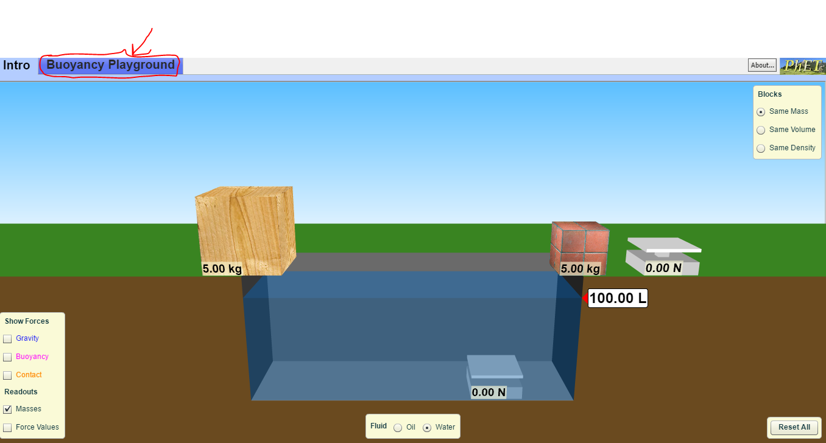
Click on the “Buoyancy Playground” tab.

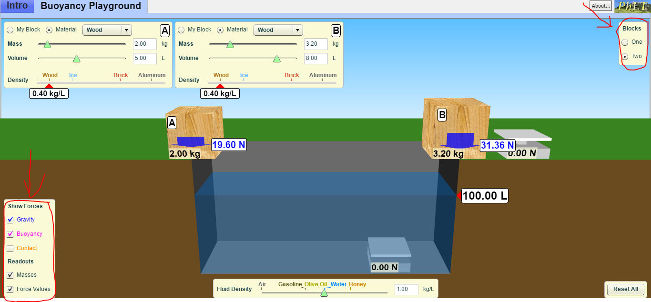
Under blocks, click “two” and under Show Forces, click “gravity,” “buoyancy,” and “force values”
Under block B, select “brick”

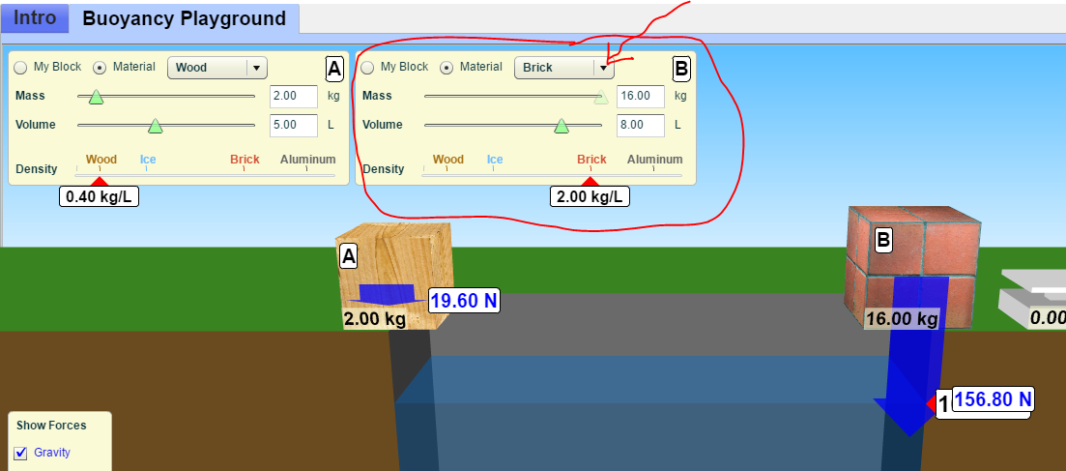

Place both blocks in the water. Drag the wood block down to the bottom of at the tub and hold it there.
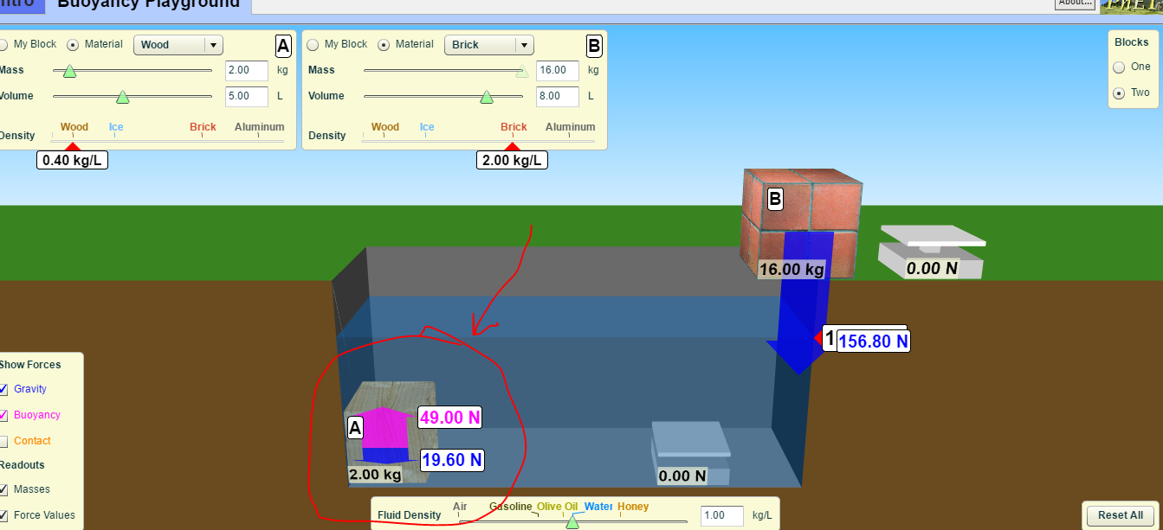

When you let go, does the block rise (float) or stay (sink)? In the table below record the gravity and buoyancy for both and if the object sinks or floats.

Repeat this for the brick.

Repeat this for the following combinations and record your findings in the table below:
Ice and aluminum
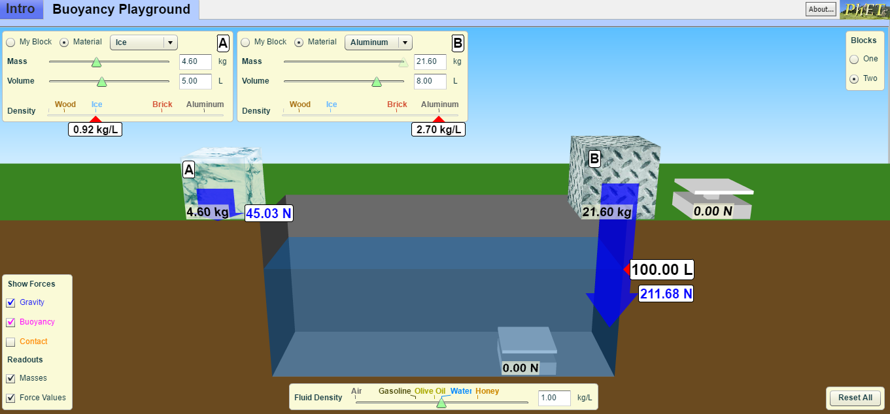

Styrofoam and wood
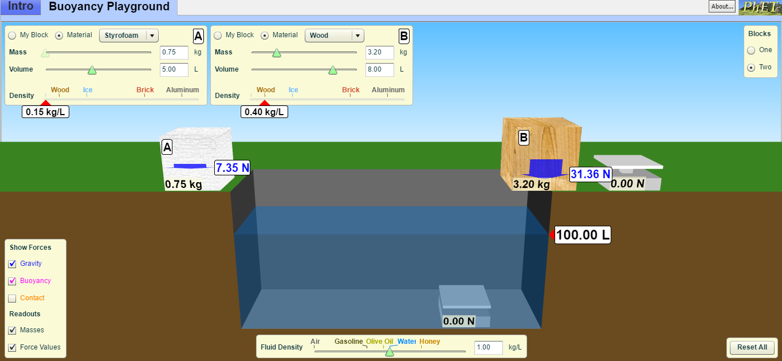

 | Gravity | Buoyancy | Sink or Float?
Wood
Brick
Ice
Aluminum
Styrofoam
Using the information you have gathered, under what conditions do objects float?

Application Phase:

Click “reset all.”

Click “my block” and check off boxes “gravity”, “buoyancy”, and “force values”.
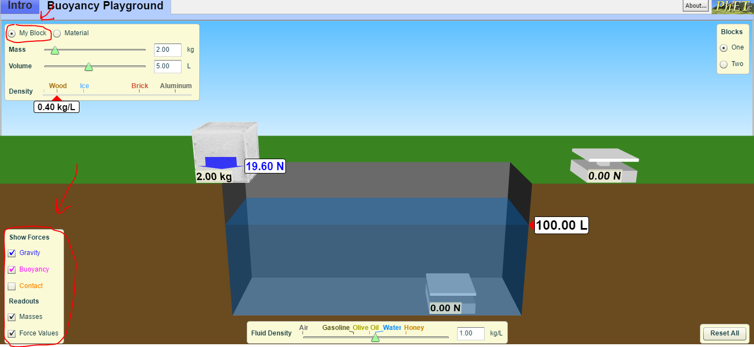

Keep your block outside the tank.

Create three different blocks by changing the mass and volumes and record them in the table below. Predict if the each block would rise (float) or stay (sink).

Now create each block.

Test it in the water by dragging the block to the bottom of the tub and then releasing it.

Record your results in the table below.
 | Mass | Volume | Prediction:  Sink or Float | Result:  Sink or Float
My Block 1
My Block 2
My Block 3

How do mass and volume affect the gravity and buoyancy of an object?

