Title: Area Builder

Introductions
In this activity you will investigate the mathematical science of area and perimeter and how to calculate both. Area is defined as the amount of space a two-dimensional (2-D) object takes up, measured in unit squares. Perimeter is defined as the distance around a 2-D shape. You find the perimeter of a rectangle or square by adding the length of all four sides.

1. Click this link: https://phet.colorado.edu/en/simulation/area-builder

This is a screenshot of the website:

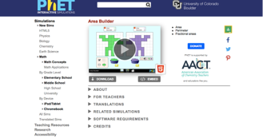

Exploration Phase

1. Click the “Explore” picture on the sim.

2. Create two different size squares and two different size rectangles.

3. Take a screenshot of each shape you create

Questions

1. Make a three by three square. Define the area (Hint: count up the squares)

2. Reset the screen. It should look like this:
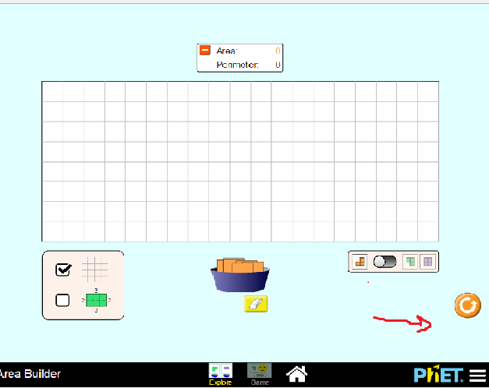

Now, make a four by four square. Define the perimeter (Hint: count all the lengths of each side)

3. Reset the screen. Now make a 6 by 6 rectangle. Define both the area and perimeter.

Explanation Phase

Aim: I can find the area of a 2-D shape.

Hide the values on the screen. The red arrow is pointing to what your screen should look like.

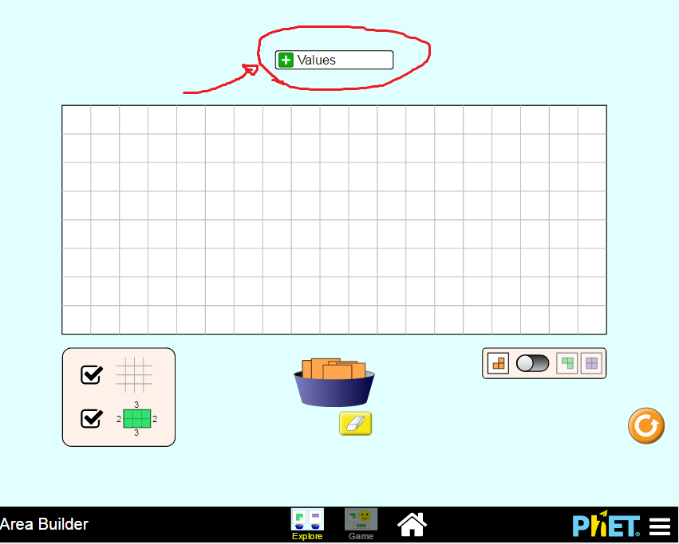

Use the sim and fill in the blanks of the following table for these various shapes.

Shape | Width | Length | Area
 | 6 | 8
 | 8 |  | 32
 |  | 5 | 25
 | 10 | 8
 |  |  | 30

Write a formula to help you find the length if given the width and area.

Write here:

Application Phase

Click the “Game” tab and play—Play Level 1
Make sure to check the box that the arrow is pointing to.
Be sure to record your area in the table below.
Use the formula from above to help you find the area.

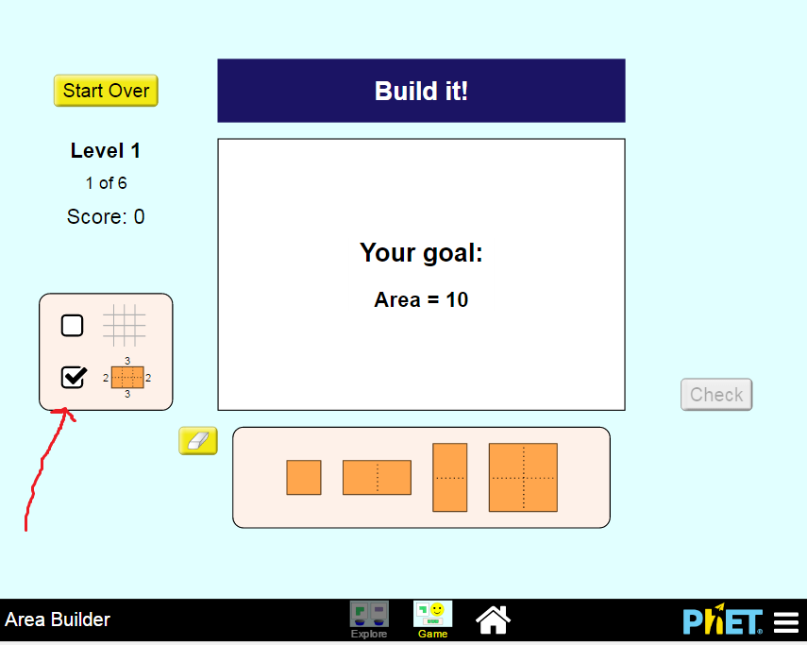

Area
Problem 1
Problem 2
Problem 3
Problem 4
Problem 5
Problem 6

Conclusions:
What operation did you use to find the area?

