Playing with atoms

In this activity students will be deducing atomic structure and ions using simulation with the “Building the atom” PhET simulation.
Open the simulation by clicking on the link:
https://phet.colorado.edu/sims/html/build-an-atom/latest/build-an-atom_en.html
Take a look at the explanatory video via YouTube:

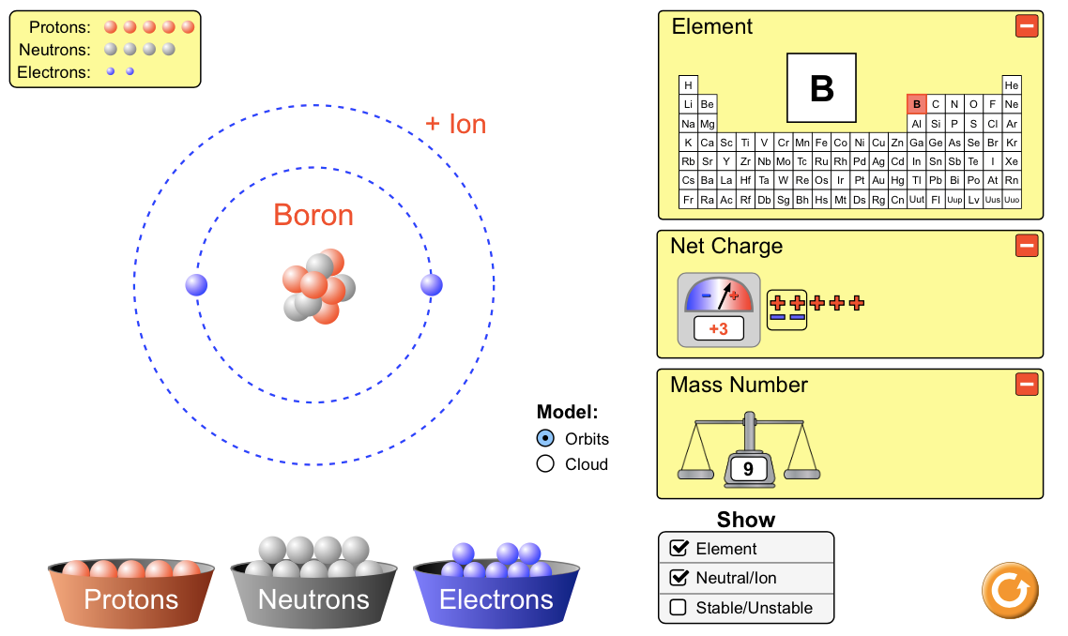
https://youtu.be/wi4yjC_RZho

Learning Objectives
____________________________________________________________
By the end of these activities it is hoped that students will have an acquired the following skills:
- Following explicit instructions to gain acquired knowledge
- Investigate how how the atom is structured.
- Giving evidence of their progress via screenshots
- Identify symbols using nomenclature with the periodic table.
- Have fun testing skills with the games

The Atom

1. Neutral atoms
- When you enter the website click down the bottom to enter the atom screen. It will look like the one opposite.
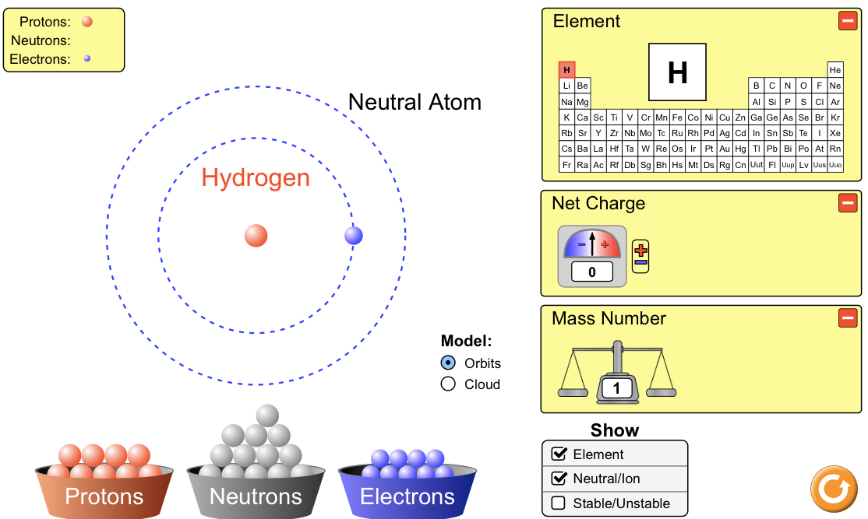
- You are going to add protons and neutrons to the centre and electrons to the outside.
- Add one proton to the centre and one electron to the outside. The screen states it is Hydrogen and and neutral. This is how it appears in the periodic table.
- Look at the net charge (blue circle) what does it it state and what does it mean?
______________________________________________________________________________________________________________________________________
- Look at the mass number (green circle) what is the mass of hydrogen?
___________________________________________________________________
- What particle makes up the mass?
___________________________________________________________________

- Now add protons, neutrons and electrons to produce the neutral atoms for the elements 2; 4; 6; 8; 10 and 12. Take a screenshot of each element and place them in the spaces provided

- As you move from element 2 to 4 what happens to the position of the electrons?
Screenshot of Element 10
______________________________________________________________________________________________________________________________________
Screenshot of Element 6
Screenshot of Element 8
Screenshot of Element 2
Screenshot of Element 4
- Look at element 10 what is the electron arrangement?
Show the number of electrons in each orbital or shell.
______________________________________________________________________________________________________________________________________

2. Ions
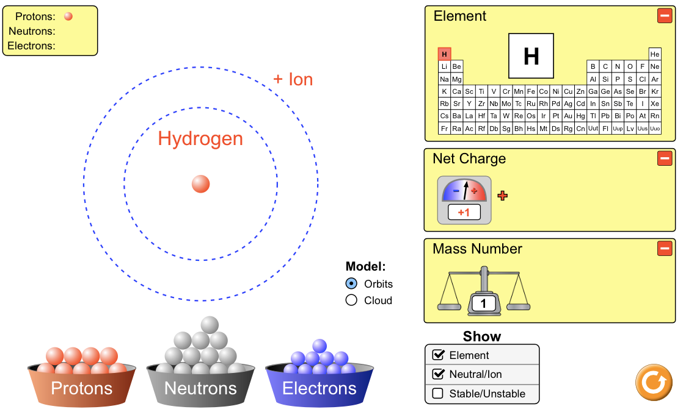
- Ions are atoms that gain and loose electrons to get a full out shell. Metals loose electrons to get to this point and non-metals gain. As a result metals make positive (+) ions and non-metals make negative (-) ions.

- Go back to the hydrogen neutral atom with 1 proton and 1 electron. Now remove the electron. Notice that it states +Ion and in the net charge box +1 (blue circle).
- Make the neutral atom for Lithium, Li with 3 protons; 3 electrons and 4 neutrons. Remove all the electrons in the outer orbital. Take a screenshot and identify the ion of Li.
Screenshot of Ion Li
- Li ion = _______________

- Now find the ions for the following elements by making the correct neutral atom and then adding or removing the outer electrons. Use the net charge section to identify the ion. Write your ions in the table on the opposite page.
- Note 1: Element 6 is omitted as it is stable as it has a half full sheet of electrons and so does not make ions.
- Note 2: Element 10 is omitted as it is stable as it already has a full outer shell of electrons and so does not make ions.
Element | Ion
3
4
5
7
8
9

- What do the ions of elements 3 - 5 have in common?
______________________________________________________________________________________________________________________________________
- What do the ions of elements 7 - 9 have in common?
______________________________________________________________________________________________________________________________________
- What do you notice about the ions of those elements in the same column or group on the periodic table? (Use the image below to help)
______________________________________________________________________________________________________________________________________

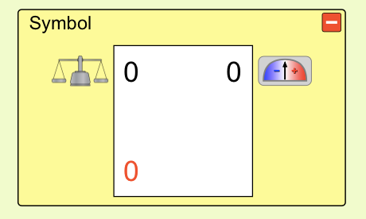
3. Symbol
- Now click the symbol icon at the bottom and look for the data box as shown opposite.
- Add a proton to the centre and see how the symbol changes.
- Complete the table below adding the appropriate protons; neutrons and electrons and screenshot just the symbol box to identify how the element or ion is written.
Element | Screenshot
Protons = 4
Neutrons = 5
Electrons = 4

Protons = 7
Neutrons = 7
Electrons = 7

Protons = 5
Neutrons = 5
Electrons = 5

Protons = 8
Neutrons = 8
Electrons = 8

- Now do the same but remove or add electrons to the outer shell and see how the symbol changes.
- Note metals remove electrons and non-metals add electrons to complete their shells. Use the periodic table to help.
- Screenshot your answers and place them in the cell in the box below:

Element | Screenshot
Protons = 4
Neutrons = 5
Electrons = 4

Protons = 7
Neutrons = 7
Electrons = 7

Protons = 5
Neutrons = 5
Electrons = 5

Protons = 8
Neutrons = 8
Electrons = 8

4. Challenge yourself
Now you are ready to test yourself. Click on the Game icon at the bottom of the screen and test yourself on your knowledge of atoms.
HAVE FUN!!
