Name:

Why can’t you trust an Atom? Because they make everything up!
Atoms make up everything, but what are atoms made of?
We’re going to learn about the parts of an atom which are the electrons, protons and Neutrons.
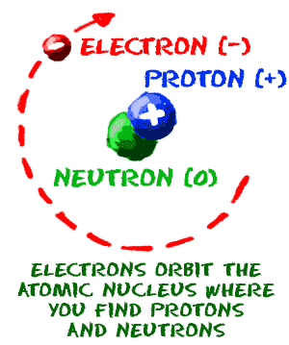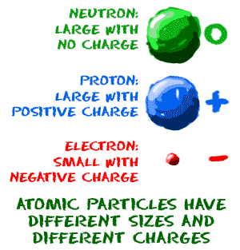

Hear is a video I made with a student to help you remember the parts of an atom.
https://photos.app.goo.gl/UlTWJNsRz5Hcl9dz2

What are the three parts of an atom?

Describe Electrons.

Describe Protons:

Describe Neutrons:

Here’s a funny song:
https://www.youtube.com/watch?v=VgVQKCcfwnU

Pause the video at 40 seconds.

Where are noble gasses located on the periodic table?

Noble gases are what?

Where are alkali on the periodic table?

Where are halogens on the periodic table?

How are alkali and Halogens similar?

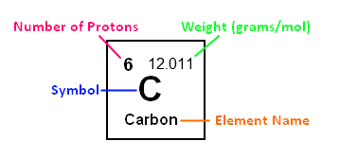
In a carbon atom, what does the 6 stand for?

What does the 12.011 stand for?

What is the C?
Instructions:
Instructions:
https://www.youtube.com/watch?v=Baps43cDgz8

Link:
https://phet.colorado.edu/sims/html/build-an-atom/latest/build-an-atom_en.html

Fill in the chart using the simulation: Make sure you have a stable ion?
Atom | Protons | Neutrons | Atomic number
Hydrogen | 0 | 1 | 1
Lithium | 3 | 3 | 6
Carbon
Oxygen
Boron

What is the relationship (connection) between the number of protons and Neutrons and the atomic number, or weight of the atom?

Your atom is a positive ions when it has more:

Your atom is a negative ion when it has more:

If the atom has more protons than electrons is it a negatively or positively charged ion?

If the atom has more electrons than protons is it a negatively or positively charged ion?

