PhET Simulation: Projectile Motion
Name_____________________________________ Period ____________ Date _____________
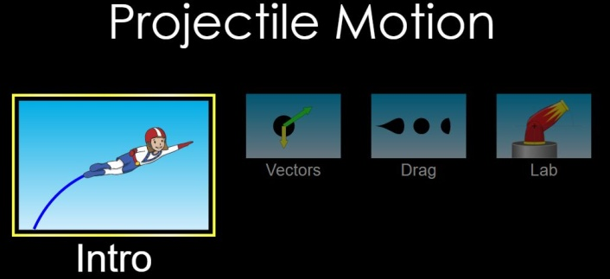
Go to PhET simulations using the link https://phet.colorado.edu/en/simulation/projectile-motion. Select the Intro icon.
Begin with the default settings of:
Cannon angle 0⁰ Target distance 15 m
Cannon height 10 m Initial speed 15 m/s
Object Pumpkin

Check the Velocity and Acceleration Vectors boxes. DO NOT check the air resistance box.
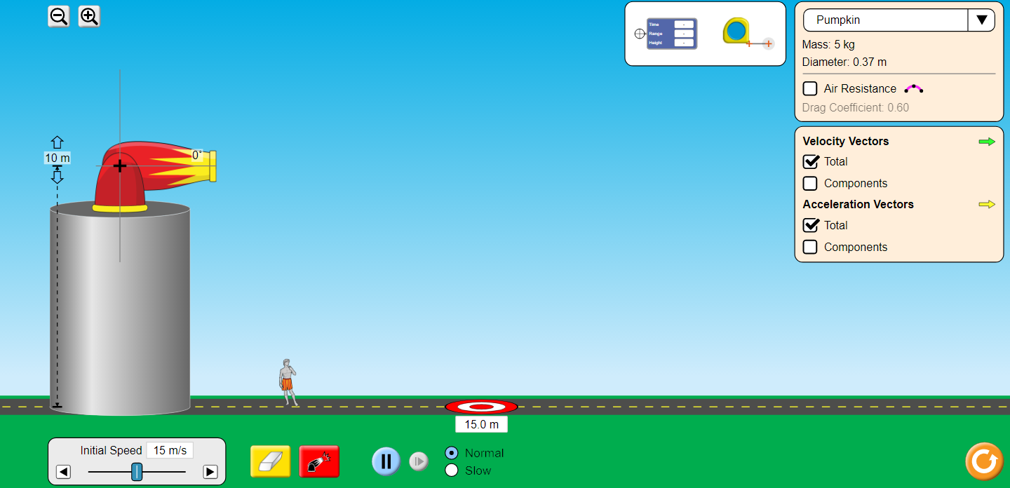
d_{x} = v_{x} t d_{y} = v_{y} t – 5 t² v_{x} = v cos θ v_{y} = v sin θ
- Use the red launch icon at the bottom of the screen to fire the cannon. The pumpkin misses the target. Does the pumpkin overshoot or fall short?

- Now adjust the cannon height until you successfully hit the target. Record the height below and explain why this combination is successful using the projectile motion equations.

- Set the cannon height to 14 m and the initial speed to 20 m/s. Show how to calculate the location of the target. Verify your prediction using the simulation.

Again use a pumpkin. Keep the initial speed at 15 m/s. Set the height of the cannon to 0 meters.
Drag the target as far to the right of the screen as you can.

Try 6 different launch angles.

Drag the crosshairs marked with time and range to the spot where the pumpkin landed. Then drag the crosshairs to the top of the parabola to find max height. Fill in the table below with the values.

Initial Angle | Time | Range | Max Height
25
35
45
55
65
75

- How does the time in the air change as the angle increases?

- How does the range changed as the angle increases?

- How does the maximum height change as the angle increases?

- Change to a different projectile like a car and repeat the same experiment. What does this tell you?

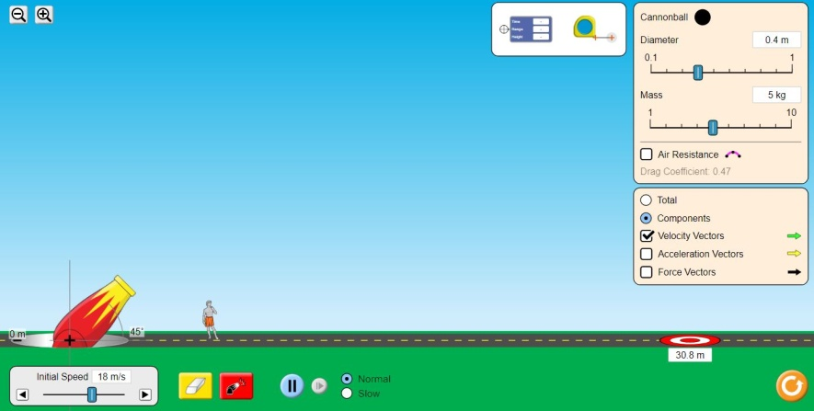
Click on the icon at the bottom of the page labeled Vectors. Use the following settings.
Cannon angle 45⁰
Initial speed 18 m/s

Check the Components and Velocity boxes.
DO NOT check the air resistance box.
Drag the target as far to the right of the screen as you can.

Use the settings Cannonball Diameter, Cannonball Mass, and Air Resistance to launch the cannonball. Drag the crosshairs marked with time and range to the spot where the pumpkin landed. Then drag the crosshairs to the top of the parabola to find max height. Fill in the table below with the values.
DO NOT RESET THE SCREEN IN BETWEEN LAUNCHES SO THAT YOU CAN SEE ALL PATHS AS YOU CHANGE SETTINGS.
Cannonball Diameter | Cannonball Mass | Air Resistance? | Time | Range | Max Height
0.4 | 10 kg | no
0.4 | 5 kg | no
0.2 | 5 kg | no
0.2 | 5 kg | yes
0.4 | 5 kg | yes
0.4 | 10 kg | yes
0.8 | 5 kg | yes
0.8 | 10 kg | yes

Idealized Conditions for Projectile Motion
With zero air resistance, how does mass affect the time, range, and height of the flight?

With zero air resistance, how does diameter affect the time, range, and height of the flight?

Real-World Conditions for Projectile Motion
With air resistance, how does increasing the diameter for the same mass cannonball affect the time, range, and height of the flight? Why do you think this occurs?

With air resistance, how does increasing the mass for the same diameter cannonball affect the time, range, and height of the flight? Why do you think this occurs?

