Extra Credit Lab – Greenhouse Gasses

For this lab you will use a simulation of Earth’s atmosphere found on the University of Colorado’s PHET website. We will be using the Greenhouse Effect simulation at this link https://phet.colorado.edu/en/simulation/legacy/greenhouse
Download the simulation (make sure you have the current form of java) and use it for this lab. The simulation has 3 tabs at the top – “Greenhouse Effect”, “Glass Layers”, and “Photon Absorption”. Work through each of these tabs by following the directions and answering the questions below. When you are finished, go to the “Submit a Lab” page to submit your answers just as with other labs. This lab score can be added onto your total lab score for extra credit.
TAB 1 – The Greenhouse Effect
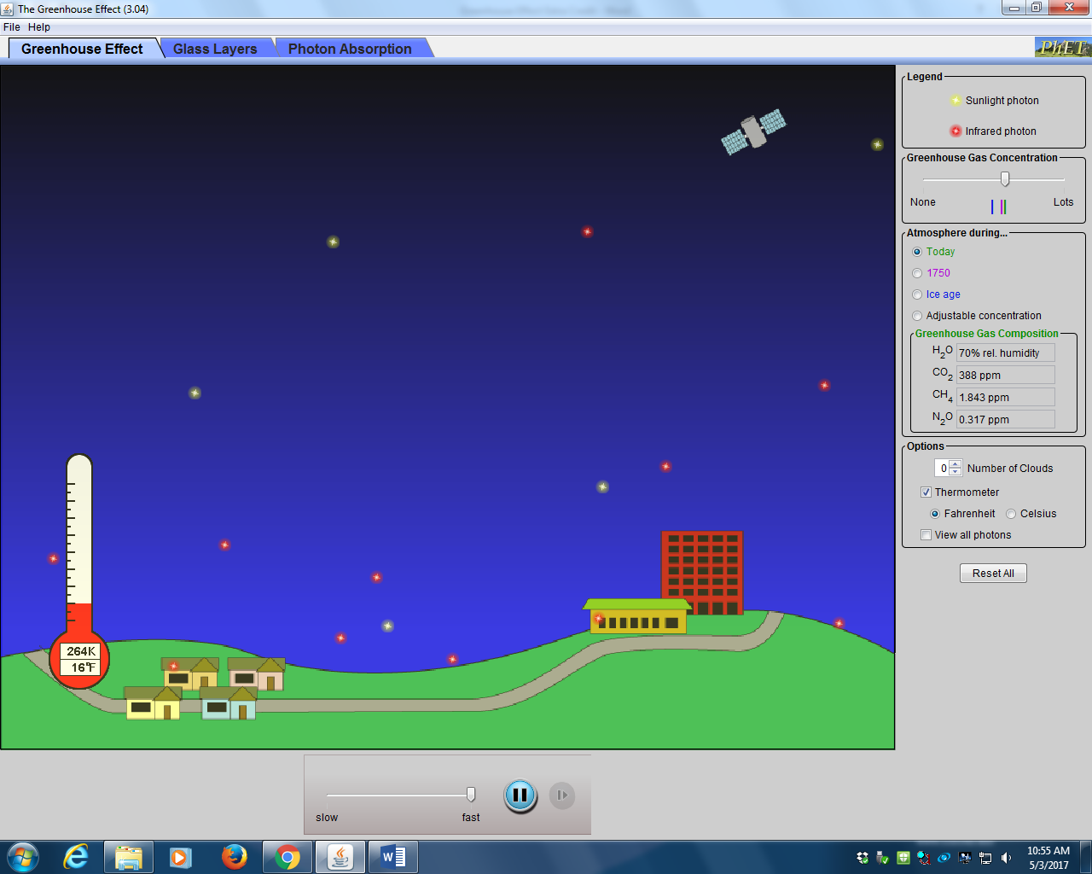

This shows a simulation of the greenhouse effect. It shows visible light photons (yellow) coming down to the surface of Earth from the Sun. Once the surface absorbs the visible light the Earth warms and gives off heat as infrared photons (red). The balance between energy absorbed and then given off by the Earth causes the temperature of the Earth to stabilize at a particular level. You’ll notice that not all the infrared photons make it out to space; some are reflected back down to the surface. This is due to greenhouse gases. Greenhouse gases don’t interfere with visible light as it passes through the atmosphere, but they do absorb and re-emit infrared light as heat. As heat leaves the surface on its way out to space, some of it is absorbed by greenhouse gases in the atmosphere, causing these gases to warm up and give off heat of their own, some of which travel back down to the surface of the Earth. If you are having trouble visualizing the motion of these photons you can adjust the speed of the simulation at the bottom of the window. The thermometer on the left of the window shows the average planet temperature. Greenhouse gas concentrations have varied throughout time and thus the planetary temperature has varied as well. You can vary the amount of greenhouse gas concentration in the atmosphere by using the slide bar on the right. Give it a try and see how increasing or decreasing the amount of greenhouse gases changes the planetary temperature. There are set levels you can try as well. Under the slider bar on the right you can set the greenhouse gas concentration to today’s level as well as during the last ice age and during the “little ice age” when Europe was colder than usual in 1750. You can add clouds to your simulation at the bottom of the right menu to see the effect on temperatures from clouds. Play around with all the variables and then answer the following:
- In what direction, relative to Earth’s surface, are all the yellow photons moving?
- In which directions, relative to Earth’s surface, are the red photons moving?
- Which color photons represent sunlight?
- Which color photons represent heat?
- Does the Earth emit visible light or heat?
- With the right menu bar set to today’s atmosphere, what is the average surface temperature of the planet?
- Slide the greenhouse gas concentration slider to no greenhouse gasses. What is the average surface temperature of the planet now?
- Could life as we know it exist on Earth without greenhouse gasses? Explain.
- Add 1 cloud to the atmosphere. What effect does it have on surface temperature?
- Add 3 clouds to the atmosphere. What effect does it have on surface temperature?
- What do the yellow photons do when they hit a cloud?
- What do the red photons do when they hit a cloud?
- As the planet warms more water vapor, a powerful greenhouse gas, evaporates into the atmosphere. But as more water vapor enters the atmosphere, more clouds form. Using this information and the simulation, explain why there is debate about whether more water vapor in the atmosphere will lead to more warming or more cooling of the Earth’s surface.

TAB 2 – Glass Layers
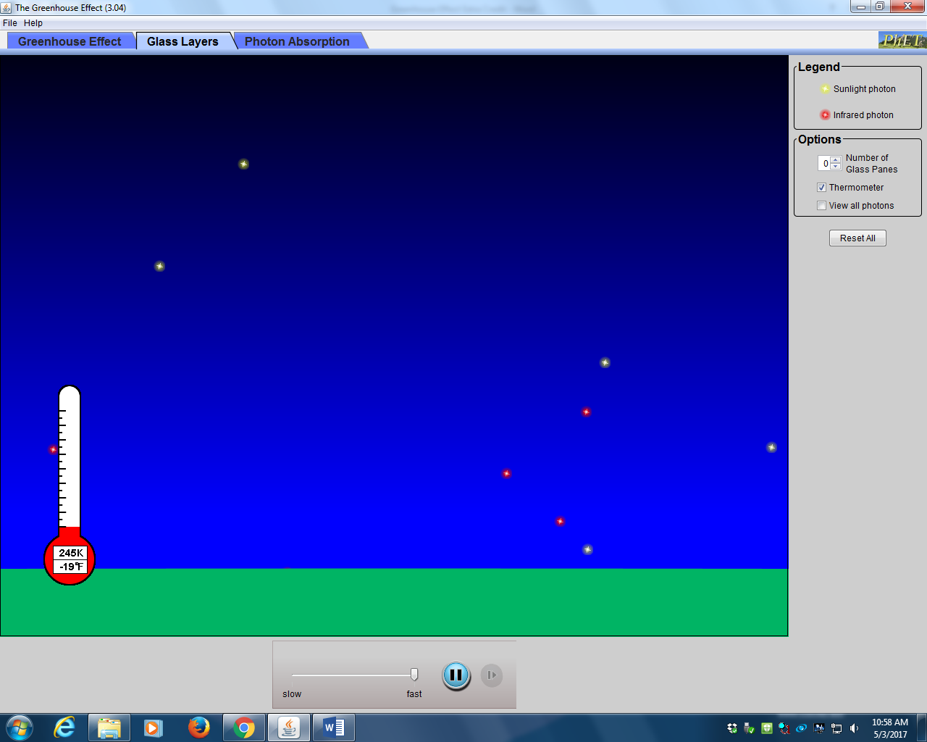

This shows a similar simulation to the first one, but in this simulation planes of glass are used to stand in for the greenhouse gases. Try adding panes of glass to the atmosphere and see the effect on the surface temperature. Play around with all the variables and then answer the following:
- Let the simulation run with no glass panes in the atmosphere. What is the surface temperature of the planet?
- What would this be analogous to with greenhouse gasses in Earth’s atmosphere?
- Add 1 pane of glass to the atmosphere. What is the surface temperature of the planet?
- Add 2, then 3 panes of glass to the atmosphere. Does the surface temperature rise, fall, or stay the same with more glass panes?
- Why do people spend more money to install double or triple pane windows in their houses instead of using single pane windows?
- The greenhouse effect is so names because certain gasses in the atmosphere act like the panes of glass in a greenhouse. Using this simulation, explain why your car becomes very hot inside during a sunny summer day.

TAB 3 – Photon Absorption
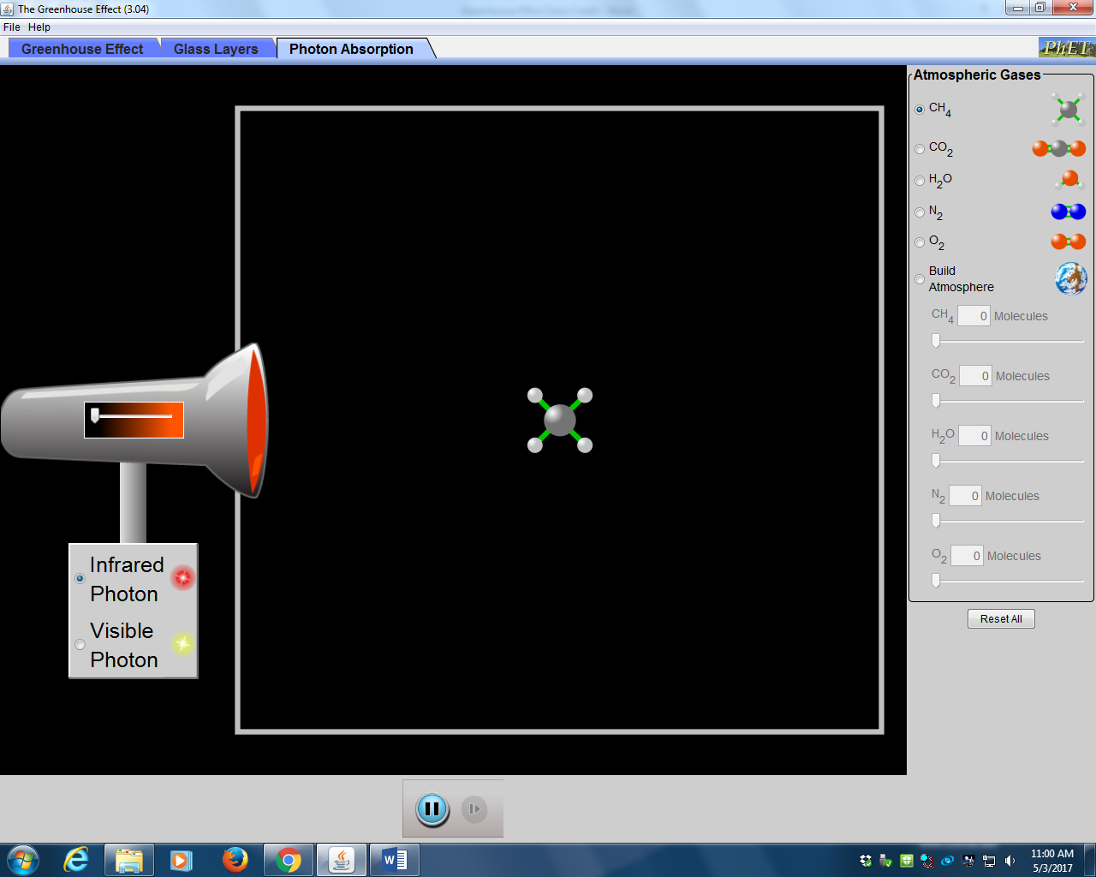

This shows how different gasses react to different forms of light. The flashlight on the left can be set to emit either visible light photons or infrared photons (heat). The amount of light it emits is controlled by a sliding pointer on the flashlight. Molecules of different gasses can be inserted into the main window by clicking on that molecule on the right menu bar at the top. Try placing a molecule of a gas into the window and then shine photons of light on it using the flashlight. Put the slider bar on the flashlight to full. If a particular molecule absorbs light, either visible or infrared, it will begin to vibrate with energy as it absorbs the photon and then it will re-emit a photon back out in a random direction, causing the molecule to stop vibrating until it absorbs another photon. Experiment with all the different gasses and both types of photons. There is an option on the right menu bar to build your own atmosphere. If you click this you can use the slider bars under this option to place different amounts of gas molecules into the window, which represents the atmosphere. Try putting different amounts of the gasses into the atmosphere and sending visible and infrared light photons through. Play around with all the variables and then answer the following:
- Which gasses absorb visible light photons?
- Which gasses absorb infrared photons?
- Which gasses can be classified as greenhouse gasses?
- What do the greenhouse gasses do with the energy they absorb?
- What would happen to the climate of Earth if there were more greenhouse gas molecules in the atmosphere?
- The Earth’s atmosphere is 99% nitrogen and oxygen (78% N₂ and 21% O₂). Describe how the Earth would be different if it was 100% nitrogen and oxygen.

