Type “PhET html Circuit intro” to find and run lab.

Notice: A circuit is a path, like a circle, whose start and end is at the same place.
- Complete the circuits below by drawing the missing element.
- Write observation about electrons
Drawing | Observations about electrons
Complete with a wire
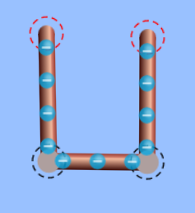
Complete with a battery
(Battery and eraser) 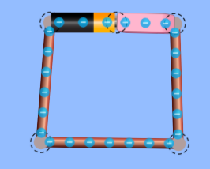
Notice: Current is the movement of electrons; it is measured at a rate through which electrons pass a certain point, like a battery, per second. The faster the electrons move, the higher the current.

2. Was there current for the circuit with the eraser? Explain why. _______________________________________________________________________________________________________________________________________________

3. Was there current for the circuit with just the wire? Explain why. _______________________________________________________________________________________________________________________________________________
Batteries, like the ones in a tv remote controller, provide voltage. That voltage is pressure force that gives electrons the potential energy to move through a circuit.

Complete /Draw with a battery & paper clip | Complete/Draw with a battery and resistor
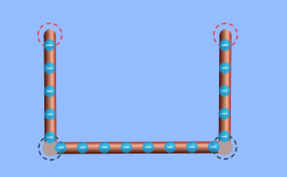

4. Compare the difference in current between the 2 pictures.
_____________________________________________________________________________________________________________________________________________

5. What does the resistor do to the electrons/current?
_____________________________________________________________________________________________________________________________________________

6. What do you think the resistor’s purpose is?
_____________________________________________________________________________________________________________________________________________

Create 3 separate circuits side by side.
7. Draw circuits below with light rays for each scenario to represent “brightness.”
Label speeds of currents “slow, medium, and fast” and Label light bulbs “dim, medium, bright”
1 battery, 1 light bulb, wires | 2 batteries, 1 light bulb, wires | 3 batteries, 1 light bulb, wires

8. What happened to the current (speed of electrons) as the number of batteries increased? _____________________________________________________________________________________________________________________________________________
9. What happened to the bulb’s brightness as the number of batteries increased?
_____________________________________________________________________________________________________________________________________________

Create 3 separate circuits side by side.
10. Draw circuits below with light rays for each scenario to represent “brightness.”
Label speeds of currents “slow, medium, and fast” and Label light bulbs “dim, medium, bright”
1 battery, 1 light bulb | 1 battery, 2 light bulbs | 1 battery, 3 light bulbs

11. What happened to the current as the number of light bulbs increased? _________________________________________________________________________________________________________________________________________________

12. What happened to the bulbs’ brightness as the number of bulbs increased?
_________________________________________________________________________________________________________________________________________________

13. Try to think about how questions 11 and 12 are related. Give a theory to explain.
_________________________________________________________________________________________________________________________________________________________________________________________________________________________________________________________________________________________________________

14. Remember what a resistor does. (Check Q&A 5). How are a resistor and a light bulb related? (A5&A11)
_________________________________________________________________________________________________________________________________________________

Notice: Place a resistor on the screen & check “show values” (on right). Both values are 10 ohms or “10$Ω."$This is because the light bulb acts as a resistor--both “resist” current.
STOP: GO TO OHM’S LAW LAB . Return when done.
15. Place a resistor on the screen. Then check “show values” (on right). Notice that both values are 10 ohms or “10$Ω"$This is because the light bulb acts as a resistor--both resist current.
PART 2: Ohm’s Law

Ohm’s Law states that current, I, through a circuit is dependant on voltage and resistance. The equation to show that dependency is I = V/R

Find the the current for the pictures below:
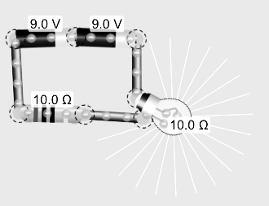
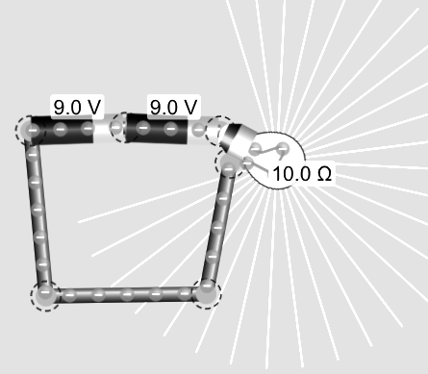
A. B.

A. Current: ___________ B. Current: ___________

16. Find the current for a circuit with 3 batteries, and 2 light bulbs. _________________

17. Find the current for a circuit with 2 batteries, and 1 light bulb and 2 resistors. __________

PART 3: Parallel v Series
18. Create circuits I and II side by side. Draw light rays and write observation about current. Try to explain.

Series

Parallel

_________________________________________________________________________________________________________________________________________

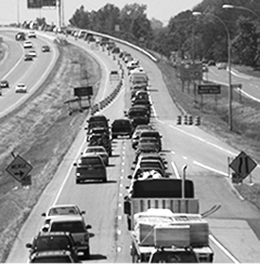
The best way to think of the difference between series and parallel circuits is like traffic. Imagine having 100 cars on the freeway. The SERIES freeway has one lane, but the PARALLEL freeway has 2 lanes. Which would you take?

Hopefully the Parallel freeway which allows more cars (electrons) to pass per second, which means a higher current and therefore a brighter bulb.

PART 4: Resistors
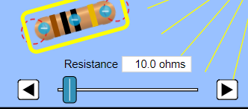
Reset lab and take out a resistor. If you click on the resistor twice you will find an index that lets you change the resistance. Each color represents a number. And each bar is specific. The first bar is the tens place, the second bar is the ones place and the third is the hundreds place.

For Example: Brown (1), Black (0), Black (0)

20. What does purple mean? ______________
21. What does orange mean? _______________
22. What colors (in order) do you need to make 025? __________________________

Post Lab Review/ Quiz:

Explain the difference between the the circuits on the left and right using your vocabulary.





