Name: ________________________________________
Grade:_________________________________________

Gravity and Orbits

Post-lab

1 Choose the picture you think shows the gravity forces on the Earth and the Sun.

(a longer arrow to represents a big force, and a shorter arrow represent a smaller force)

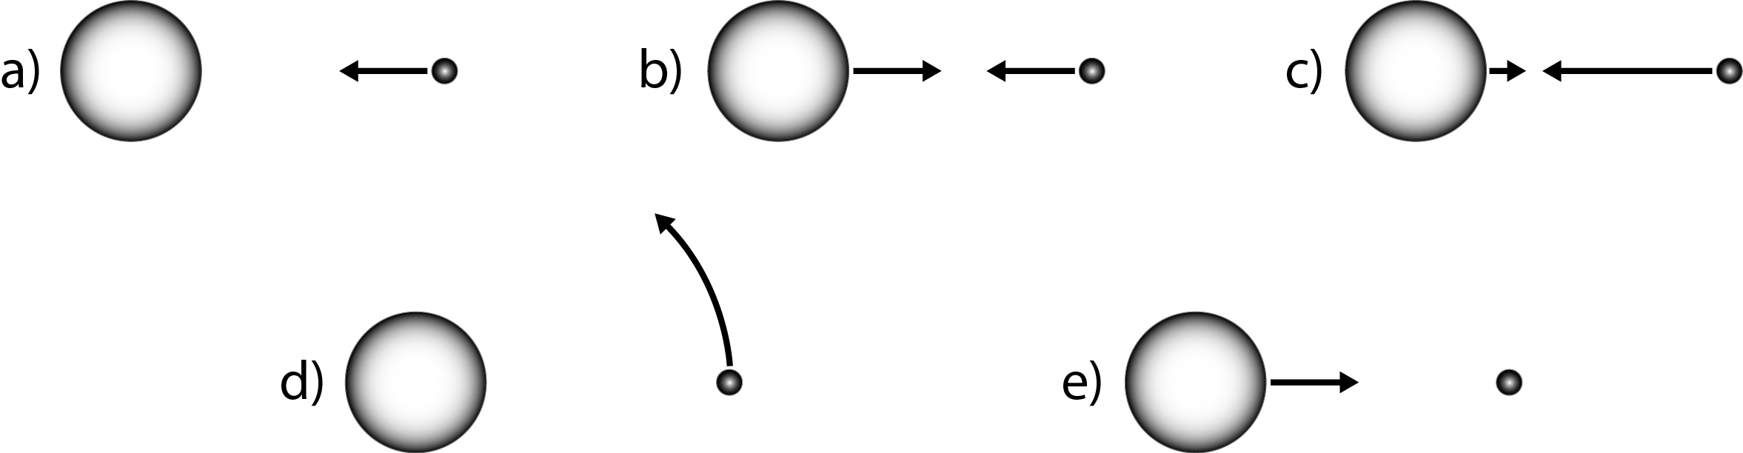

2. How would these gravity forces change if the Sun got much bigger?
Increase
Decrease
Stay the same

3. How would these gravity forces change if the Earth was much closer to the Sun?
Increase
Decrease
Stay the same

4. How would these gravity forces change if the Earth got much smaller?
Increase
Decrease
Stay the same

5. How would these gravity forces change if the Earth and Sun were moved far apart?
Increase
Decrease
Stay the same

6. Choose the picture of how the Earth would move if you “turned off” the gravity forces.

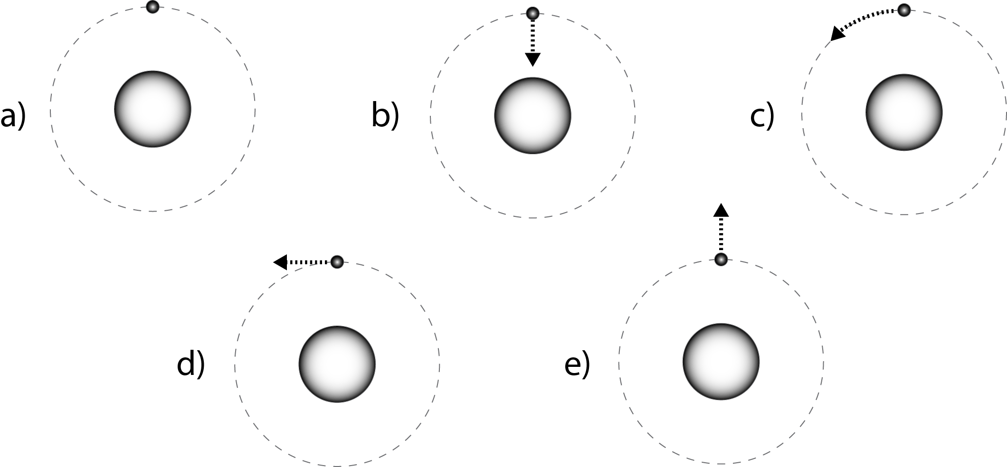

7. How useful for your learning was this activity, compared to other science class activities? (circle)
More useful
Less useful
About the same

How enjoyable was this science class activity, compared to other science class activities? (circle)
More enjoyable
Less enjoyable
About the same

Why did you or did you not find it useful or enjoyable? ____________________________________________________________________________________________________________________________________________________________________________________________________________________________________________________________________________________________________________________

