Name: _____________________________
Grade: _____________________________
Sound Waves
Pre-lab
A wave is created on this string by moving the wrench up and down.
- What would change if the wave had a higher frequency and smaller amplitude?
Draw how the string would look for a higher frequency, smaller amplitude wave over this picture of the wave:

- What would change if the wave had a lower frequency and larger amplitude?
Draw how the string would look for a lower frequency, larger amplitude wave over this picture of the wave:

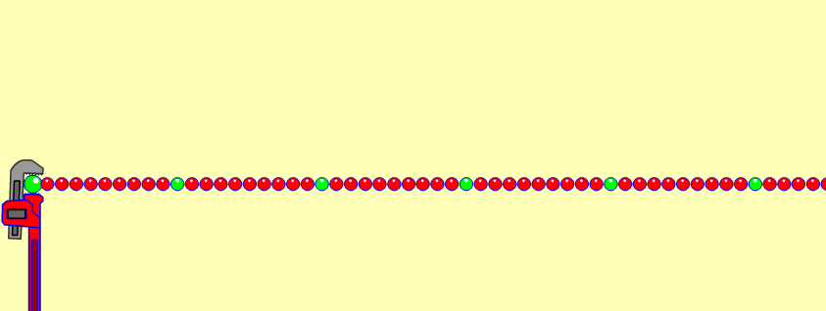
- If you were to create this wave by moving the wrench up and down, describe how you would move the wrench differently to make the high frequency, small amplitude wave compared to a low frequency, large amplitude wave?
Motion to make a high frequency, small amplitude?

Motion to make a low frequency, large amplitude?

- A student is listening to some pure notes that are produced using an electronic piano:
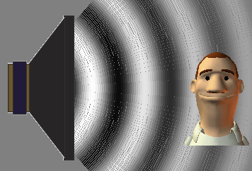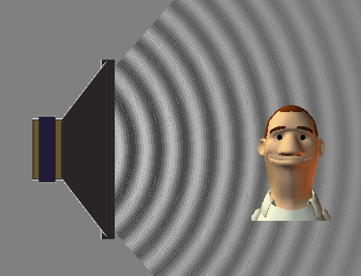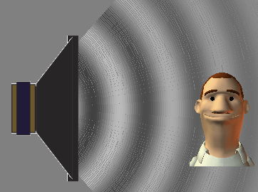
A B C

- Which picture or pictures (A, B, or C) would best show the student listening to a high-pitched sound?
Why do you think so?

- Which picture or pictures would best show the student listening to a loud sound?
Why do you think so?

- Which picture or pictures would best show the student listening to a low frequency sound?
Why do you think so?

Sound Waves (Teacher Notes)

Class Demonstration
After the pre-lab, and before starting activity, demo 2 tuning forks, or instruments – a high-pitch one and a low-pitch one.
Ask: Which one of these is a high-pitch? Which is a low pitch? Ask some more examples things that make a high-pitch sound and things that make a low-pitch sound.

The goal of this demo is only to make sure students to associate sounds with “high-pitch” and “low-pitch”.

Students will then be discovering *how* to make high-pitched noises and low-pitched noises in terms of frequency/amplitude and in terms of vibrational motion of a speaker.
Name: _____________________________
Sound Waves
Learning Objectives:
- Explore and draw conclusions about the nature, properties and behaviors of sound waves.
- Use the simulation to develop your own definition of frequency and amplitude.
- Describe how frequency and amplitude affect the sounds we hear.
- Given a description of a sound like “high pitched and loud”, describe the amplitude and frequency.

- Discuss examples of things that make the different types of sounds listed in the table below. Write your examples in the table below.

- Open Sound simulation from the icon on your computer.
Use the Listen to a Single Source tab. Turn on the Audio Enabled so you can hear the sound.

Create the sounds in the table below!

Sound | Example of something that makes this sound | Explain how you used  the simulation to  make the right noise | Draw what the  sound waves look like  in the simulation
Case A:
Loud, High-pitched
Case B:
Soft, High-pitched
Case C:
Loud, Low-pitched
Case D:
Soft, Low-pitched

- Which cases in Question #2:
  - Have a high frequency? __________________
  - Have a large amplitude?_________ _________
Explain what controls pitch, and what controls loudness.

- Creating Sounds …

Sound | - Compare how you would have to move the speaker to produce the sound in each case.  - Describe the motions below.  - Be sure to describe what is different about each one. |  | Is this sound Low or high pitch?  Loud or soft?
Case E:  Low Frequency,  Low Amplitude | 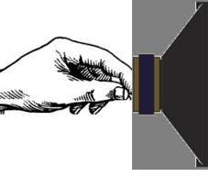
Case F:
High Frequency,
Low Amplitude
Case G:
Low Frequency,
High Amplitude
Case H:
High Frequency,
High Amplitude

- Develop rules for what effects frequency and what effects amplitude to explain your observations from Question 4.

- Some of your friends are confusing frequency and amplitude. How would you describe these terms in your own words or pictures to help your friends understand each one?

Name: _____________________________
Sound Waves
Post-lab
A wave is created on this string by moving the wrench up and down.
- What would change if the wave had a higher frequency and smaller amplitude?
Draw how the string would look for a higher frequency, smaller amplitude wave over this picture of the wave:

- What would change if the wave had a lower frequency and larger amplitude?
Draw how the string would look for a lower frequency, larger amplitude wave over this picture of the wave:

- If you were to create this wave by moving the wrench up and down, describe how you would move the wrench differently to make the high frequency, small amplitude wave compared to a low frequency, large amplitude wave?
Motion to make a high frequency, small amplitude?

Motion to make a low frequency, large amplitude?

- A student is listening to some pure notes that are produced using an electronic piano:
A B C

- Which picture or pictures (A, B, or C) would best show the student listening to a high-pitched sound? _______________________
Why do you think so?
__________________________________________________________________________________________________________________________________________________________
- Which picture or pictures would best show the student listening to a loud sound?___________
Why do you think so?
__________________________________________________________________________________________________________________________________________________________
- Which picture or pictures would best show the student listening to a low frequency sound?
Why do you think so?
__________________________________________________________________________________________________________________________________________________________

- How useful for your learning was this science activity, compared to other science class activities? (circle)
More useful About the same Less useful
How enjoyable was this science class activity, compared to other science class activities? (circle)
More enjoyable About the same Less enjoyable
Why did you or did you not find it useful or enjoyable? ________________________________________________________________________________________________________________________________________________________________________________________________________________________________________________________________________________________________________________________________

