Name: _____________________________
Sound Waves
Post-lab
A wave is created on this string by moving the wrench up and down.
- What would change if the wave had a higher frequency and smaller amplitude?
Draw how the string would look for a higher frequency, smaller amplitude wave over this picture of the wave:

- What would change if the wave had a lower frequency and larger amplitude?
Draw how the string would look for a lower frequency, larger amplitude wave over this picture of the wave:

- If you were to create this wave by moving the wrench up and down, describe how you would move the wrench differently to make the high frequency, small amplitude wave compared to a low frequency, large amplitude wave?
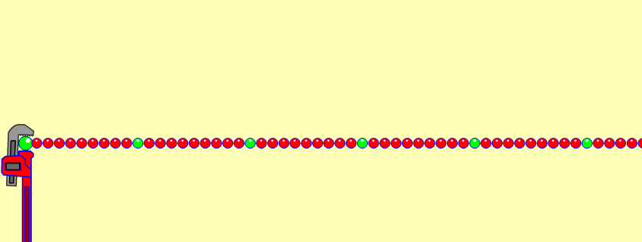
Motion to make a high frequency, small amplitude?

Motion to make a low frequency, large amplitude?

- A student is listening to some pure notes that are produced using an electronic piano:
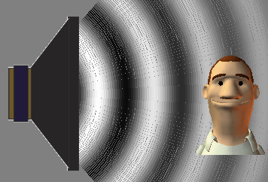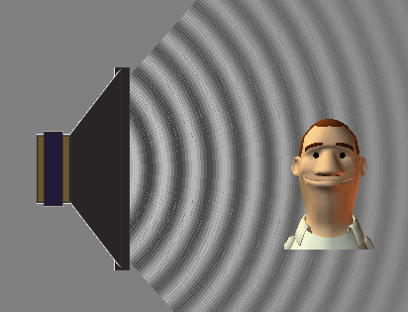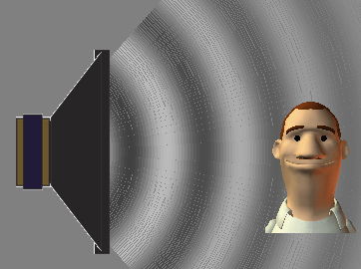
A B C

- Which picture or pictures (A, B, or C) would best show the student listening to a high-pitched sound? _______________________
Why do you think so?
__________________________________________________________________________________________________________________________________________________________
- Which picture or pictures would best show the student listening to a loud sound?___________
Why do you think so?
__________________________________________________________________________________________________________________________________________________________
- Which picture or pictures would best show the student listening to a low frequency sound?
Why do you think so?
__________________________________________________________________________________________________________________________________________________________

- How useful for your learning was this science activity, compared to other science class activities? (circle)
More useful About the same Less useful
How enjoyable was this science class activity, compared to other science class activities? (circle)
More enjoyable About the same Less enjoyable
Why did you or did you not find it useful or enjoyable? ________________________________________________________________________________________________________________________________________________________________________________________________________________________________________________________________________________________________________________________________

